March 2017

Draft FY18 Operating Plan and Budget

Table of Contents

0 – Summary of Changes 4

1 – Introduction 5

2 – Planning and Budget Overview 7

3 – ICANN Operations 9

3.1 – Financial Overview 9

3.2 – Funding 11

3.3 – Baseline Cash Expenses 14

3.5 – Risks and Opportunities 17

3.6 – Unfunded Potential FY18 Activities 18

3.7 – Caretaker Budget 19

4 – PTI Operating Plan and Budget and IANA Budget Process Overview 20

4.1 – IANA Budget Overview 21

5 – New gTLD Program 22

5.1 – New gTLD Program – Financial Summary 22

5.2 – New gTLD Program – Multiyear View 23

5.3 – New gTLD Program – Variance Analysis 24

5.4 – New gTLD Program – Operating Expenses Variance Analysis 25

6 – Total ICANN Overview 26

6.1 – FY18 Financial Overview 26

6.2 – Headcount – Three Year Overview 27

6.3 – Cash Flow Synopsis 28

7 – FY18 Operating Plan and Budget – Description 29

7.1 – Management System 29

7.2 – 1.1 Further Globalize and Regionalize ICANN Functions 31

7.3 – 1.2 Bring ICANN to the World by Creating a Balanced and Proactive Approach to Regional Engagement with Stakeholders 33

7.4 – 1.3 Evolve Policy Development and Governance Processes, Structures and Meetings to be More Accountable, Inclusive, Efficient, Effective and Responsive 34

7.5 – 2.1 Foster and Coordinate a Healthy, Secure, Stable, and Resilient Identifier Ecosystem 36

7.6 – 2.2 Proactively Plan for Changes in the Use of Unique Identifiers and Develop Technology Roadmaps to Help Guide ICANN Activities 38

7.7 – 2.3 Support the Evolution of Domain Name Marketplace to be Robust, Stable and Trusted 40

7.8 – 3.1 Ensure ICANN’s Long-Term Financial Accountability, Stability and Sustainability 42

7.9 – 3.2 Ensure Structured Coordination of ICANN’s Technical Resources 44

7.10 – 3.3 Develop a Globally Diverse Culture of Knowledge and Expertise Available to ICANN’s Board, Staff, and Stakeholders 45

7.11 – 4.1 Encourage Engagement with the Existing Internet Governance Ecosystem at National, Regional and International Levels 47

7.12 – 4.2 Clarify the Role of Governments in ICANN and Work with them to Strengthen their Commitment to Supporting the Global Internet Ecosystem 48

7.13 – 4.3 Participate in the Evolution of a Global, Trusted, Inclusive Multistakeholder Internet Governance Ecosystem that Addresses Internet Issues 49

7.14 – 4.4 Promote Role Clarity and Establish Mechanisms to Increase Trust within the Ecosystem Rooted in the Public Interest 50

7.15 – 5.1 Act as a Steward of the Public Interest 52

7.16 – 5.2 Promote Ethics, Transparency and Accountability Across the ICANN Community 53

7.17 – 5.3 Empower Current and New Stakeholders to Fully Participate in ICANN Activities 55

Appendix 56

A – FY18 Budget by Project 56

B – Registrar Fees 57

C – ICANN Bylaws excerpts – Caretaker budget Annex E and F 59

0 – Summary of Changes

This section will show changes made to the final budget based on input received from the Public Comment period.

1 – Introduction

This document contains ICANN’s draft Fiscal-Year 2018 (FY18) Operating Plan and Budget, which is being submitted for public comment as required by ICANN’s Bylaws, and in accordance with [ICANN’s public comment policy](https://www.icann.org/resources/pages/rules-procedures-2014-03-17-en).

Enabling the engagement of all stakeholders in the planning process of ICANN, through accessible information and effective interaction, is a fundamental part of ICANN’s multistakeholder model. Publishing this draft version of the FY18 Operating Plan and Budget for public comment is a key element of the transparency and community engagement in ICANN's planning process. [ICANN online glossary](https://www.icann.org/resources/pages/glossary-2014-02-03-en) defines and explains terminology used in this document.

ICANN welcomes and recognizes the past, present and future engagement of all stakeholders into the ICANN’s planning process, whether relative to the strategic plan, operating plan, budget, or on-going operational and financial updates.

This document provides draft details of ICANN’s planned activities for its fiscal year 2018 (FY18) that will run from 1 July 2017 to 30 June 2018. Where useful, comparative information for FY17 is provided, using actual and forecast information. As [PTI](https://pti.icann.org/)’s operations are an aspect of ICANN’s total operations, they are documented here. They are presented with background shading to indicate that PTI’s FY18 Operating Plan and Budget was consulted on in late 2016 and adopted by the PTI Board in January 2017.

The IANA Stewardship Transition was completed in early FY17. All of the Implementation activities for the project are estimated to be completed in FY17 and no expense is projected for FY18.

The Operating Plan and Budget includes:

* Highlights of ICANN Operations (excluding the New gTLD Program).
* The activities that have already been consulted on and adopted as a part of PTI’s FY18 Operating Plan and Budget.
* Highlights of the New gTLD Program.
* An overview of ICANN’s FY18 Budget, combining ICANN Operations and the New gTLD Program.
* The detailed Operating Plan predefined in the management system:
  + Planned portfolios of activities to support the achievement of the goals and objectives described in ICANN’s Strategic Plan with detailed descriptions.
  + Updated Key Performance Indicators for each strategic goal.
  + An Appendix linking to a list of projects, for each portfolio, with the project-level budgeted costs by category.

The Supporting Organization (SO) and Advisory Committee (AC) Additional Budget Requests will be evaluated and the Board will make its decision at its May 2017 meeting. The list of the special request decisions adopted will be published on the [Finance Community Wiki](https://community.icann.org/display/projfinadhocws/Community+Group+Workspace).

This draft Operating Plan and Budget includes data on all projects planned to be carried out during FY18, and displays all costs categories for each project. Each project is also mapped to one of the five objectives of the ICANN Strategic Plan for fiscal years 2016–2020, through the hierarchy of portfolios and goals, making the rationale for each project and activity clear and transparent.

2 – Planning and Budget Overview

This graphic shows the five-year planning cycle (FY16-FY20), at a high level. The planning process consists of the ICANN Strategic Plan for fiscal years 2016–2020 and the Five-Year Operating Plan, which provide input and a basis for the annual planning process. This FY18 process has seen the introduction of the consultation on and development of an Operating Plan and Budget for PTI. PTI’s plans feed into the consultation on and development of both the IANA Services and ICANN Budgets.

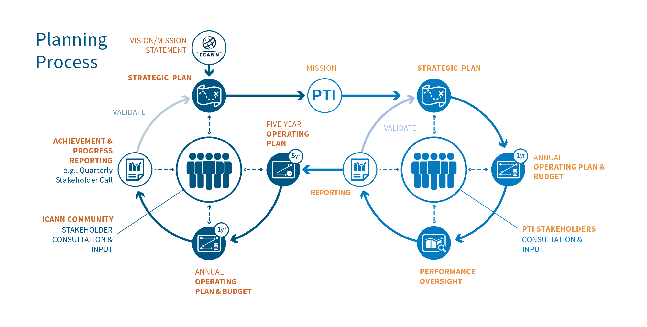

This diagram shows the structure of the budget data in the rest of this document.

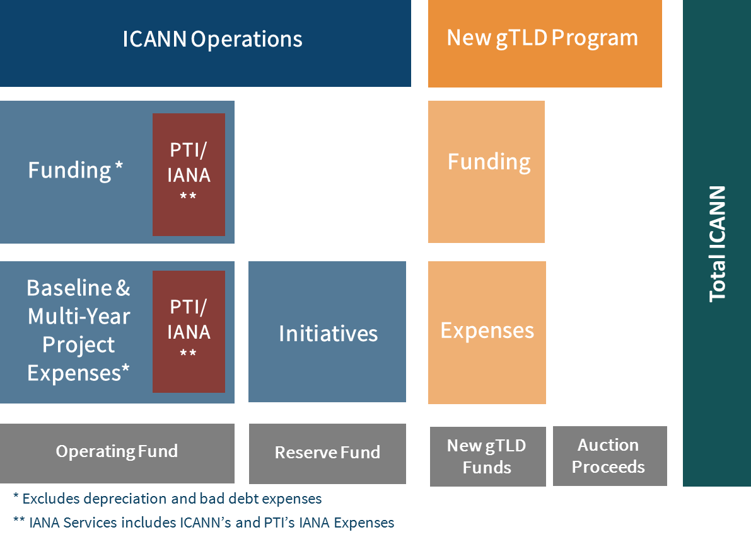

3 – ICANN Operations

This section provides an overview of the ICANN Operations funding and baseline cash expenses.

# 3.1 – Financial Overview

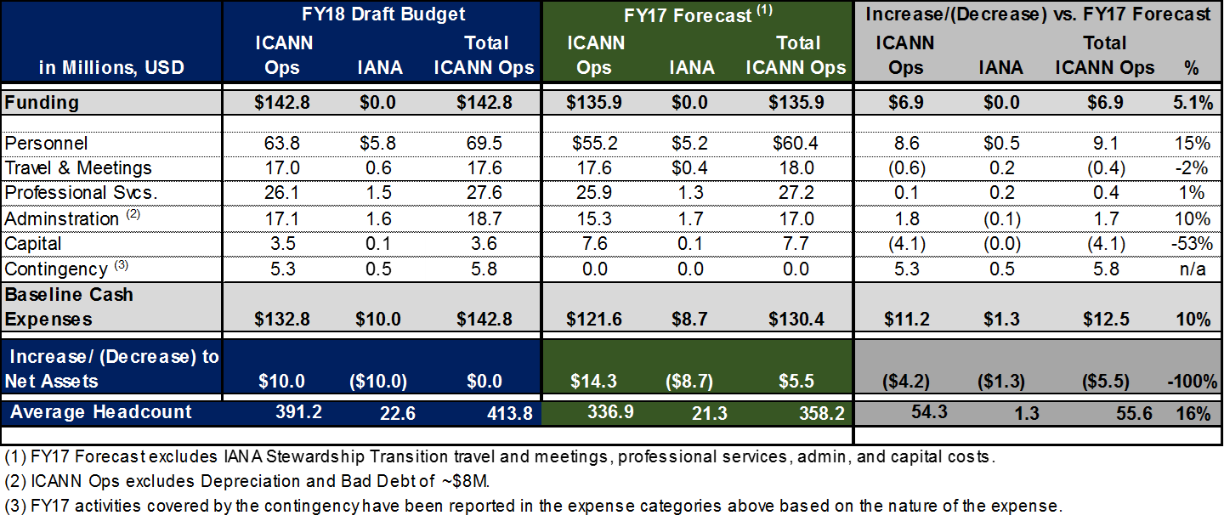

The following table describes ICANN Operation’s planned baseline cash expenses by function for FY18.

# 3.2 – Funding

This section provides an overview of ICANN’s funding, starting with the assumptions that support the FY18 estimates. The best estimate matches the FY18 funding included in the FY18 budget. The high and low estimates provide for a sensitivity analysis of some of the funding items and are the result of variations of the best estimate.

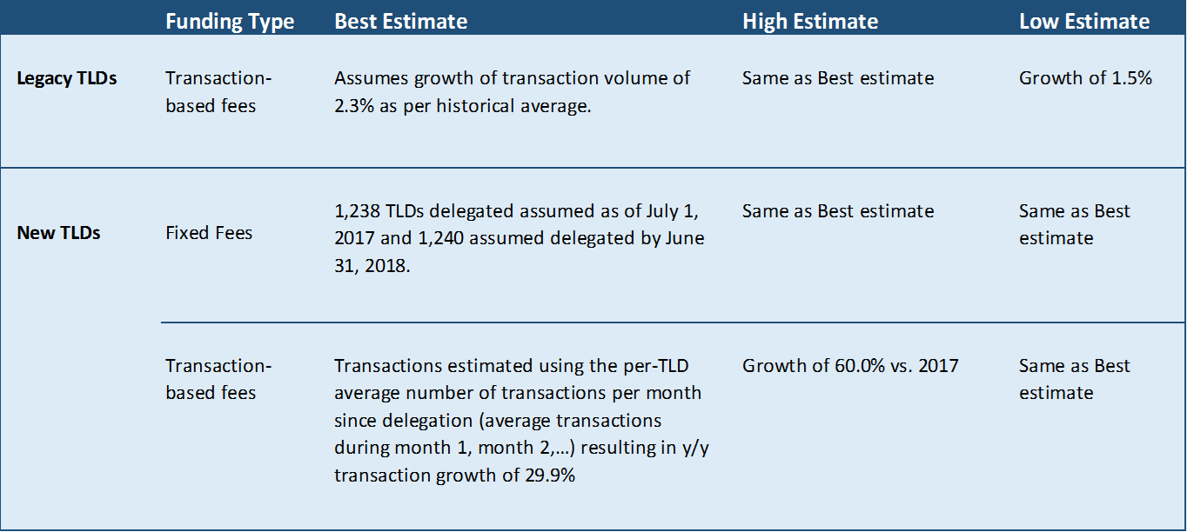

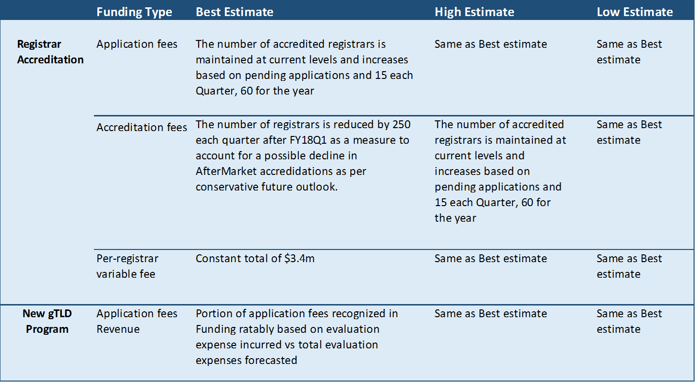

The following table describes ICANN’s funding by source and type, comparing for each the best estimate for the FY18 budgeted year and for the FY17 current year.

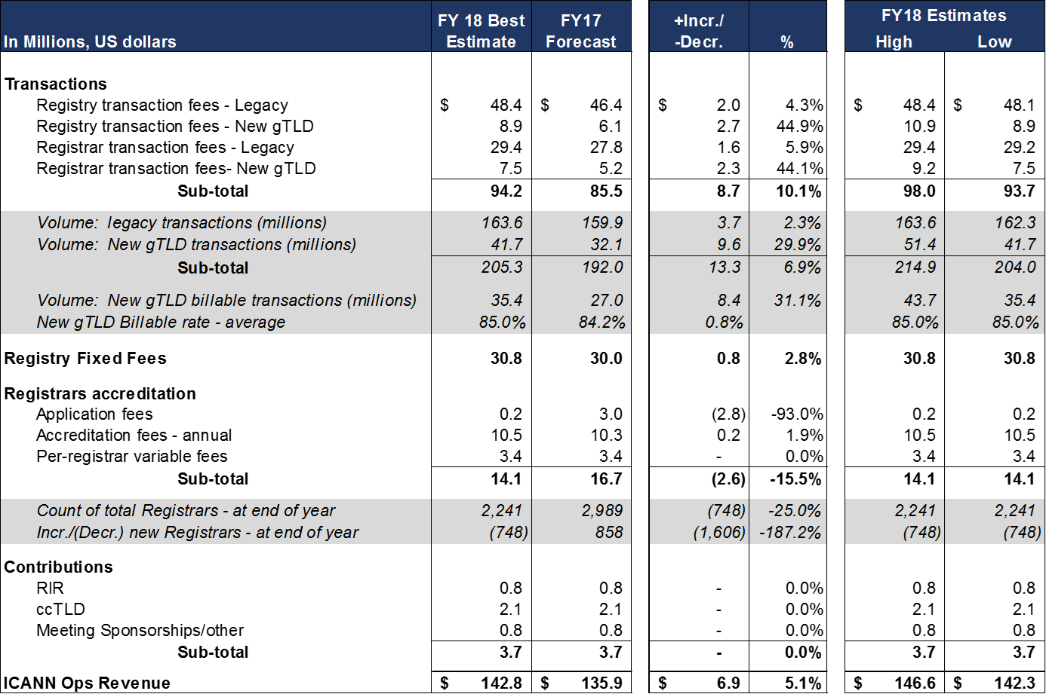

# 3.3 – Baseline Cash Expenses

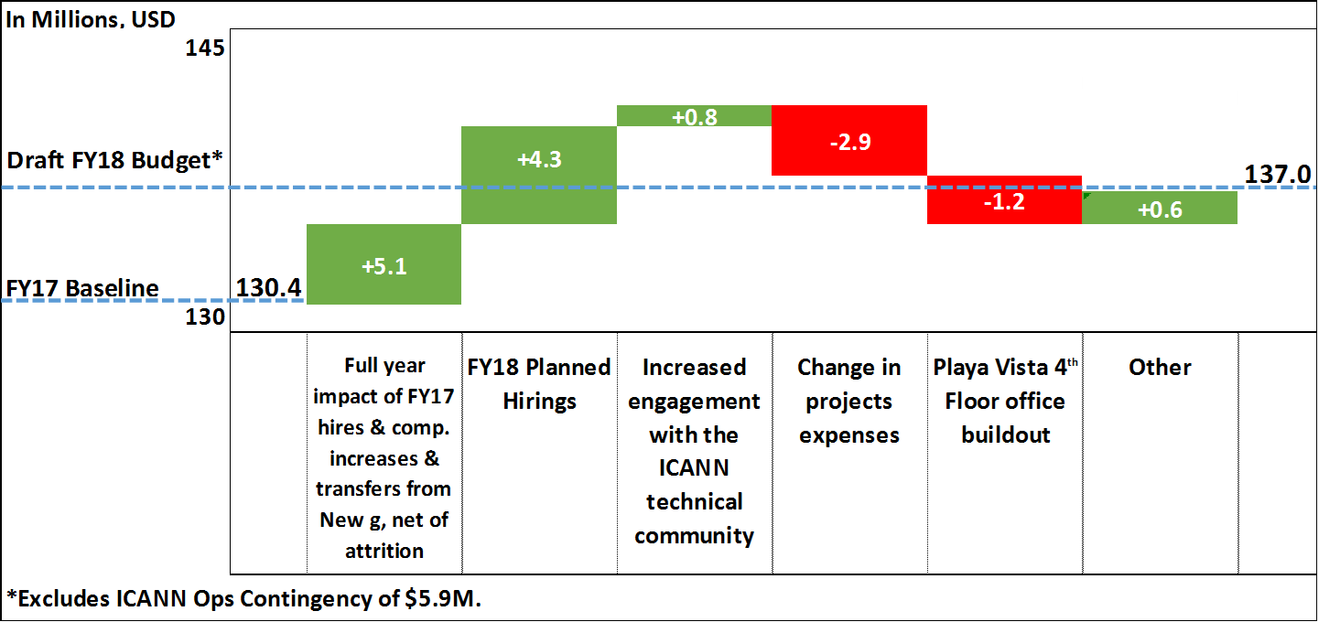

The ICANN Operations baseline cash expenses budget (excludes contingency) is $137.0 million. This represents a $6.6 million increase from $130.4 million in FY17, driven by the following:

* Full year impact of people hired in FY17 on FY18 budget: Increase in personnel costs due to:
  1. 44 staff members estimated to be hired in FY17 working a full year in FY18 versus a partial year in FY17.
  2. Personnel costs increases (merit, taxes, and fringe benefits).
  3. 9 staff members transferring from the New gTLD Program to ICANN Operations at the beginning of FY18.
  4. Partially offset by estimated attrition.
* Impact of staff hired in FY18: average 26.1 Full-Time Equivalents (FTEs).
* Increased technical engagement with the ICANN Community, with emphasis on proactively planning for changes in the use of unique identifiers and developing technology roadmaps to help guide ICANN activities.
* Lower projects expenses in FY18 due to the planned completion of prior year projects in FY17, such as the Root Zone Management System (RZMS) Enterprise Resource Planning (ERP) projects.
* Expenses for the Playa Vista fourth floor office buildout incurred in FY17 that will not be incurred in FY18.
* Other: Limited growth in all other areas (for example, inflationary increases).

The following table describes ICANN’s planned capital projects for FY18.



KMF: An ISO term. A protected enclosure for a room and cryptographic equipment and its contents where cryptographic elements reside. This is used to manage the Root DNS Key Signing Key

# 3.4 – Risks and Opportunities

This section outlines the risks and opportunities to the FY18 budget and provides the potential impact of the risk or opportunity on the FY18 budget assumptions as either lower or higher funding or cost.

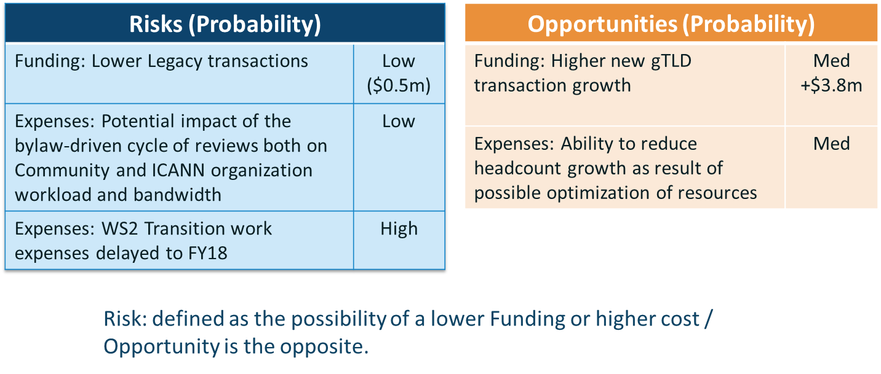

# 3.5 – Unfunded Potential FY18 Activities

The following table describes activities that were considered during budget development, but are not included in the draft FY18 Operating Plan and Budget. These activities will be considered for approval during FY18, based on priority and availability of funding. The list of activities is evolving and may change as additional information becomes available.



# 3.6 – Caretaker Budget

As per “Section 6.2. Powers and Acknowledgements”, ICANN bylaws define powers and rights attributed to the Empowered Community. One of these powers is:

(iii) Reject ICANN Budgets, IANA Budgets, Operating Plans (as defined in Section 22.5(a)(i)) and Strategic Plans (as defined in Section 22.5(b)(i));

In the event such rejection power is exercised, the Board shall adopt a temporary budget called “Caretaker IANA Budget” and “Caretaker ICANN Budget”, which shall be effective until such time as an IANA and ICANN budgets, respectively, are adopted by the Board of Directors and not rejected by the Empowered Community.

Such caretaker budgets are defined in Annex E (for ICANN) and Annex F (for IANA) of the ICANN Bylaws. These annexes are reproduced in Appendix C.

Below is an attempt at a pragmatic approach to define the ICANN caretaker budget:

Using the Operating Plan and Budget that the ICANN Board would adopt as a basis, and with respecting the principles of the caretaker budget:

* Suspend the publication of any new positions for hire, from the date of the rejection by the Empowered Community, that is the veto date, until a new budget is adopted by the Board.
* Reduce by 10% the total amount of allowed expenses for the categories Travel/Meeting and Professional Services of the Board-adopted budget, for the period starting on the date of the rejection by the Empowered Community until a new budget is adopted by the Board, using the monthly breakdown of the adopted budget.
* Exclude any expense directly associated with the reason for which the rejection of the board-adopted budget was approved by the Empowered Community, if such expense can reasonably be isolated and avoided.

4 – PTI Operating Plan and Budget and IANA Budget Process Overview

The planning process for PTI and the IANA Budget is incorporated into the ICANN planning process. PTI’s and IANA’s multiyear plans are a part of ICANN’s Five-Year Operating Plan. The adopted version of the PTI Operating Plan and Budget becomes a component of ICANN’s FY18 Operating Plan and Budget.

FY17 is the first year of the PTI and the IANA Budget planning process. To further enhance the understanding and transparency of its activities, and ultimately its accountability in the management of funds in the public interest, the CCWG recommended that “PTI should submit a budget to ICANN at least nine months in advance of the fiscal year to ensure the stability of the IANA Services. It is the view of the CWG-Stewardship that the IANA Budget should be approved by the ICANN Board in a much earlier timeframe than the overall ICANN budget.”

Consultations were conducted on PTI’s draft FY18 Operating Plan and Budget. After developing a draft, it was published for Public Comment from 24 October 2016 until 10 December 2016. A report of responses to Public Comments was published in January 2017 and the completed Operating Plan and Budget the PTI Board adopted by PTI’s Board at the end of January 2017. The sections of the plans relating to PTI are therefore already finalized and described in the PTI Operating Plan and Budget document.

# 4.1 – IANA Budget Overview

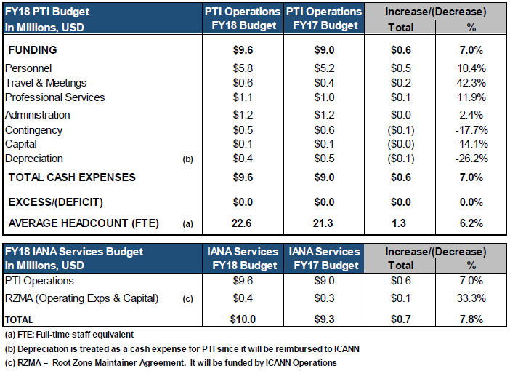ICANN receives the input from PTI on its budget and then develops a IANA Budget each year. The draft Plan is presented for Public Comment, using ICANN’s Public Comment process. When that process ends, staff develops a proposed Operating Plan and Budget for the ICANN Board to review and adopt. The adopted Plan forms the basis for ICANN’s funding of PTI operations.

5 – New gTLD Program

# 5.1 – New gTLD Program – Financial Summary

This section provides a financial summary of the New gTLD program.



**\*All information is related to the current round of the New gTLD Program (2012-2018)**

# 5.2 – New gTLD Program – Multiyear View

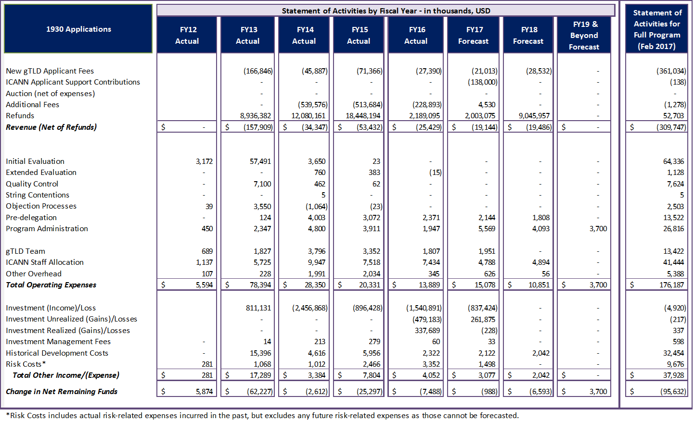

# 5.3 – New gTLD Program – Variance Analysis



# 5.4 – New gTLD Program – Operating Expenses Variance Analysis

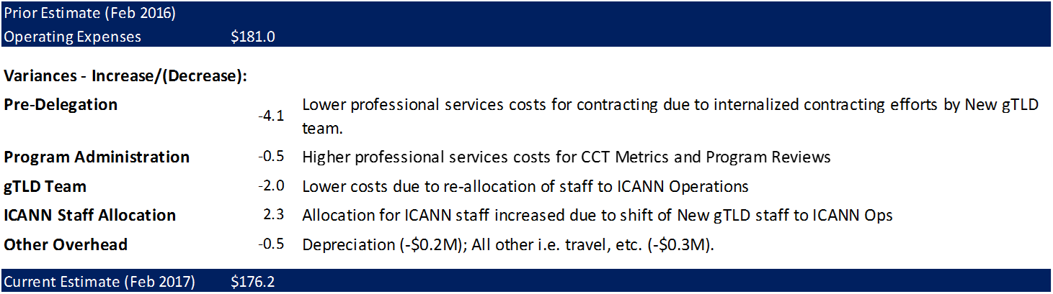

6 – Total ICANN Overview

# 6.1 – FY18 Financial Overview

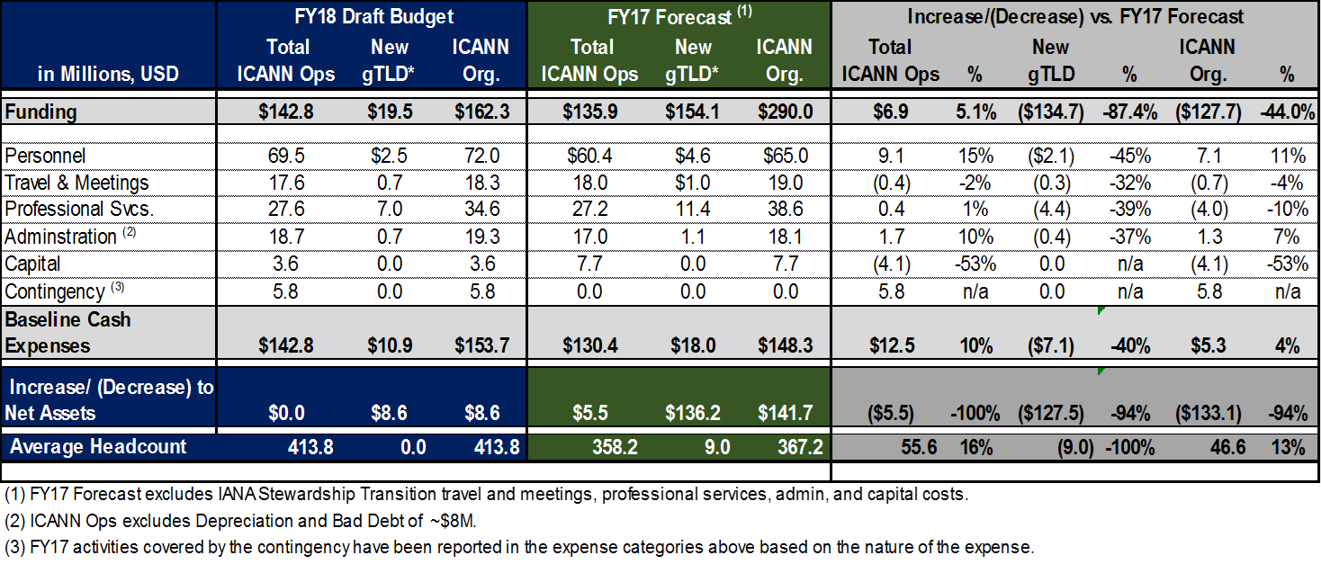

# 6.2 – Headcount – Three Year Overview

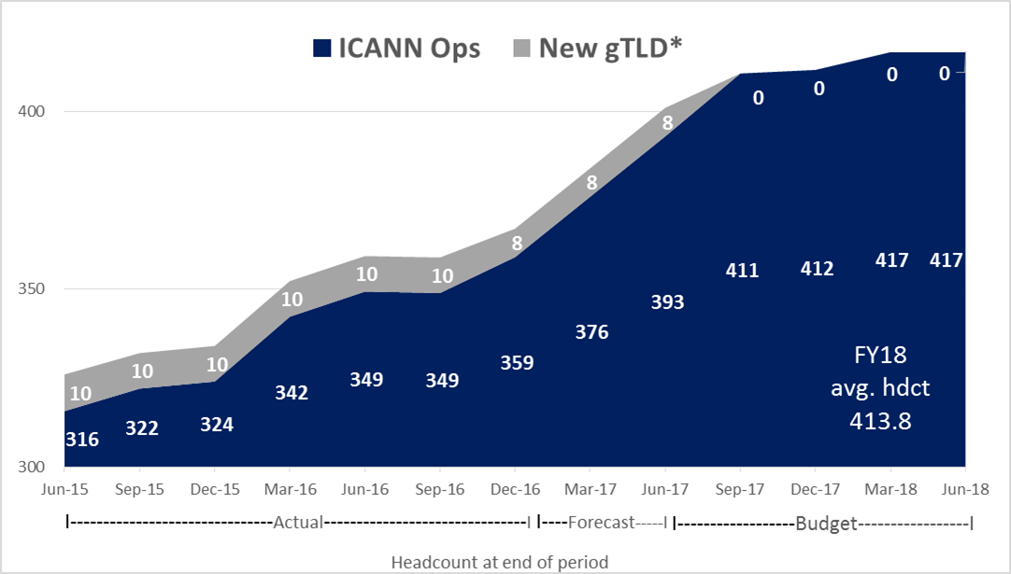The headcount below represents the number of individuals working for ICANN on the last calendar day of each period.

*As the New gTLD Program progresses, the dedicated resources previously reported under the Program are transferring to ICANN Operations in FY18 and continue to support the Program as required.

# 6.3 – Cash Flow Synopsis

The following table describes ICANN’s planned cash inflows and outflows for FY18.



7 – FY18 Operating Plan and Budget – Description

# 7.1 – Management System

ICANN’s Five-Year Operating Plan informs the FY18 Operating Plan and Budget, which is aligned with its phasing and its Key Performance Indicators. This allows us to map all activities and resources back to the five main Strategic Objectives developed by a community driven bottom up process.

* Five Objectives – these were reviewed and revised during the development of ICANN Strategic Plan for fiscal years 2016–2020, which was adopted by the Board in October 2014.
* 16 Goals – owned by the CEO’s executive team. Each goal has defined Key Success Factors to clarify what constitutes progress towards achieving a goal.
* 59 Portfolios – each goal contains a set of portfolios, which are groups of related projects. These also have defined success metrics.
* Over 320 Projects – Projects reflect ongoing work. Expenses are budgeted at the project level. A breakdown of all projects is linked from the Appendix. The budgeted amounts in this document are inclusive of capital expenditures and multiyear projects.

The budget amounts for each portfolio in the following sections are provided by cost category:

|  |  |
| --- | --- |
| **Meaning** | **Abbreviation** |
| Personnel | Pers |
| Travel and Meetings | T&M |
| Administration | Admin |
| Capital | Capital |
| Full Time Equivalent | FTE |

Values are shows in millions, USD. The term FTE refers to the full-time staff equivalent dedicated to each portfolio.

The next page shows how ICANN’s five strategic objectives are subdivided into 16 strategic goals. These are each divided into portfolios of projects.

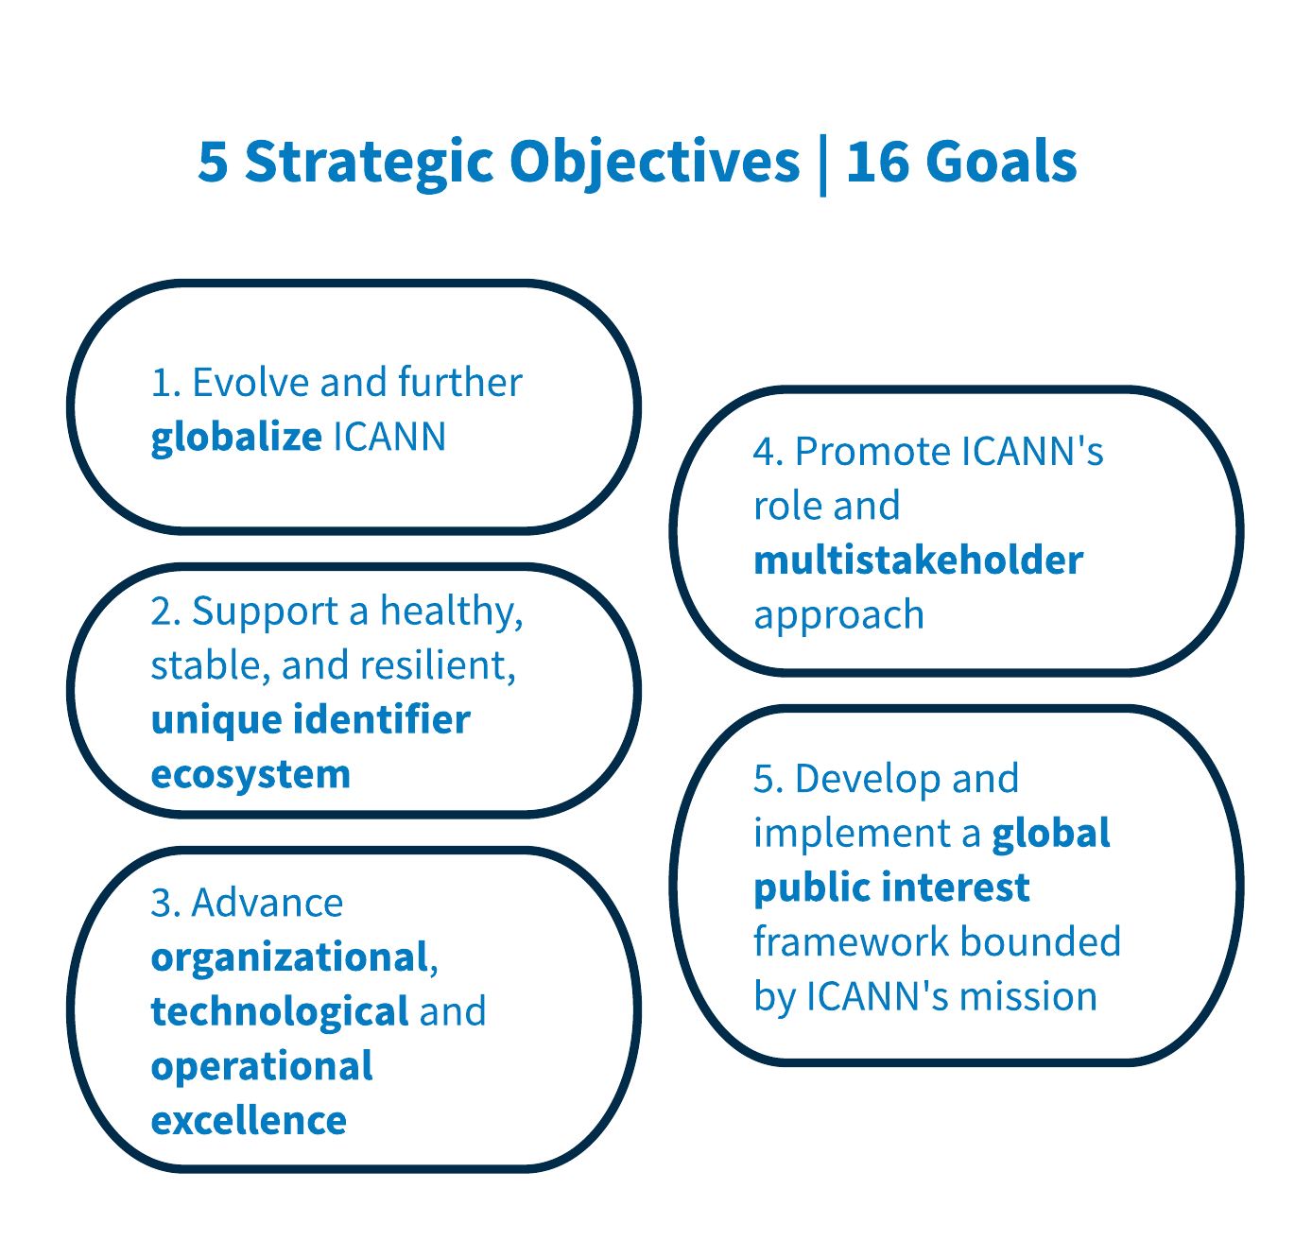

|  |  |
| --- | --- |
| 1.1 | Further Globalize and Regionalize ICANN Functions |
| 1.2 | Bring ICANN to the world by creating a balanced and proactive approach to regional engagement with stakeholders |
| 1.3 | Evolve Policy Development and Governance Processes, Structures and Meetings to be More Accountable, Inclusive, Efficient, Effective and Responsive |
| 2.1 | Foster and Coordinate a Healthy, Secure, Stable, and Resilient Identifier Ecosystem |
| 2.2 | Proactively Plan for Changes in the Use of Unique Identifiers, and Develop Technology Roadmaps to Help Guide ICANN Activities |
| 2.3 | Support the Evolution of the Domain Name Marketplace to be Robust, Stable and Trusted |
| 3.1 | 3.1 Ensure ICANN’s Long-Term Financial Accountability, Stability and Sustainability |
| 3.2 | Ensure Structured Coordination of ICANN’s Technical Resources |
| 3.3 | Develop a globally diverse culture of knowledge and expertise  available to ICANN’s Board, staff and stakeholders |
| 4.1 | Encourage Engagement with the Existing Internet Governance Ecosystem at National, Regional and Global Levels |
| 4.2 | Clarify the Role of Governments in ICANN and Work with Them to Strengthen their Commitment to Supporting the Global Internet Ecosystem |
| 4.3 | Participate in the Evolution of a Global, Trusted, Inclusive Multistakeholder Internet Governance Ecosystem that Addresses Internet Issues |
| 4.4 | Promote Role Clarity and Establish Mechanisms to Increase Trust Within the Ecosystem Rooted in the Public Interest |
| 5.1 | Act as a Steward of the Public Interest |
| 5.2 | Promote ethics, transparency and accountability across the ICANN community |
| 5.3 | Empower Current and New Stakeholders to Fully Participate in ICANN Activities |

# 7.2 – 1.1 Further Globalize and Regionalize ICANN Functions

In FY18, we will focus on the following activities that work towards further globalizing and regionalizing ICANN functions:

1. Map community to regional engagement.
2. Implement recommendations resulting from examination of ICANN regional offices in support of ICANN globalization.

We will measure our success in achieving this goal by:

* # of remote participation session hours and number of remote participants at ICANN meetings
* % of sessions with live interpretation at ICANN meetings

Portfolios

1.1.1 – Raising Stakeholder Awareness of ICANN Worldwide

Description: This portfolio pertains to how ICANN communicates with stakeholders around the world to help raise awareness of ICANN’s mission, its multistakeholder model and its work. This portfolio is grouped with 1.2.1. Metrics to measure ongoing communications activities include active social and traditional media monitoring and measurement, global newsletter open rates and reach of speaking engagements.

1.1.2 – GSE Executive team coordination and administration

Description: This portfolio covers ICANN’s Global Stakeholder Engagement (GSE) prioritization and planning, across regions and functional areas. This portfolio is grouped closely with 1.2.2. The planning portfolio covers the organization of GSE and regionalization of ICANN functions and communications.

1.1.3 – Language Services

Description: Make information about ICANN and its work accessible to those who speak languages other than English in ways that enhance participation in, and the effectiveness of, the multistakeholder model. ICANN's translations are available in the six United Nations languages – Arabic, Chinese (Simplified), English, French, Russian and Spanish – to make ICANN more effective as a global organization. More languages are being supported to promote inclusion. We do this in two ways:

* By providing support to hub and engagements offices, such as Turkish for the Istanbul hub.
* By promoting the Translation/Localization Kit Program, where ICANN Language Services works with the community to translate documents into languages not supported within the UN set of languages.

These languages include Japanese, Korean, and some others. ICANN Language Services also promotes teleconference interpretation support in the six United Nations languages for all working group calls and any other teleconference call where the presence of support of availability of other languages may increase and facilitate participation.



# 7.3 – 1.2 Bring ICANN to the World by Creating a Balanced and Proactive Approach to Regional Engagement with Stakeholders

In FY18, we will focus on the following activities that work towards bringing ICANN to the world by creating a balanced and proactive approach to regional engagement with stakeholders:

1. Map Stakeholder Journey to regional engagement.
2. Enhance online ICANN meeting hubs to contribute to and increase engagement during meetings.
3. Review effectiveness of ICANN web tools for supporting globalization and regionalization for community.

We will measure our success in achieving this goal by:

* Global/regional engagement activities to show a balanced and proactive approach to regional engagement
* Stakeholder Participation at ICANN meetings by region

Portfolios

1.2.1 – Engage Stakeholders Regionally

Description: This portfolio covers the mechanisms for delivering on ICANN’s regional and functional engagement strategies (including regional and functional area work plans, stakeholder engagement heat map).

1.2.2 –Meeting Services

Description: All work associated with planning and running ICANN’s three public meetings a year.



# 7.4 – 1.3 Evolve Policy Development and Governance Processes, Structures and Meetings to be More Accountable, Inclusive, Efficient, Effective and Responsive

For FY18, we continue to consolidate progress made towards the following activities that work towards evolving policy development and governance processes, structures and meetings to be more accountable, inclusive, efficient, effective and responsive:

1. Complete a comprehensive assessment, every two years, of delivery of all resources and capabilities that are provided to the stakeholders.
2. Analyze, evaluate and plan for how to balance resource abilities and capabilities among stakeholders (every two years).
3. Assess progress towards five-year goal – toward wide use of improved tools and mechanisms for global participation and representation, including the use of remote participation to engage stakeholders from emerging regions.
4. Implement improvements resulting from ICANN Reviews as part of continuous accountability enhancement work.
5. Support one or more At-Large General Assemblies.

We will measure our success in achieving this goal by:

* Representation and Participation in the policy development and governance processes
* Quantity of Activity index
* Quantity of Activity and Productivity index

Portfolios

1.3.1 – Support Policy Development, Policy-Related and Advisory Activities

Description: Optimize efficiency and effectiveness of community policy development and advice efforts.

1.3.2 – Reinforce Stakeholder Effectiveness, Collaboration and Communication Capabilities

Description: To optimize collaboration and engagement of ICANN Supporting Organizations and Advisory Committees, and increase and measure the number of exchanges (meetings and correspondence) that take place between them (and the Board as appropriate) as they consult and discuss strategic and policy issues/matters.

1.3.3 – Evolving Multistakeholder Model

Description: Planning and implementation of ICANN’s online education platform to:

* Support increased, informed, global involvement in ICANN
* Plan for evolving ICANN’s multistakeholder model
* Facilitate the development and publication of academic research on the multi-stakeholder model for DNS coordination, Internet policy development and governance.



# 7.5 – 2.1 Foster and Coordinate a Healthy, Secure, Stable, and Resilient Identifier Ecosystem

In FY18, we intend to do the following to foster and coordinate a healthy, secure, stable, and resilient identifier ecosystem:

1. Deliver services to the ICANN Community according to service level targets.
2. Monitor and manage service delivery against targets, identify opportunities for improvement and efficiency.
3. Standardize methodology, processes and tools for managing action request and Implement process improvements for increased operational efficiency and customer satisfaction.
4. Implement system enhancements for increased operational efficiency and effectiveness.
5. Implementation and Deployment of enhancements to User Interface for the Protocol Parameter requests.
6. Modernization and enhancements of the IANA website.
7. Root Zone customer API for operators that manage portfolios of many domains.
8. Continue to lead and support Registration Data Services (WHOIS) activities to promote trust and confidence in the Internet for all stakeholders.

We will measure our success in achieving this goal by:

* % of Service Level Targets met for delivery of services across multiple departments including but not limited to IANA Services, GDD Operations, and Global Customer Support departments

Portfolios

2.1.1 – PTI Operations[1]

Description: Operational responsibilities for maintaining registries for protocol parameters, IP numbers, Autonomous System Numbers, and root zone changes. Maintenance of relationship with Internet Engineering Task Force, Internet Architecture Board, five Regional Internet Registries, and TLD operators

2.1.2 – PTI Technical System Enhancements[2]

Description: Software enhancements, tool development, and other discrete projects to improve delivery of the IANA Services

2.1.3 – Action Request Register Management

Description: Implementation of processes and tools to track the receipt, consideration, response, and closure of request made to ICANN’s Board, CEO or Organization. Requests to include items from Supporting Organizations, Advisory Committees, Review Teams, and others.

2.1.4 – Global Domains Division Operations

Description: Projects related to the service implementation and ongoing delivery of services to contracted parties by the GDD. This includes reviewing and improving the way services are delivered.

2.1.5 – Global Customer Support

Description: Projects related to the development, implementation and ongoing operations of the ICANN Customer Service Center. This includes support, engagement and advocacy for the global registrant community.

2.1.6 – Product Management

Description: Projects and ongoing activities in support of the New gTLD Program, including technical development work for service platforms.

2.1.7 – Registration Data Services (WHOIS)

Description: Projects related to Registration Data Services (WHOIS) activities and efforts aimed at promoting trust and confidence in the Internet for all stakeholders.



# 7.6 – 2.2 Proactively Plan for Changes in the Use of Unique Identifiers and Develop Technology Roadmaps to Help Guide ICANN Activities

In FY18, we will continue focusing on the activities that work towards proactively planning for changes in the use of unique identifiers and developing technology roadmaps to help guide ICANN activities:

1. Complete implementation of first year of technology roadmaps.
2. Publish at least two more white papers on identifier technology.
3. Demonstrate growth in ratios in developing regions.

We will measure our success in achieving this goal by:

* An Identifier Technologies Health Index, which will measure ICANN's contribution to the health of identifiers in both the ICANN and broader Internet communities.

Portfolios

2.2.1 – Identifier Evolution

Description: Track and support the evolution of the Internet’s system of unique identifiers through venues such as the [IETF](https://www.ietf.org/), [DNS-OARC](https://www.dns-oarc.net/), [W3C](https://www.w3.org/), the [RIRs](https://www.nro.net/about-the-nro/regional-internet-registries), and other relevant bodies.

2.2.2 – Technical Reputation

Description: Measure ICANN’s technical reputation across diverse communities and use this to help ICANN develop and improve to grow satisfaction with its performance.

2.2.3 – Security, Stability, and Resiliency of Internet Identifiers

Description: Work to observe, assess and improve the security, stability, and resiliency (SSR) of the Internet’s Identifier systems in close collaboration with other ICANN departments and the wider community. This will be achieved through a range of activities including risk awareness and preparedness, measurement and analysis of identifier system behaviors or performance, and cooperative outreach that emphasizes coordination, capability building, and knowledge transfer.



# 7.7 – 2.3 Support the Evolution of Domain Name Marketplace to be Robust, Stable and Trusted

In FY18, we will continue to support the development of a robust, stable and trusted domain marketplace by:

1. Ongoing development and monitoring of the Domain Name Marketplace Health Index.
2. Improving customer satisfaction by reducing survey gap by at least 10% year over year.
3. Showing stable healthy year over year growth in the domain name industry.

We will measure our success in achieving this goal by:

* Publishing a twice yearly Domain Name Marketplace Health Indicators Report

Portfolios

2.3.1 – GDD Technical Services

Description: Projects to enhance systems, services and technical subject matter expertise related to a safe, secure, and reliable operation of the DNS.

2.3.2 – Internationalized Domain Names

Description: Support the introduction and universal acceptance and adoption of Internationalized Domain Names (IDNs).

2.3.3 – New gTLD Program

Description: Projects and ongoing activities in support of the New gTLD Program. Activities include:

* Program Operations to support new gTLD contracting, as well as before delegation operations including Pre-Delegation Testing, Registry On-boarding and Transition to Delegation.
* Operate and support Trademark Clearinghouse to enable New gTLD launch processes.
* Project to capture FY17 cost allocations from ICANN to New gTLD Program budget.

2.3.4 – Outreach and Relationship Management with Existing and New Registry and Registrar Community Members

Description: Create outreach and engagement strategies for registry and registrar operators to promote and cultivate a positive and constructive relationship among ICANN Staff, registries, registrars and other participants in the domain name industry value chain. Activities include having dedicated account managers, conducting workshops, webinars, and inter-sessional meetings, and attending ICANN meetings.

2.3.5 – Domain Name Services

Description: Domain Name Services ongoing operations and Industry Engagement.

2.3.6 – Development of Subsequent Procedures for New gTLDs

Description: Projects related to (1) tracking and reporting on the community’s work to prepare for subsequent procedures for new gTLDs; (2) planning for and implementation of any Board-adopted review or policy recommendations on subsequent procedures.

2.3.7 – Universal Acceptance

Description: ICANN support to the Internet community to enable all protocol valid domains - including ccTLDs, gTLDs, and IDNs - to work in applications regardless of the age or script. This work is intended to support the goals of user choice, user confidence, and competition.

2.3.8 – Registry Services

Description: Projects related to managing the contracts, defining new services, and building a strong relationship with current and future registry operators.

2.3.9 – Registrar Services

Description: Projects related to managing the contracts, defining new services, and building a strong relationship with current and future registrar operators.

2.3.10 – Registrant Services

Description: Projects related to defining activities to better inform, educate, service and support registrants while staying within ICANN’s restated mission.



# 7.8 – 3.1 Ensure ICANN’s Long-Term Financial Accountability, Stability and Sustainability

In FY18, we will focus on the following activities that work towards ICANN’s long-term financial accountability, stability and sustainability:

1. Achieve the foundation for Key Success Factors (outcome) supported by adequate system advancement in place.
2. Continue to improve and achieve elevated target performance levels as per roadmap.
3. Modify roadmap as needed.

We will measure our success in achieving this goal by:

* Financial accountability, stability and sustainability indices (composite index of ratios and metrics) including but not limited to:
  + Actual to budget Reserve Fund balance and utilization, and financial performance metrics
  + Internal control performance indicators
  + % project completion indices (with emphasis on major projects)
  + % comparisons of actual to target succession plan readiness
  + % comparisons of actual to target enterprise risk management roadmap achievements
* On-time delivery index of the ICANN Planning process (includes: ICANN Five-Year Strategic Plan for FY16-FY20, Five-Year Operating Plan, Fiscal-Year Operating Plan and Budget, achievements and progress reporting)

Portfolios

3.1.1 – Strategic and Operating Planning

Description: Review of the Five-Year Strategic and Operating Plan Implementation, and the development of FY18 Operating Plan and Budget.

3.1.2 – Finance and Procurement

Description: All finance and procurement activities for the entire organization, in all locations. Includes the following functions: accounting (including accounts payable and billing), reporting and analysis, planning, tax, audit, procurement (purchase order processing, approval), sourcing.

3.1.3 – Enterprise Risk Management

Description: Continue the focus on planning, assessing risk, evaluating mitigation, monitoring and progress reporting to minimize the effects of risks to the organization.

3.1.4 – Security Operations

Description: Further development of ICANN’s Security Operations roadmap for effective internal security. Key aspects include identifying, understanding and treating the security risks within our environment, and minimizing the likelihood of a risk impacting the ICANN team and work.



# 7.9 – 3.2 Ensure Structured Coordination of ICANN’s Technical Resources

In FY18, we will focus on the following activities that work towards ensuring structured coordination of ICANN’s technical resources:

1. Drive IT Services uptime for Tier 1 towards 99.99% availability.
2. Measure and compare metric for the IANA Services against baseline for year over year improvement.
3. Report on metric for on-time, on-budget IT projects delivery, driving to improvement year over year on performance.

We will measure our success in achieving this goal by:

* % of global IT infrastructure uptime (scaling from 99.9% in FY 2016 to 99.999% in 2020 for ICANN Community engagement and information web services)

Portfolios

3.2.1 – Cybersecurity Hardening and Control

Description: All on-going infrastructure projects and services to maintain adequate performance of the systems supporting all ICANN operations.

3.2.2 – IT Infrastructure and Service Scaling

Description: Work towards a top-tier global IT infrastructure performing at 99.999% uptime and have ICANN recognized by the global community as having technical excellence and thought leadership.

3.2.3 – Root Systems Operations

Description: Facilitating the continued evolution of the root server system to ensure its ongoing security, stability, and resiliency as DNS technology and operations change over time: maintenance of relationships with the Root Server Operators, RSSAC, and related stakeholders.



# 7.10 – 3.3 Develop a Globally Diverse Culture of Knowledge and Expertise Available to ICANN’s Board, Staff, and Stakeholders

In FY18, we will focus on one core activity to work towards developing a globally diverse culture of knowledge and expertise available to ICANN’s Board, staff and stakeholders.

1. Identify gaps and continue to improve.
2. Advance on applying systems to refine measurements.
3. Collaborate with stakeholders on progress evaluation and improvements.

We will measure our success in achieving this goal by:

* % of achievement in comparison to best practice benchmark metrics of global diverse culture, and knowledge levels of Board, staff and stakeholders
* % of completion - actual to target implementation milestones of global development programs to advance the knowledge and expertise of staff, Board and stakeholders

Portfolios

3.3.1 – People Management

Description: Establishing and developing the right mix of skills to accomplish critical business needs at both leadership and staff level. Work includes focuses on areas including talent acquisition, leadership development, team effectiveness, learning and skill development, and organizational change management.

3.3.2 – ICANN Technical University

Description: Providing a mechanism to improve the technical understanding of the technology ICANN coordinates.

3.3.3 – Organizational Assessment and Continuous Improvement

Description: Integration between ICANN’s organizational planning, assessment, reporting, and improvement activities. Guidance to advance organizational, technological and operational excellence.

3.3.4 – Board Operations

Description: Provide staff support to the ICANN and PTI Boards of Directors.

3.3.5 – Global Operations

Description: Various programs and projects to support the globalization of operations functions, such as HR and Finance.



# 7.11 – 4.1 Encourage Engagement with the Existing Internet Governance Ecosystem at National, Regional and International Levels

In FY18, we will focus on the following activities that work towards encouraging engagement with the existing Internet Governance (IG) Ecosystem at national, regional and international levels:

1. Complete third year review and revisions of strategy as necessary based up FY17 work.
2. Evolution of global and regional work plans if necessary to reflect outcome of strategy review and revision.

We will measure our success in achieving this goal by:

* A trended composite index measuring interactions between ICANN and national governments, regional governmental entities, and Intergovernmental organizations, and international organizations

Portfolios

4.1.1 – Coordination of ICANN Participation in Internet Governance

Description: This portfolio includes those projects that coordinate ICANN’s support for and participation in the Internet Governance Ecosystem as well as collaboration with other entities in the ecosystem on projects and initiatives of shared interest.



# 7.12 – 4.2 Clarify the Role of Governments in ICANN and Work with them to Strengthen their Commitment to Supporting the Global Internet Ecosystem

In FY18, we will focus on the following activities that work towards clarifying the role of governments in ICANN and work with them to strengthen their commitment to supporting the global Internet ecosystem:

1. Third year review of strategy and implementation of any changes developed through review and revision brought forward to FY17.
2. Revise global and regional work plans to reflect outcome of strategy review.
3. Two informational and technical skills workshops for regional GAC members as part of demand driven engagement.

We will measure our success in achieving this goal by:

* Increase # of GAC members attending ICANN public meetings, reported by region

Portfolios

4.2.1 – Support GAC Engagement

Description: This portfolio includes those projects supporting the activities of the Governmental Advisory Committee and those that facilitate outreach to increase participation in the work of the GAC.

4.2.2 – Engagement with Governments and Intergovernmental Organizations

Description: This portfolio includes those projects supporting and coordinating outreach and engagement with governments and IGOs nationally, regionally and internationally to increase governments knowledge of and participation in the global Internet Governance ecosystem.



# 7.13 – 4.3 Participate in the Evolution of a Global, Trusted, Inclusive Multistakeholder Internet Governance Ecosystem that Addresses Internet Issues

In FY18, we will focus on the following activities that work towards participating in the evolution of a global, trusted, inclusive multistakeholder Internet Governance Ecosystem that addresses Internet issues:

1. Third year review of the goals and delivery strategy for those goals with the mission and mandate of ICANN following the IANA Stewardship Transition.
2. Evolution and improvement of global engagement work plan based on completed review.
3. Definition of new measurements for activity if the work of 4.3 is still separate from 4.1 - if so continuation of FY17 projects and work to reflect collaboration with respective Internet organizations.

We will measure our success in achieving this goal by:

* Quarterly trend data showing cumulative participation in IG Ecosystem Evolution

Portfolios

4.3.1 – Support Internet Governance Ecosystem Advancement

Description: The portfolio encompasses the collaborative work within the Internet Governance ecosystem to support evolution of multistakeholder distributed approaches.



# 7.14 – 4.4 Promote Role Clarity and Establish Mechanisms to Increase Trust within the Ecosystem Rooted in the Public Interest

In FY17, we will focus on the following activities that work towards promoting role clarity and establish mechanisms to increase trust within the ecosystem rooted in the public interest:

1. Implement Overall Satisfaction Survey (based on the feedback Contractual Compliance requests from reporters and contracted parties at the closure of a complaint) and report the results and outcomes.
2. Implement ongoing measurement, benchmarking and reporting.
3. Assess current practices in light of the changing environment and adjust as needed.
4. Integrate safeguard role within ICANN organization and the community.
5. Develop safeguard strategic outreach plan and execute.
6. Develop a report on the role of safeguards in the DNS market place, including successes and areas for improvement.

We will measure our success in achieving this goal by:

* % of Contractual Compliance service level targets that are met
* Ensure that the safeguards role becomes an important part of the ICANN organization’s portfolio of responsibilities and is fully integrated and active within the ICANN Community

Portfolios

4.4.1 – Contractual Compliance Functions

Description: Day-to-day activities to ensure compliance by registrars and registries with their contractual obligations to ICANN and to report back to the community.

4.4.2 – Contractual Compliance Initiatives and Improvements

Description: This portfolio comprises a series of projects focused on the continuous improvement of contractual compliance operations and systems. Work includes addressing contractual compliance interpretation issues and working with the ICANN stakeholders to define relevant metrics to improve transparency and reporting of contractual compliance.

4.4.3 – Contractual Compliance and Safeguards

Description: Projects relating to: (1) outreach to ICANN stakeholders regarding contractual compliance; (2) development of an analytic and nuanced approach to complex contractual compliance issues; and (3) cooperation and coordination on consumer safeguards that are beyond the scope of pure contract compliance



# 7.15 – 5.1 Act as a Steward of the Public Interest

In FY18, we will focus on the following activities that work towards acting as a steward of the public interest:

1. Measure and baseline the % of actions by ICANN in decision making and how rationales are including the public interest assessments as part of decision making.

We will measure our success in achieving this goal by:

* # of ICANN decisions and advice (Board, staff and stakeholders) that are rationalized based on common consensus-based definitions and understandings of public interest within ICANN's remit

Portfolios

5.1.1 – Legal Advisory Function

Description: Provide legal advice to all functions at ICANN.

5.1.2 – Public Interest Decision Making

Description: Collaborative work with Community, Board, and Staff to work towards developing a consensus-based framework on understanding public interest within ICANN's remit, how to reflect public interest considerations in decision making across ICANN, and provide operational impact across all groups.

5.1.3 – Legal Internal Support

Description: Provide legal support to all functions at ICANN.

5.1.4 – Support ICANN Board

Description: Provide staff support to the ICANN and PTI Boards of Directors.



# 7.16 – 5.2 Promote Ethics, Transparency and Accountability Across the ICANN Community

In FY18, we will focus on the following activities that work towards promoting ethics, transparency and accountability across the ICANN Community:

1. Meet increased metrics developed in FY16-FY17 and show increase in acceptance and impact of Accountability and Ethical Framework.
2. Reviews Streamlining and Recalibration work in consultation with the community.
3. Coordinate the operationalization of the output of Cross Community Working Group on Accountability.
4. Implementation of the recommendations from the first Review on Competition, Consumer Choice and Trust in new gTLDs.
5. Conclude the second Specific Review on Security, Stability and Resiliency of the DNS; begin planning for implementation.
6. Conclude the second Specific Review on Registration Directory Service; begin planning for implementation.
7. Conclude the third Specific Review on Accountability and Transparency; begin planning for implementation.
8. Conclude Organizational Reviews of ASO and NomCom, start Reviews of RSSAC, SSAC and ccNSO and begin planning for implementation. Continue implementation of GNSO Review and At-Large Review.
9. Evolve Operating Standards for Reviews as a well-understood and accepted guide for conducting reviews.

We will measure our success in achieving this goal by:

* Public interest framework index (for example, ICANN’s Documentary Information Disclosure Policy and correspondence posted on time, compliance with the conflict of interest policy and compliance with the Board Code of Conduct):
  + - Develop a framework for increasing trust in ICANN’s fulfillment of its commitments through efficient and effective Reviews:
    - Broad and diverse participation in ICANN Reviews
    - Community engagement in using ICANN Reviews to drive continuous improvement in accountability, transparency and organizational effectiveness (such as community participation in public comments pertaining to Reviews and other forms of engagement)
    - Transparent and timely reporting mechanisms on the progress of each review
* Effective and timely support of the work of the Cross-Community Working Group on Enhancing Accountability (CCWG-Accountability WS2) to enable their timely development of consensus recommendations

Portfolios

5.2.1 – [Specific Reviews](https://www.icann.org/resources/reviews) (Bylaws Article 4, Section 4.6)

Description: In reference to Bylaws Article 4, Section 4.6 - Conduct mandated, regularly scheduled reviews of ICANN commitments and ICANN entities to support effectiveness and ongoing improvement in ICANN’s accountability and governance structures. Support effective community engagement and Board assessment and development of plans to maximize improvements to each entity and benefits to ICANN as a whole. Integrate outcomes into strategic planning efforts.

5.2.2 – [Organizational Reviews](https://www.icann.org/resources/reviews)

Description: Conduct regularly scheduled reviews of ICANN entities to support their effectiveness and ongoing improvement. Support effective community engagement and development of plans to maximize improvements to each entity and benefits to ICANN as a whole. This includes:

* Manage processes to conduct all Organizational Reviews according to the ICANN’s Bylaws.
* Facilitate community engagement and participation in the review process, including input on the feasibility and usefulness of recommendations.
* Support Board assessment of recommendations produced by independent examiners.
* Oversee timely and effective implementation of Board-approved recommendations and coordinate a predictable schedule of consistent implementation updates and measures of progress.

5.2.3 – Conflicts of Interest and Organizational Ethics

Description: Support compliance with ICANN's conflict of interest and organizational ethics policy and framework.

5.2.4 – Accountability and Transparency Mechanisms

Description: Support compliance with ICANN’s Accountability and Transparency Mechanisms framework.

5.2.5 – Strategic Initiatives

Description: Consider and formulate Institutional Confidence Index (long-range) while assembling and refining Accountability-related KPIs, in line with the Accountability Framework proposed by One World Trust (short-range). Finalized metrics will have benchmarks and targets.



# 7.17 – 5.3 Empower Current and New Stakeholders to Fully Participate in ICANN Activities

In FY18, we will continue to build upon the previous years’ work that empowers current and new stakeholders to fully participate in and advance ICANN activities in the broader ecosystem. This work is achieved through specific and measurable development and public responsibility tools, programs, and collaborations along focus areas that strengthen the multistakeholder model.

1. Continue improvement of increased access, knowledge, and capability of target audiences and consolidation of regional strategies.

We will measure our success in achieving this goal by:

* # of stakeholders participating in development and public responsibility programs, tools, and collaborations

Portfolios

5.3.1 – Supporting Public Interest Initiatives

Description: Public Responsibility activities to broaden and support the multistakeholder model through concrete tools and programs. Work includes initiatives related to strengthening diversity, supporting the public interest and human rights within ICANN’s remit.

5.3.2 – Supporting Stakeholder Participation

Description: Public Responsibility activities to broaden and support the multistakeholder model through concrete tools and programs. Work includes the Fellowship Program, NextGen@ICANN, Newcomer Program, Community Onboarding and Remote Hubs.

5.3.3 – Supporting Education

Description: Public Responsibility activities to broaden and support the multistakeholder model through concrete tools and programs. Work includes supporting and helping to facilitate the Online Learning Platform ICANN Learn, Leadership Program and ICANN History Project.



Appendix

# A – FY18 Budget by Project

The FY18 Budget by Portfolio and Project document is linked from the page for this Public Comment proceeding. It can be navigated to by clicking on “Public Comment” in the navigation menu at the top of the front page on icann.org.

The document includes the detail of the costs by category as well as full-time equivalent number of allocated staff to each project. The file is provided in both PDF and Excel formats.

# B – Registrar Fees

The Registrar fees are to be approved by the Board before submission to voting by the Registrars.

Approximately 2,950 registrars are currently accredited by ICANN. This relationship is governed by the Registrar Accreditation Agreement (RAA), of which the most recent version was approved in June 2013. The two versions of the agreement currently in use were approved in 2009 and 2013. The RAA is a five-year agreement that provides for the following types of fees:

* Application fees
* Annual accreditation fees
* Variable accreditation fees
* Per registrar variable fees
* Transaction-based fees

In addition, since 2009, the budget has assumed an Add Grace Period (AGP) excess deletion fee to eliminate domain tasting. The amount for AGP deletion fees was assumed to be zero in past budgets and is also assumed to be zero for the FY18 budget.

Application fees are paid one time by prospective registrars at the time of application. For FY18, the application fees are estimated to be $140,000 based on a volume of 40 applications and a per application fee of $3,500 per application.

Annual accreditation fees are fees that all registrars are required to pay annually to maintain accreditation. The fee is $4,000 per year. Registrars have the option of paying the annual $4,000 accreditation fee in quarterly installments of $1,000. For FY18, the annual accreditation fees are estimated at $6.3 million, based on an average of 2,000 registrars renewing and being newly accredited.

Variable accreditation fees are determined based on the transaction type and volume of each registrar. There are two types of fees associated with the variable accreditation fees:

* Per registrar variable fee
* Transaction-based fee

Per registrar variable fees are based on a validated concept that ICANN often expends the same quantum of effort in providing services to a registrar regardless of size. However, provided that the registrar is considerably smaller in size and in activity, some registrars will continue to be eligible for “forgiveness” of two-thirds of the standard per-registrar variable fee. To be eligible for forgiveness, the registrar must have: (1) less than 350,000 gTLD names under its management; and (2) no more than 200 attempted adds per successful net add in any TLD. Forgiveness will be granted each quarter to all registrars that qualify.

The amount per registrar is calculated each quarter by dividing $950,000 (one-fourth of $3.8 million) equally among all registrars that have at least been accredited for one full quarter or have made at least one transaction, taking into consideration the forgiveness factor.

In addition, a discount of 10 percent is granted to all registrars operating under the 2009 and 2013 RAA.

Transaction based fees are assessed on each annual increment of an add, renew or a transfer transaction that has survived a related add or auto-renew grace period. This fee will be billed at $0.18 per transaction for registrars operating under the 2009 or 2013 RAA (resulting from a $0.20 base fee, discounted by 10 percent to $0.18).

Add-grace period excess deletion fees are assessed on each domain name deleted, in excess of the threshold, during an add-grace period. The threshold is the larger of 50 or 10 percent of total adds, per month, per TLD. The rate per excess deletion is $0.20.

Below is a summary of the estimated Registrar fees for FY18 by fee type.



# C – ICANN Bylaws excerpts – Caretaker budget Annex E and F

Annex E: Caretaker ICANN Budget Principles

1. Principles

The caretaker ICANN budget (the "**Caretaker ICANN Budget**") is defined as an annual operating plan and budget that is established by the CFO in accordance with the following principles (the "**Caretaker ICANN Budget Principles**"):

* 1. It is based on then-current ICANN operations;
  2. It allows ICANN to "take good care" and not expose itself to additional enterprise risk(s) as a result of the rejection of an ICANN Budget by the EC pursuant to the Bylaws;
  3. It allows ICANN to react to emergency situations in a fashion that preserves the continuation of its operations;
  4. It allows ICANN to abide by its existing obligations (including Articles of Incorporation, Bylaws, and contracts, as well as those imposed under law);
  5. It enables ICANN to avoid waste of its resources during the rejection period (i.e., the period between when an ICANN Budget is rejected by the EC pursuant to the Bylaws and when an ICANN Budget becomes effective in accordance with the Bylaws) or immediately thereafter, by being able to continue activities during the rejection period that would otherwise need to be restarted at a materially incremental cost; and
  6. Notwithstanding any other principle listed above, it prevents ICANN from initiating activities that remains subject to community consideration (or for which that community consideration has not concluded) with respect to the applicable ICANN Budget, including without limitation, preventing implementation of any expenditure or undertaking any action that was the subject of the ICANN Budget that was rejected by the EC that triggered the need for the Caretaker ICANN Budget.

1. Examples

Below is a non-exhaustive list of examples, to assist with the interpretation of the Caretaker ICANN Budget Principles, of what a Caretaker ICANN Budget would logically include:

i. the functioning of the EC, the Decisional Participants, and any Supporting Organizations or Advisory Committees that are not Decisional Participants;

ii. the functioning of all redress mechanisms, including without limitation the office of the Ombudsman, the IRP, and mediation;

iii. employment of staff (i.e., employees and individual long term paid contractors serving in locations where ICANN does not have the mechanisms to employ such contractors) across all locations, including all related compensation, benefits, social security, pension, and other employment costs;

iv. hiring staff (i.e., employees and individual long term paid contractors serving in locations where ICANN does not have the mechanisms to employ such contractors) in the normal course of business;

v. necessary or time-sensitive travel costs for staff (i.e., employees and individual long term paid contractors serving in locations where ICANN does not have the mechanisms to employ such contractors) or vendors as needed in the normal course of business;

vi. operating all existing ICANN offices, and continuing to assume obligations relative to rent, utilities, maintenance, and similar matters;

vii. contracting with vendors as needed in the normal course of business;

viii. conducting ICANN meetings and ICANN intercessional meetings previously contemplated; and

ix. participating in engagement activities in furtherance of the approved Strategic Plan.

* 1. Below is a non-limitative list of examples, to assist with the interpretation of the Caretaker ICANN Budget Principles, of what a Caretaker ICANN Budget would logically exclude:

i. hiring staff (i.e., employees and individual long term paid contractors serving in locations where ICANN does not have the mechanisms to employ such contractors) or entering into new agreements in relation to activities that are the subject of the rejection of the ICANN Budget by the EC pursuant to the Bylaws, unless excluding these actions would violate any of the Caretaker ICANN Budget Principles;

ii. in the normal course of business, travel not deemed indispensable during the rejection period, unless the lack of travel would violate any of the Caretaker ICANN Budget Principles;

iii. entering into new agreements in relation to opening or operating new ICANN locations/offices, unless the lack of commitment would violate any of the Caretaker ICANN Budget Principles;

iv. entering into new agreements with governments (or their affiliates), unless the lack of commitment would violate any of the Caretaker ICANN Budget Principles; and

v. the proposed expenditure that was the basis for the rejection by the EC that triggered the need for the Caretaker ICANN Budget.

Annex F: Caretaker IANA Budget Principles

1. Principles

The caretaker IANA Budget (the "**Caretaker IANA Budget**") is defined as an annual operating plan and budget that is established by the CFO in accordance with the following principles (the "**Caretaker IANA Budget Principles**"):

* 1. It is based on then-current operations of the IANA functions;
  2. It allows ICANN, in its responsibility to fund the operations of the IANA functions, to "take good care" and not expose itself to additional enterprise risk(s) as a result of the rejection of an IANA Budget by the EC pursuant to the Bylaws;
  3. It allows ICANN, in its responsibility to fund the operations of the IANA functions, to react to emergency situations in a fashion that preserves the continuation of its operations;
  4. It allows ICANN, in its responsibility to fund the operations of the IANA functions, to abide by its existing obligations (including Articles of Incorporation, Bylaws, and contracts, as well as those imposed under law);
  5. It allows ICANN, in its responsibility to fund the operations of the IANA functions, to avoid waste of its resources during the rejection period (i.e., the period between when an IANA Budget is rejected by the EC pursuant to the Bylaws and when an IANA Budget becomes effective in accordance with the Bylaws) or immediately thereafter, by being able to continue activities during the rejection period that would have otherwise need to be restarted at an incremental cost; and
  6. Notwithstanding any other principle listed above, it prevents ICANN, in its responsibility to fund the operations of the IANA functions, from initiating activities that remain subject to community consideration (or for which that community consultation has not concluded) with respect to the applicable IANA Budget, including without limitation, preventing implementation of any expenditure or undertaking any action that was the subject of the IANA Budget that was rejected by the EC that triggered the need for the Caretaker IANA Budget.

1. Examples
   1. Below is a non-exhaustive list of examples, to assist with the interpretation of the Caretaker IANA Budget Principles, of what a Caretaker IANA Budget would logically include:

i. employment of staff (i.e., employees and individual long term paid contractors serving in locations where the entity or entities performing the IANA functions does not have the mechanisms to employ such contractors) across all locations, including all related compensation, benefits, social security, pension, and other employment costs;

ii. hiring staff (i.e., employees and individual long term paid contractors serving in locations where the entity or entities performing the IANA functions does not have the mechanisms to employ such contractors) in the normal course of business;

iii. necessary or time-sensitive travel costs for staff (i.e., employees and individual long term paid contractors serving in locations where the entity or entities performing the IANA functions does not have the mechanisms to employ such contractors) or vendors as needed in the normal course of business;

iv. operating all existing offices used in the performance of the IANA functions, and continuing to assume obligations relative to rent, utilities, maintenance, and similar matters;

v. contracting with vendors as needed in the normal course of business;

vi. participating in meetings and conferences previously contemplated;

vii. participating in engagement activities with ICANN's Customer Standing Committee or the customers of the IANA functions;

viii. fulfilling obligations (including financial obligations under agreements and memoranda of understanding to which ICANN or its affiliates is a party that relate to the IANA functions; and

ix.  participating in engagement activities in furtherance of the approved Strategic Plan.

* 1. Below is a non-limitative list of examples, to assist with the interpretation of the Caretaker IANA Budget Principles, of what a Caretaker IANA Budget would logically exclude:

i. hiring staff (i.e., employees and individual long term paid contractors serving in locations where the entity or entities performing the IANA functions does not have the mechanisms to employ such contractors) or entering into new agreements in relation to activities that are the subject of the rejection of the IANA Budget by the EC pursuant to the Bylaws, unless excluding these actions would violate any of the Caretaker IANA Budget Principles;

ii. in the normal course of business, travel not deemed indispensable during the rejection period, unless the lack of travel would violate any of the Caretaker IANA Budget Principles;

iii. entering into new agreements in relation to opening or operating new locations/offices where the IANA functions shall be performed, unless the lack of commitment would violate any of the Caretaker IANA Budget Principles;

iv. entering into new agreements with governments (or their affiliates), unless the lack of commitment would violate any of the Caretaker IANA Budget Principles; and

v. the proposed expenditure that was the basis for the rejection by the EC that triggered the need for the Caretaker IANA Budget.



**Headquarters**

Los Angeles, CA, USA

12025 Waterfront Drive

Suite 300

Los Angeles, CA

90094-2536

USA

Phone: +1 310 301 5800

Fax: +1 310 823 8649

**Hub Offices**

Istanbul, Turkey

Hakki Yeten Cad. Selenium

Plaza No:10/C K:10

34349 Fulya, Besiktas,

Istanbul

Turkey

Phone: +90 212 999 6222

Singapore

South Beach Tower

38 Beach Road

Unit 04-11

Singapore 189767

Phone: +65 6816 1288

Fax: +65 6822 6212

**Engagement Offices**

Beijing, China

For Global Support Inquiry Contact:

+86 10 5904 5561

Brussels, Belgium

6 Rond Point Schuman

Bt. 1

Brussels B-1040 Belgium

Phone: +32 2 894 7400

Geneva, Switzerland

Regus Center

Rue du Rhone 14

1204 Geneva

Switzerland

Phone: +41 22 819 1844

Fax: +41 22 819 1900

Montevideo, Uruguay

La Casa de Internet de Latinoamérica y el Caribe

Rambla República de México 6125

Montevideo, 11400

Uruguay

Phone: +598 2604 2222 ext 5701

Fax: +598 2604 2222 ext 4112

Seoul, Korea

17F IT Venture Tower West Wing

135, Jungdae-ro, Songpa-gu, Seoul, 138-950

Korea, Republic of

Phone: +82 2 405 6592

Fax: +82 2 405 6593

Washington, D.C., USA

801 17th Street, NW, Suite 400

Washington, DC 20006

USA

Phone: +1 202 570 7240

Fax: +1 202 789 0104

1. This portfolio is a part of PTI’s FY18 plans, which have been consulted on ([Appendix B](https://www.icann.org/en/system/files/files/report-comments-draft-pti-fy18-op-plan-budget-23jan17-en.pdf)), published for [Public Comment](https://www.icann.org/public-comments/fy18-pti-operating-plan-budget-2016-10-24-en), adopted by the [PTI Board](https://pti.icann.org/en/pti/adopted-board-resolutions-special-meeting-of-the-pti-board-18-january-2017).
2. This portfolio is a part of PTI’s FY18 plans, which have been consulted on ([Appendix B](https://www.icann.org/en/system/files/files/report-comments-draft-pti-fy18-op-plan-budget-23jan17-en.pdf)), published for [Public Comment](https://www.icann.org/public-comments/fy18-pti-operating-plan-budget-2016-10-24-en), adopted by the [PTI Board](https://pti.icann.org/en/pti/adopted-board-resolutions-special-meeting-of-the-pti-board-18-january-2017).