FY17 Operating Plan & Budget

Draft for Public Comment

5 March 2016

# Table of Contents

Table of Contents 2

0 - Changes Following Initial Publication 5

1 - Introduction 6

2 - Planning & Budget Overview 8

3 - ICANN Operations 10

3.1 - Resource Utilization 10

3.2 - Support and Revenue 12

3.3 - Operating & Capital Expenses 15

3.4 - Multiyear Projects (formerly Initiatives) 18

3.5 - Risks & Opportunities 20

4 - Overview of the IANA Stewardship Transition and implementation (including PTI) 21

4.1 - Overview of Transition and Implementation 21

4.2 – Focus on the Post-Transition IANA (PTI) implementation 23

4.3 - Focus on the IANA Functions Operating Plan and Budget 26

5 - New gTLD Program 29

5.1 - New gTLD Financial Summary 29

5.2 - New gTLD Program Multiyear View 30

5.3 - New gTLD Program – Variance Analysis 31

5.4 - New gTLD Program – Operating Expenses Variance Analysis 32

6 - Total ICANN Overview 33

6.1 - Resource Utilization (including multiyear projects) 33

6.2 - Headcount – Three Year Overview 34

The headcount below represents staff employed on the last calendar day of each period. 34

7 - FY17 Operating Plan & Budget – Description 35

7.1 - Management System 35

7.2 - Objective 1: Evolve and Further Globalize ICANN 37

7.3 - 1.1 Further globalize and regionalize ICANN functions 37

7.4 - 1.2 Bring ICANN to the world by creating a balanced and proactive approach to regional engagement with stakeholders 39

7.5 - 1.3 Evolve policy development and governance processes, structures and meetings to be more accountable, inclusive, efficient, effective and responsive 40

7.6 - Objective 2: Support A Healthy, Stable, and Resilient Unique Identifier Ecosystem 42

7.7 - 2.1 Foster and coordinate a healthy, secure, stable, and resilient identifier ecosystem 42

7.8 - 2.2 Proactively plan for changes in the use of unique identifiers and develop technology roadmaps to help guide ICANN activities 44

7.9 - 2.3 Support the evolution of domain name marketplace to be robust, stable and trusted 46

7.10 - Objective 3: Advance Organizational, Technological and Operational Excellence 49

7.11 - 3.1 Ensure ICANN’s long-term financial accountability, stability and sustainability 49

7.12 - 3.2 Ensure structured coordination of ICANN’s technical resources 51

7.13 - 3.3 Develop a globally diverse culture of knowledge and expertise available to ICANN’s Board, staff, and stakeholders 53

7.14 - Objective 4: Promote ICANN’s Role and Multistakeholder Approach 54

7.15 - 4.1 Encourage engagement with the existing Internet governance ecosystem at national, regional and international levels 54

7.16 - 4.2 Clarify the role of governments in ICANN and work with them to strengthen their commitment to supporting the global Internet ecosystem 55

7.17 - 4.3 Participate in the evolution of a global, trusted, inclusive multistakeholder Internet Governance ecosystem that addresses Internet issues 56

7.18 - 4.4 Promote role clarity and establish mechanisms to increase trust within the ecosystem rooted in the public interest 57

7.19 – Objective 5: Develop and Implement a Global Public Interest Framework Bounded by ICANN’s Mission 59

7.20 - 5.1 Act as a steward of the public interest 59

7.21 - 5.2 Promote ethics, transparency and accountability across the ICANN community 61

7.22 - 5.3 Empower current and new stakeholders to fully participate in ICANN activities 63

Appendix 65

A - FY17 Budget by Project 65

B - FY17 IANA Operations by activity 66

C - Registrar Fees 77

D - Summary of Changes 80

# 0 - Changes Following Initial Publication

This document was originally posted on Friday 4 March, 2016. Following publication it was realized that a graphic and a table had become obscured during conversion to PDF. This updated version fixes the graphic and table that did not render correctly in that initial version. In publishing the update we have also taken the opportunity to make three clarifications. The full set of changes are set out in the table below.

|  |  |
| --- | --- |
| **Page Number** | **Change** |
| P12 | Added definition of “Corporate” below ICANN Operations Functions table |
| P18 | Added definitions of KMF and RZMS below Capital Purchases table |
| P25 | Fixed previously obscured text on PTI budget diagram |
| P27 | Fixed previously obscured text in IANA activities table |
| P76 | Minor changes to Total Budget by Expense Category by Operational Communities table (overall total remains unchanged) |

# 1 - Introduction

This document contains ICANN’s draft FY17 Operating Plan & Budget, which is submitted for public comment as required by ICANN’s Bylaws, and in accordance with [ICANN’s public comment policy](https://www.icann.org/resources/pages/rules-procedures-2014-03-17-en).

Enabling the engagement of stakeholders in the planning process of ICANN, through accessible information and effective interaction, is a fundamental part of ICANN’s multistakeholder model. The publishing of this draft Operating Plan and Budget for public comment is a key element of the transparency and community engagement in ICANN's planning process.

ICANN welcomes and recognizes the past, present and future engagement of all stakeholders into the ICANN’s planning process, whether relative to the strategic plan, operating plan, budget, or on-going operational and financial updates.

This document provides the details of ICANN’s activities for its fiscal year 2017 (FY17) that runs from 1 July 2016 to 30 June 2017. Where useful, comparative information for FY16 is provided, using actual and forecast information for this fiscal year, in progress at the time of this document’s publication.

ICANN is publishing its draft FY17 Operating Plan and Budget two weeks earlier than last year, and nine weeks earlier than the previous year, in a constant effort to allow more time for review and interaction. This is intended to further enhance the understanding and transparency of its activities, and ultimately its accountability in the management of funds in the public interest.

The Operating Plan & Budget includes:

* Highlights of ICANN Operations (excluding the new gTLD Program)
* Overview of the IANA Stewardship Transition and implementation (including Post Transition IANA)
* Highlights of the new gTLD Program
* An overview of ICANN’s FY17 Budget, combining ICANN Operations and the new gTLD Program
* The detailed Operating Plan predefined in the management system:
  + Planned portfolios of activities to support the achievement of the goals and objectives described ICANN’s Strategic Plan with detailed descriptions.
  + An Appendix linking to list of projects, for each portfolio, with the project-level budgeted costs by category

The Supporting Organization (SO) and Advisory Committee (AC) additional budget requests will be evaluated and approved by the Board by the end of April 2016. The list of the special request decisions adopted will be found on the [Community Wiki](https://community.icann.org).

This year’s Operating Plan & Budget includes data on all projects to be carried out during FY17, and displays all costs categories for each project. Each project is also mapped to one of the five objectives of the ICANN Strategic Plan for fiscal years 2016-2020, through the hierarchy of portfolios and goals, making the rationale for each project and activity clear and transparent.

**References and Notes**

1. The ICANN Community includes all ICANN’s stakeholders —including its Supporting Organizations, Advisory Committees, Nominating Committee, Board of Directors, and Staff. ICANN’s multistakeholder model, therefore, defines its community.
2. Definition of terms can be found in the ICANN online glossary.
3. ICANN will continue to evolve and refine the metrics / Key Performance Indicators (KPIs) over time as we build out a Dashboard.

# 2 - Planning & Budget Overview

The graphic below depicts the five-year planning cycle (FY16-FY20), at a high level. The planning process consists of the ICANN Strategic Plan for fiscal years 2016-2020 and the Five-Year Operating Plan, which provide input and a basis for the annual planning process.

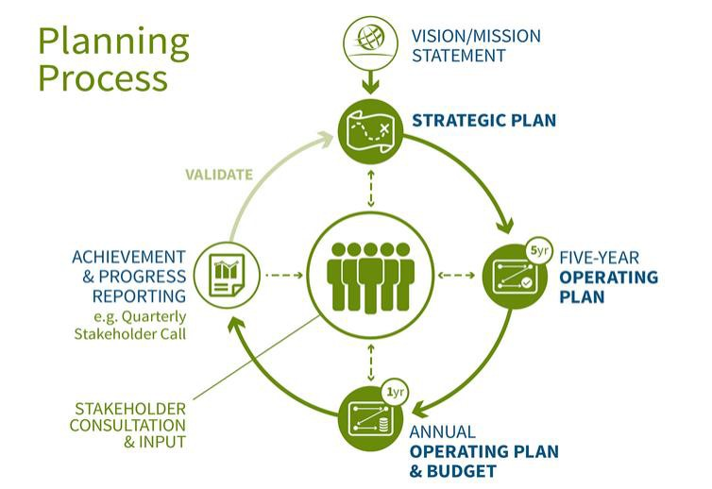

The structure of the budget data that follows in the rest of this document is displayed below.



# 3 - ICANN Operations

This section provides an overview of the ICANN Operations cash expenses.

## 3.1 - Resource Utilization





“Corporate” includes as staff attrition.

## 3.2 - Support and Revenue

This section provides an overview of ICANN’s revenue, starting with the assumptions that are underlying to the FY17 estimates. The best estimate corresponds to the FY17 revenue included in the FY 17 budget. The high and low estimates provide for a sensitivity analysis of some of the revenue items and are the result of variations of the best estimate.





The following table provides the revenues of ICANN by source and type, comparing for each the best estimate for the FY17 budgeted year and for the FY16 current year.



## 3.3 - Operating & Capital Expenses



The ICANN Operations Baseline operating and capital expenses budget (excluding multiyear projects and IANA Stewardship Transition costs) is $121.5M. This represents a $13.4M increase from $108.1M in FY16.

* Baseline increase resulting from FY16 multiyear projects: The portion of IT infrastructure strengthening, Salesforce.com development and Public Responsibility costs that have become ongoing baseline work in FY17.
* Reduction of new gTLD allocations: The allocation of ICANN Operations shared services to the new gTLD Program is decreasing due to fewer ICANN resources allocated to the program.
* Full year impact of FY16 Hirings: Increase in personnel costs due to 45 employees hired in FY16 working a full year in FY17 versus a partial year in FY16, plus personnel costs increases, less attrition.
* Impact of FY17 Hirings: average 18.5 Full Time Equivalents (FTEs)
* IANA/PTI costs increase: Incremental costs for the formation of a separate legal entity for Post-transition IANA
* Other: Limited growth in all other areas (for example, inflationary increases)



KMF: An ISO term. A protected enclosure for a room and cryptographic equipment and its contents where cryptographic elements reside. This is used to manage the Root DNS Key Signing Key

RZMS: The Root Zone Management System is use by the Root Zone Management Partners to maintain the Root DNS Zone

## 3.4 - Multiyear Projects (formerly Initiatives)

ICANN carries out projects relating to significant activities not in ICANN’s normal/core scope or, while core, projects that relate to activities exceptional in their frequency, level of spend, or impact. These projects may be completed upon achievement of the intended outcome, or lead to defining future ongoing activities, which will add to the scope of core operations.

In FY15 and FY16, ICANN funded from its Reserve Fund, the IANA Stewardship Transition initiative, as well as public responsibility and IT infrastructure projects.

The funding of the IANA Stewardship Transition project is the subject of requested input from the community as part of the public comment process on this draft FY17 Operating Plan and Budget. For FY17, all but the IANA Stewardship Transition project are suggested to be funded from ICANN’s annual revenues.

As the funding by annual revenue of multiyear projects, whose financial burden varies year on year, may continue to be a challenge, ICANN will work on developing funding guidelines for these projects. These will aim at allowing ICANN to carry out its activities in a stable, secure and sustainable manner. Also, ICANN has been working on expanding the governing documentation of its Reserve Fund. Community engagement will be organized on these topics as comprehensive solutions become available.



## 3.5 - Risks & Opportunities

This section outlines the risks and opportunities to the FY17 Budget and provides the potential impact of the risk or opportunity on the FY17 Budget assumptions as either lower or high revenue or cost.



# 4 - Overview of the IANA Stewardship Transition and implementation (including PTI)

## 4.1 - Overview of Transition and Implementation

Since NTIA’s announcement in March of 2014 of its intent to transition its stewardship of the IANA Functions to the global multistakeholder community, individuals, operational communities, ICANN Supporting Organizations (SOs) and Advisory Committees (ACs), businesses and trade associations, civil society groups, governments, and others from all regions of the world have engaged in a multistakeholder process to develop recommendations for transitioning the stewardship of the IANA Functions. These recommendations are contained in the IANA Stewardship Transition Coordination Group (ICG) proposal (the Proposal).

In implementing the recommendations of the Proposal, ICANN is guided by its mission to ensure the stable and secure operation of the Internet’s unique identifier systems and by its duty to ensure the stability of ICANN’s operations while respecting the IANA contract obligations.

There are three tracks of work. Planning for the new IANA stewardship arrangements is based on an expectation that the contract between NTIA and ICANN for the IANA Functions will expire on of 30 September 2016 of the. ICANN is developing plans to implement new IANA stewardship arrangements resulting from the Proposal by the ICG and new ICANN accountability mechanisms resulting from the Cross Community Working Group on Enhancing ICANN Accountability (CCWG-Accountability). The three tracks are:

Track 1: Root Zone Management (RZM) – contains the work related to changes to the Root Zone Management System (RZMS) to remove NTIA's Root Zone Administrator (RZA) role, and execution of an agreement between ICANN and Verisign for Verisign to serve as the Root Zone Maintainer (RZM).

Track 2: Stewardship Transition – contains work related to developing relationship documentations with the three operational communities, including Service Level Agreements, creation of a Post-Transition IANA (PTI) entity, establishment of a Customer Standing Committee (CSC) and a Root Zone Evolution Review Committee (RZERC), and operationalizing the IANA customer service escalation mechanisms and SLAs.

Track 3: Accountability Enhancements (Workstream 1) – contains work related to implementing enhancements to ICANN’s Independent Review and Reconsideration Request processes, updating ICANN’s governance documents, and operationalizing new community powers defined by the CCWG-Accountability.

Workstream 2: The CCWG-Accountability will, following transmission of the Workstream 1 proposal, focus work on issues identified that are not related to the IANA Stewardship Transition but are issues the community notes should be addressed as part of ICANN's broader continued accountability enhancement work.

For FY17, all the activities described above (tracks 1 to 3 and Workstream 2) will require support from ICANN staff, for calls organization, notes and follow up, meetings organization and support, constituent travel support, professional services and advice (including Legal advice). These activities will trigger expenses that require funding. This funding is currently not included in the ICANN Operations proposed budget described in the preceding pages. The activities and costs need to be defined, the corresponding expenses quantified, and their funding identified.

A placeholder for the above activities was offered for a range of $6m to $9m, awaiting for a more detailed and comprehensive costs estimate.

A project costs support team is currently being organized to define such activities and costs, and suggest funding solutions. The community input on possible funding approaches is welcome as part of the public comment submitted on this document.

## 4.2 – Focus on the Post-Transition IANA (PTI) implementation

In its proposal to the IANA Stewardship Transition Coordination Group (ICG), the CWG-Stewardship recommends that a new, separate legal entity, Post-Transition IANA, be formed as an affiliate of ICANN to perform the naming function post transition.

The following graph is an excerpt from the draft Implementation Plan currently under review, to depict the post-transition state:

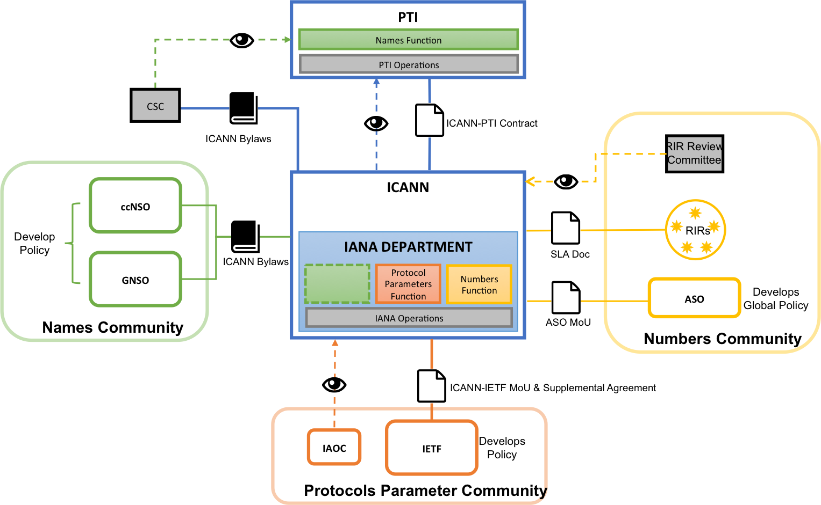

The structure of ICANN’s Operating Plan and Budget that results from the above future state, focusing on the PTI, is described below:

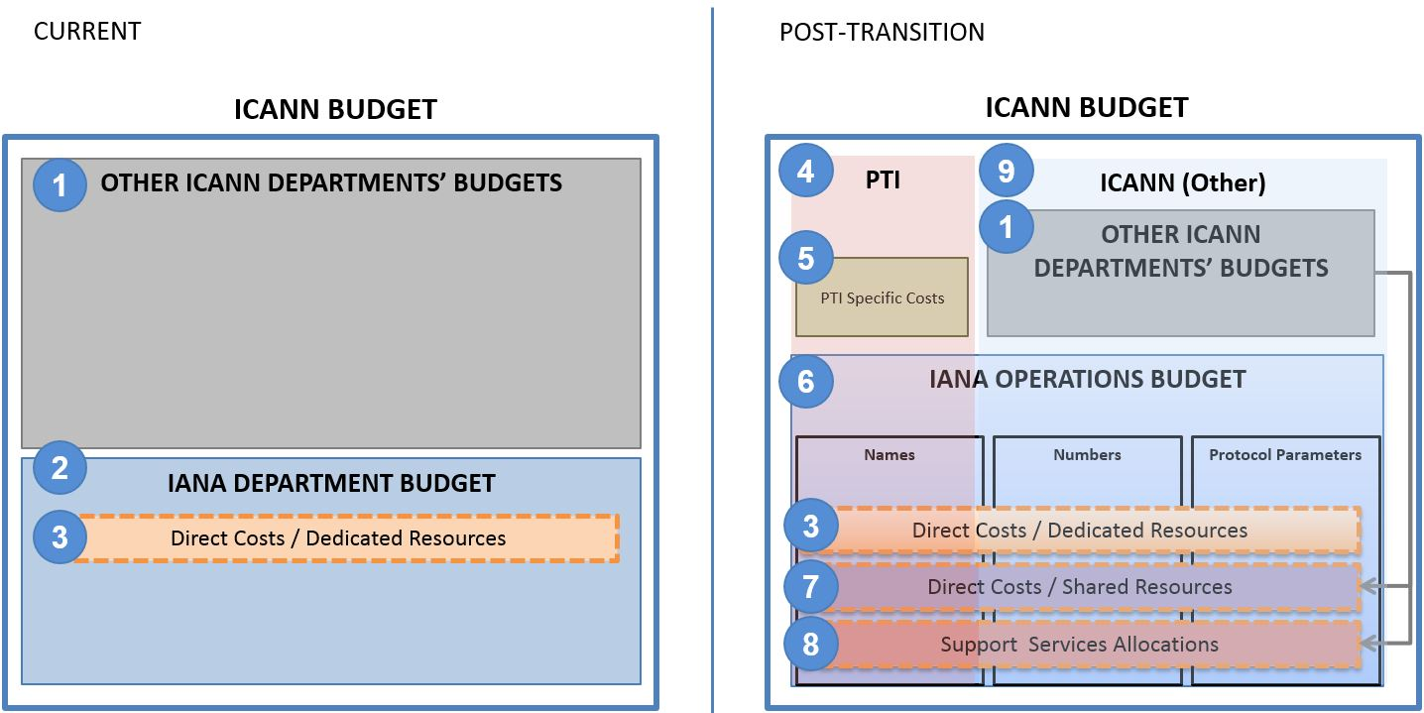



## 4.3 - Focus on the IANA Functions Operating Plan and Budget

The IANA Functions operating plan is defined by 13 activities, listed below, and further described in the Appendix.

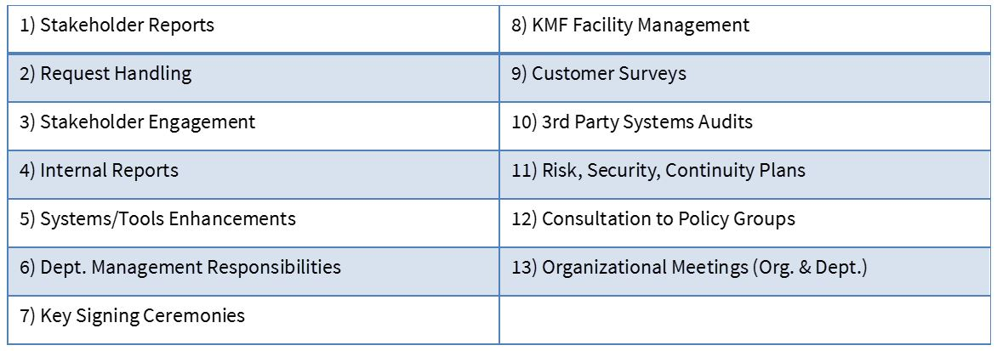

The budget of the IANA Functions is defined by three sources of costs:

* Direct Costs (from both dedicated and shared resources) resulting from the 13 activities required to perform the IANA Functions.
* Direct costs of shared resources
* Support Services Allocations represent the cost of support functions allocated to IANA.

The IANA Functions activities as defined above are then detailed or allocated by operational community, on the basis of estimated effort percentages, or through allocation keys. The portion of the IANA Functions related to Names as a result of this exercise, is included in the PTI entity, along with PTI specific costs.

Below is a summarized view of the total IANA Functions costs, and its breakdown by operational community, and by the three sources of costs:



The three sources of costs are further described below.

**Direct costs of dedicated resources**

These costs cover direct and dedicated personnel (16 employees) and associated costs assigned to delivering the IANA Functions: registration and maintenance of protocol parameter registries; allocation of Internet numbers and the maintenance of the Internet number registries; validation and processing of root zone change requests as well as maintenance of the root zone registry; management of the .int and .arpa domains; and holder of the root zone key signing key for the security of the DNS root zone.

**Direct costs of shared resources**

Within ICANN, departments other than the IANA department perform or participate to processes directly related to the delivery of the IANA Functions.

The costs of the activities carried out by other departments to perform the IANA Operations were evaluated by each department's budget owner. They identified the direct external costs (professional services and infrastructure) and estimated the time spent by personnel from the department on the identified activities valued at the annual cost of each employee (base+benefits).

The Appendix contains a full description of the activities carried out by those departments, which are summarized below:

* Request processing - IT
* Root Key Signing - IT, Registry technical Services, SSR, GSE
* IANA Website - IT, Legal, Web-admin
* Protection of data and systems - IT, Security, Legal
* Continuity and Contingency of service - IT
* Conflict of Interest assertions - IT, Legal
* Monthly reporting of performance - IT, Legal, Gov. Engagement
* Administrative support (shared with Compliance)
* Annual updates to Agreements - Legal

The direct costs of shared resources also include an estimate for the depreciation costs of capital assets of $0.5m.

**Allocated support functions costs**

The total costs of the allocated support functions after excluding the shared from those functions were divided by the total costs of operational functions to determine a percentage of support functions. This percentage was then applied to the total IANA Functions costs (both IANA department direct costs and shared resources direct costs as defined above), to determine a cost of support function allocated to delivering the IANA Functions.

List of functions included in the Allocated support functions are:

* Executive
* Communications
* Operations (HR, Finance, Procurement, ERM, HR development, Operations Executive, Administrative / Real Estate)
* IT (cyber-security, admin, infrastructure, PMO, Staff facing solutions)
* Governance support (Legal, Board support, NomCom)

# 5 - New gTLD Program

This section provides a financial summary of the New gTLD program.

## 5.1 - New gTLD Financial Summary



## 5.2 - New gTLD Program Multiyear View



## 5.3 - New gTLD Program – Variance Analysis





## 5.4 - New gTLD Program – Operating Expenses Variance Analysis



# 6 - Total ICANN Overview

## 6.1 - Resource Utilization (including multiyear projects)



## 6.2 - Headcount – Three Year Overview

## The headcount below represents staff employed on the last calendar day of each period.



# 7 - FY17 Operating Plan & Budget – Description

## 7.1 - Management System

The FY17 Operating Plan & Budget is informed by and aligns with the Five-Year Operating Plan’s Phasing and its Key Performance Indicators. This allows us to map all activities and resources back to the five main Strategic Objectives developed by a community driven bottom up process.

* Five Objectives – these were reviewed and revised during the development of ICANN Strategic Plan for fiscal years 2016-2020, which was adopted by the Board in October 2014.
* 16 Goals – owned by the CEO’s direct reports. Each goal has defined Key Success Factors to clarify what constitutes progress towards achieving a goal.
* 63 Portfolios – each goal contains a set of portfolios, which are groups of related projects. These also have defined success metrics.
* Over 340 Projects – Projects reflect ongoing work. Expenses are budgeted at the project level. A breakdown of all projects is linked from the Appendix. The budgeted amounts in this document are inclusive of capital expenditures and initiatives.

The draft budget amounts for each portfolio in the following sections are provided by cost category:

|  |  |
| --- | --- |
| **Meaning** | **Abbreviation** |
| Personnel | Pers |
| Travel and Meetings | T&M |
| Administration | Admin |
| Capital | Capital |
| Full Time Equivalent | FTE |

Values are shows in millions, USD. The FTE refers to the full time staff equivalent dedicated to each portfolio.

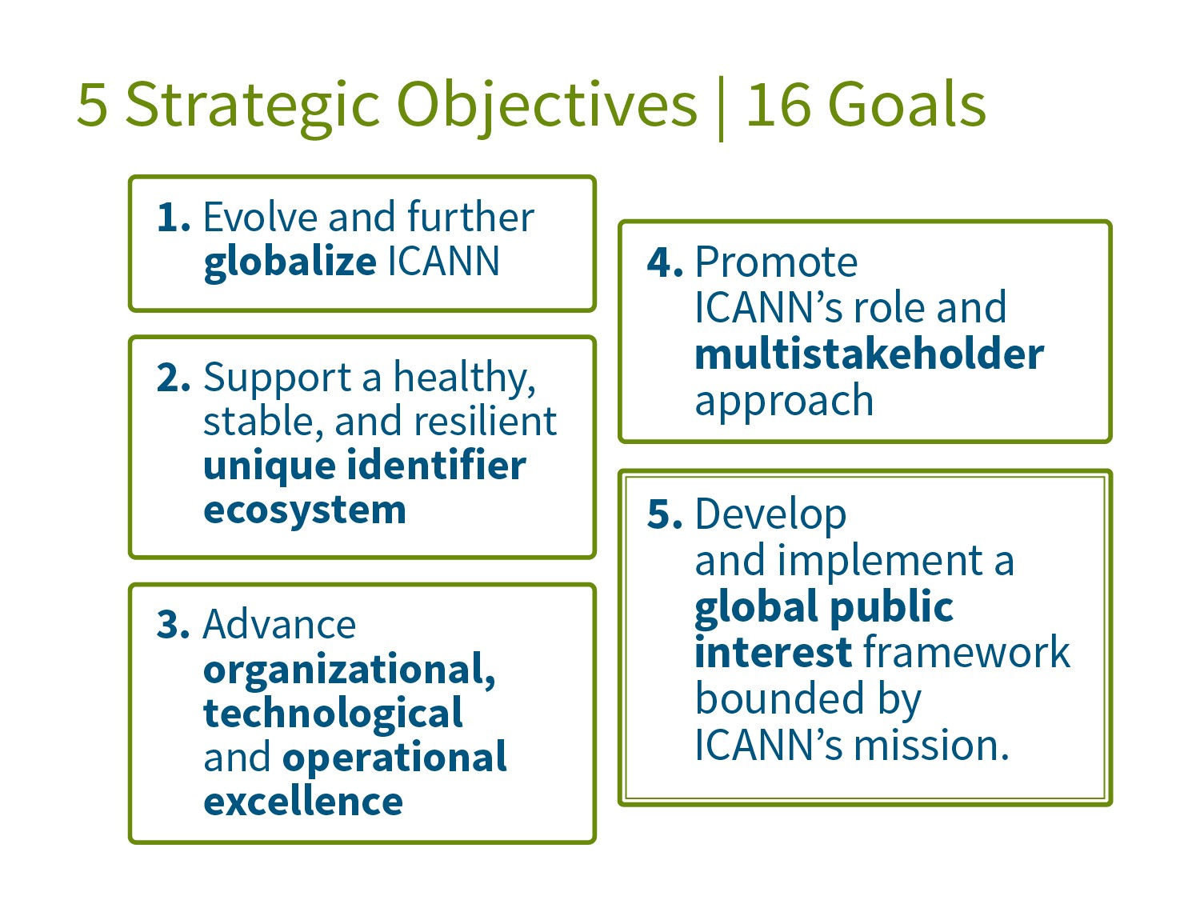

## 7.2 - Objective 1: Evolve and Further Globalize ICANN

## 7.3 - 1.1 Further globalize and regionalize ICANN functions

In FY17, we will focus on the following activities that work towards further globalizing and regionalizing ICANN functions:

1. Sustain implementation of regional communication strategies
2. Examine how hubs and engagement offices are supporting ICANN globalization
3. Language Services

We will measure our success in achieving this goal by:

* Meeting Services Scorecard, Engagement with community in major languages and scripts
* % of ICANN organizational functions globalized and available by region
* Stakeholder Engagement scorecard (previously an index) now belongs in Strategic Goal 1.2 beginning with FY17

#### Portfolios

* + 1. Raising Stakeholder Awareness of ICANN Worldwide.

Description: This portfolio pertains to how ICANN communicates with stakeholders around the world to help raise awareness of ICANN’s mission, its multistakeholder model and its work. This portfolio is grouped with 1.2.1 below. Metrics to measure ongoing communications activities include active social and traditional media monitoring and measurement, global newsletter open rates and reach of speaking engagements.

* + 1. Engagement Planning

Description: This portfolio covers ICANN’s Global Stakeholder Engagement (GSE) prioritization and planning, across regions and functional areas. This portfolio is grouped closely with 1.2.2. The planning portfolio covers the organization of GSE and regionalization of ICANN functions and communications.

* + 1. Language Services

Description: Facilitate access to ICANN and participation in its work for those who do not speak or are not fluent in English by making information accessible to those who speak other languages to enhance participation in, and the effectiveness of, the multistakeholder model.



## 7.4 - 1.2 Bring ICANN to the world by creating a balanced and proactive approach to regional engagement with stakeholders

In FY17, we will focus on the following activities that work towards bringing ICANN to the world by creating a balanced and proactive approach to regional engagement with stakeholders:

1. Examine # of community participants in ICANN programs to enable measurement of the Stakeholder Journey

We will measure our success in achieving this goal by:

* Global/regional engagement scorecard (this metric includes the regional Engagement Strategies and Fiscal Year work plans for each of the regions and each regional scorecard is balanced against the ICANN objectives)
* Digital services metrics (to be phased in during FY17)

#### Portfolios

* + 1. Engage Stakeholders Regionally

Description: This portfolio covers the mechanisms for delivering on ICANN’s regional and functional Engagement Strategies (including regional and functional area work plans, stakeholder engagement heat map).

* + 1. Broadcast and Engage with Global Stakeholders

Description: Conceptualize and build a set of integrated digital tools to inform and enable engagement and collaboration within the ICANN Community.



## 7.5 - 1.3 Evolve policy development and governance processes, structures and meetings to be more accountable, inclusive, efficient, effective and responsive

For FY17, we continue to consolidate progress made towards the following activities that work towards evolving policy development and governance processes, structures and meetings to be more accountable, inclusive, efficient, effective and responsive:

* The goal is to ensure that the policy development and decision-making processes are open, transparent, inclusive and legitimate. Ongoing efforts are directed at:
* Greater inclusion by diverse global stakeholders
* More online tools and mechanisms for participation and
* SO/AC structures evolving to increase Community efficiencies and effectiveness in ICANN processes and activities.

We will measure our success in achieving this goal by:

* # of participants in the policy development and governance processes by type, status and location
* Quality-of-service index (for example, “active” participants in policy development calls and meetings; # of publication subscribers/readers in "print" and on web; # of public comments submitted in ICANN Public Forums; Twitter Subscribers & Tweets; and so on)

#### Portfolios

* + 1. Support Policy Development, Policy Related and Advisory Activities

Description: Optimize efficiency and effectiveness of community policy development and advice efforts

1.3.2 Reinforce Stakeholder Effectiveness, Collaboration and Communication Capabilities

Description: To optimize collaboration and engagement of ICANN SOs and ACs, and increase and measure the number of exchanges (meetings and correspondence) that take place between various SOs and ACs (and the Board as appropriate) as they consult and discuss strategic and policy issues/matters

1.3.3 Evolving Multistakeholder Model

Description: Planning and implementation of ICANN’s online education platform to:

* Support increased, informed, global involvement in ICANN;
* Plan for evolving ICANN’s multistakeholder model
* Facilitate the development and publication of academic research on the multi-stakeholder model for DNS coordination, Internet policy development and governance.



## 7.6 - Objective 2: Support A Healthy, Stable, and Resilient Unique Identifier Ecosystem

## 7.7 - 2.1 Foster and coordinate a healthy, secure, stable, and resilient identifier ecosystem

In FY17, we intend to do the following to foster and coordinate a healthy, secure, stable, and resilient identifier ecosystem:

1. Deliver services to the ICANN Community according to service level targets.
2. Monitor and manage service delivery against targets, identify opportunities for improvement and efficiency.
3. Implement process improvements for increased operational efficiency and customer satisfaction.
4. Implement system enhancements for increased operational efficiency and effectiveness

We will measure our success in achieving this goal by:

* % of Service Level Targets met across multiple departments including but not limited to IANA, GDD Operations, and Global Customer Support departments

#### Portfolios

2.1.1 IANA Department Operations

Description: Operational responsibilities for maintaining registries for protocol parameters, IP numbers, Autonomous System Numbers, and root zone changes. Maintenance of relationship with Internet Engineering Task Force (IETF), Internet Architecture Board (IAB), five Regional Internet Registries (RIRs), and TLD operators.

2.1.2 IANA System Enhancements

Description: Software enhancements, tool development, and other discrete projects to improve delivery of the IANA services.

2.1.3 Advice Registry Management

Description: Development of processes and software used to track the acceptance, implementation, and resolution of advice provided to ICANN via Supporting Organizations, Advisory Committees, Review Teams, and others.

2.1.4 Global Domains Division (GDD) Operations

Description: Projects related to the service implementation and ongoing delivery of services to contracted parties by the GDD.

2.1.5 Global Customer Support

Description: Projects related to the development, implementation and ongoing operations of the ICANN Customer Service Center.

2.1.6 Product Management

Description: Projects and ongoing activities in support of the new gTLD Program

2.1.7 Implementation of IANA Functions Stewardship Transition & Enhancing ICANN Accountability

Description: Implementation of the community-developed proposals to transition the IANA Functions stewardship and enhance ICANN’s accountability.



## 7.8 - 2.2 Proactively plan for changes in the use of unique identifiers and develop technology roadmaps to help guide ICANN activities

In FY17, we will continue focusing on the activities that work towards proactively planning for changes in the use of unique identifiers and developing technology roadmaps to help guide ICANN activities:

1. Expanding the department to enhance logistical support for research and SSR-related projects.
2. Gain approval of Technology Roadmaps from the community.
3. Continue to expand and enhance relationships with protocol/technology development organizations.
4. Deploy automated systems to collect data and compute ratio of registered domain names to active IP addresses.
5. Deploy automated systems to collect data and compute ratio of registered domain names to Internet users regionally and globally.
6. Publish analyses of data collected, implications of changes in data over time, and other topics relevant to the use of unique identifiers and evolution of identifier technologies
7. Document growth in ratios in developing regions.

We will measure our success in achieving this goal by:

* Technical Reputation Index will measure ICANN's reputation for technical excellence in both the ICANN and broader Internet communities

#### Portfolios

2.2.1 WHOIS Core Function/Service & Improvements

Description: To promote trust and confidence in the Internet for all stakeholders, ICANN is committed to:

* Enforcing its current WHOIS policy
* Identifying improvements to the accuracy and reliability of the WHOIS system
* Determining whether there is a better system for providing information about gTLD domain names, consistent with applicable data protection and privacy laws.

2.2.2 Identifier Evolution

Description: Track and support the evolution of the Internet’s system of unique identifiers through venues such as the [IETF](https://www.ietf.org), [DNS-OARC](https://www.dns-oarc.net/), [W3C](https://www.w3.org/), the [RIRs](https://www.nro.net/about-the-nro/regional-internet-registries), and other relevant bodies.

2.2.3 Technical Experts Group

Description: Support and enhance the Technical Expert Group, facilitating its activities related to exploration of technical issues and opportunities facing ICANN.

2.2.4 Security, Stability, and Resiliency of Internet Identifiers

Description: Work to observe, assess and improve the security, stability, and resiliency (SSR) of the Internet’s Identifier systems in close collaboration with other ICANN departments and the community at large. This will be achieved through a range of activities including risk awareness and preparedness, measurement and analysis of identifier system behaviors or performance, and cooperative outreach that emphasizes coordination, capability building, and knowledge transfer.



## 7.9 - 2.3 Support the evolution of domain name marketplace to be robust, stable and trusted

In FY17, we will continue to support the development of a robust, stable and trusted domain marketplace by:

1. Ongoing monitoring of the Domain Name Marketplace Health Index
2. Improve multistakeholder satisfaction by reducing survey gap by at least 10% year over year
3. Show stable healthy year over year growth in the domain name industry
4. Finish the current round of the New gTLD Program and have agreement on the start of next round

We will measure our success in achieving this goal by:

* Domain Name Marketplace Health Index

#### Portfolios

2.3.1 WHOIS Coordination & Implementation

Description: To promote trust and confidence in the Internet for all stakeholders, ICANN is committed to:

* Enforcing its current WHOIS policy
* Identifying improvements to the accuracy and reliability of the WHOIS system
* Determining whether there is a better system for providing information about gTLD domain names, consistent with applicable data protection and privacy laws.

2.3.2 GDD Registrant Engagement & Support

Description: Support, engagement and advocacy for the global registrant community.

2.3.3 GDD Technical Services

Description: Projects to enhance systems, services and technical subject matter expertise related to a safe, secure, and reliable operation of the DNS

2.3.4 Internationalized Domain Names

Description: Support the introduction and universal acceptance and adoption of Internationalized Domain Names (IDNs).

2.3.5 New gTLD Program

Description: Projects and ongoing activities in support of the new gTLD Program.

2.3.6 Outreach and Relationship Management with Existing and new Registry, Registrar Community

Description: Create outreach and engagement strategies for registry and registrar operators to promote and cultivate a positive and constructive relationship among ICANN Staff, registries, registrars and other participants in the domain name industry value chain. Activities include having dedicated account managers, conducting workshops, webinars, and inter-sessional meetings, and attending ICANN meetings.

2.3.7 Domain Name Services

Description: Domain Name Services ongoing operations and Industry Engagement.

2.3.8 Next gTLD Round Planning

Description: Projects to design, plan and operationally prepare for the next application round of the new gTLD Program.

2.3.9 Universal Acceptance

Description: ICANN support to the Internet community to enable all protocol valid domains - including ccTLDs, gTLDs, and IDNs - to work in applications regardless of the age or script. This work is intended to support the goals of the user choice, user confidence, and competition

2.3.10 Registry Services

Description: Projects related to managing the contracts, defining new services, and building a strong relationship with current and future registrar operators.

2.3.11 Registrar Services

Description: Projects related to managing the contracts, defining new services, and building a strong relationship with current and future registry operators. 

## 7.10 - Objective 3: Advance Organizational, Technological and Operational Excellence

## 7.11 - 3.1 Ensure ICANN’s long-term financial accountability, stability and sustainability

In FY17, we will focus on the following activities that work towards ICANN’s long-term financial accountability, stability and sustainability:

1. Achieve financial roadmap annual targets (as designed in FY16)
2. Review operational processes and implement improvements.
3. Modify roadmap as needed and approved by Board, staff and stakeholders.

We will measure our success in achieving this goal by:

* Financial accountability, stability & sustainability indices (composite index of ratios and metrics) including but not limited to:
  + Actual to budget Reserve Fund balance & utilization, and financial performance metrics
  + Internal control performance indicators
  + % project completion indices (with emphasis on major projects)
  + % comparisons of actual to target succession plan readiness
  + % comparisons of actual to target enterprise risk management roadmap achievements
* On-time delivery index of the ICANN Planning process (includes: ICANN Five-Year Strategic Plan for FY16-FY20, Five-Year Operating Plan, Fiscal-Year Operating Plan & Budget, achievements and progress reporting)

#### Portfolios

3.1.1 Strategic and Operating Planning

Description: Review of the Five-Year Strategic & Operating Plan Implementation, and the development of FY18 Operating Plan & Budget.

3.1.2 Organizational Excellence and Intelligence

Description: Assessment, evaluation, reporting, and guidance to advance organizational, technological and operational excellence.

* + 1. Finance and Procurement

Description: All finance and procurement activities for the entire organization, in all locations. Includes the following functions: accounting (including accounts payable and billing), reporting and analysis, planning, tax, audit, procurement (PO processing, approval), sourcing.

* + 1. Enterprise Risk Management

Description: Continue the focus on planning, assessing risk, evaluating mitigation, monitoring and progress reporting to minimize the effects of risks to the organization.

* + 1. Support Operations

Description: Various programs and projects that support functional operations.



## 7.12 - 3.2 Ensure structured coordination of ICANN’s technical resources

In FY17, we will focus on the following activities that work towards ensuring structured coordination of ICANN’s technical resources:

1. Measure and record a baseline for IT Services uptime by tier.
2. Measure and compare metric for the IANA Functions against baseline for YoY improvement.
3. Report on metric for on-time, on-budget IT projects delivery.

We will measure our success in achieving this goal by:

* % of global IT infrastructure uptime (scaling from 99.9% in FY 2016 to 99.999 % in 2020 for top tier services)

#### Portfolios

* + 1. Cybersecurity Hardening and Control

Description: All on-going infrastructure projects and services to maintain adequate performance of the systems supporting all ICANN operations.

* + 1. IT Infrastructure and Service Scaling

Description: Work towards a top-tier global IT infrastructure performing at 99.999% uptime and have ICANN recognized by the global community as having technical excellence and thought leadership.

* + 1. Root Systems Operations

Description: Facilitating the continued evolution of the root server system to ensure its ongoing security, stability, and resiliency as DNS technology and operations change over time: maintenance of relationships with the Root Server Operators, RSSAC, and related stakeholders.



## 7.13 - 3.3 Develop a globally diverse culture of knowledge and expertise available to ICANN’s Board, staff, and stakeholders

In FY17, we will focus on one core activity to work towards developing a globally diverse culture of knowledge and expertise available to ICANN’s Board, staff and stakeholders.

We will measure our success in achieving this goal by:

* % of achievement in comparison to best practice benchmark metrics of global diverse culture, and knowledge levels of Board, staff and stakeholders
* % of completion - actual to target implementation milestones of global development programs to advance the knowledge and expertise of successors, key staff, all staff, Board and stakeholders

#### Portfolios

3.3.1 Talent Management

Description: Establishing and developing the right mix of skills to accomplish critical business needs at both leadership and staff level. This includes focus on areas such as talent acquisition, leadership development, team effectiveness, learning and skill development and organizational change management.

3.3.2 ICANN Technical University

Description: Providing a mechanism to improve the technical understanding of the technology ICANN coordinates.



## 7.14 - Objective 4: Promote ICANN’s Role and Multistakeholder Approach

## 7.15 - 4.1 Encourage engagement with the existing Internet governance ecosystem at national, regional and international levels

In FY17, we will focus on the following activities that work towards encouraging engagement with the existing Internet Governance (IG) Ecosystem at national, regional and international levels:

1. Increase % participation rates documented as baseline established in FY16.
2. Well-functioning and global acceptance by stakeholders of the post NTIA IANA Stewardship Transition, as reflected in feedback from stakeholders.

We will measure our success in achieving this goal by:

* This is a compound index measuring the # of touch points between ICANN and national governments, regional governmental entities, and Intergovernmental organizations, and International Organizations
* Measurement of quarterly engagement comparing to previous fiscal year quarterly engagement to show trend data

#### Portfolios

4.1.1 Coordination of ICANN Participation in Internet Governance (IG)

Description: This portfolio includes those projects that coordinate ICANN’s support for and participation in the Internet Governance Ecosystem as well as collaboration with other entities in the ecosystem on projects and initiatives of shared interest.



## 7.16 - 4.2 Clarify the role of governments in ICANN and work with them to strengthen their commitment to supporting the global Internet ecosystem

In FY17, we will focus on the following activities that work towards clarifying the role of governments in ICANN and work with them to strengthen their commitment to supporting the global Internet ecosystem:

1. Increase the # of governmental entities actively participating in ICANN.
2. Increase the # of trust agreements or frameworks for cooperation

We will measure our success in achieving this goal by:

* Increase # of GAC members (level of actual active participation and level of representation at ICANN meetings)

#### Portfolios

4.2.1 Support GAC Engagement

Description: This portfolio includes those projects supporting the activities of the Government Advisory Committee and those that facilitate outreach to increase participation in the work of the GAC.

* + 1. Engagement with Governments and IGOs

Description: This portfolio includes those projects supporting and coordinating outreach and engagement with governments and IGOs nationally, regionally and internationally to increase governments knowledge of and participation in the global Internet Governance ecosystem.



## 7.17 - 4.3 Participate in the evolution of a global, trusted, inclusive multistakeholder Internet Governance ecosystem that addresses Internet issues

In FY17, we will focus on the following activities that work towards participating in the evolution of a global, trusted, inclusive multistakeholder Internet Governance Ecosystem that addresses Internet issues:

1. Increase in # of cooperation agreements with respective Internet organizations over baseline established in FY16.
2. Identification of potential best practices among national and regional multistakeholder IG approaches to be highlighted in outreach work for further adoption of multistakeholder model IG governance mechanisms

We will measure our success in achieving this goal by:

* Participation in the evolution of the IG ecosystem

#### Portfolios

* + 1. Support Internet Governance (IG) Ecosystem Advancement

Description: The portfolio encompasses the collaborative work within the Internet governance ecosystem to support evolution of multistakeholder distributed approaches.



## 7.18 - 4.4 Promote role clarity and establish mechanisms to increase trust within the ecosystem rooted in the public interest

In FY17, we will focus on the following activities that work towards promoting role clarity and establish mechanisms to increase trust within the ecosystem rooted in the public interest:

1. Assess current practices and documentation.
2. Identify and propose best practices.
3. Propose measurements and benchmarks.

We will measure our success in achieving this goal by:

* Develop a framework that generates institutional confidence in ICANN and builds trust over time
  + Assemble and refine Accountability-related KPIs as a means of measuring ICANN's accountability
  + Implement means of measuring long-range progress

#### Portfolios

4.4.1 Contractual Compliance Functions

Description: Day-to-day activities to ensure compliance by registrars and registries with their contractual obligations to ICANN and to report back to the community.

4.4.2 Contractual Compliance Initiatives & Improvements

Description: This portfolio comprises a series of projects focused on the continuous improvement of contractual compliance operations and systems. This includes addressing contractual compliance interpretation issues and working with the ICANN stakeholders to define relevant metrics to improve transparency and reporting of contractual compliance.

4.4.3 Contractual Compliance and Safeguards

Description: Projects relating to: (1) outreach to ICANN constituents regarding contractual compliance; (2) development of an analytic and nuanced approach to complex contractual compliance issues; and (3) cooperation and coordination on consumer safeguards that are beyond the scope of pure contract compliance.

4.4.4 Strategic Initiatives

Description: Consider and formulate Institutional Confidence Index (long-range) while assembling and refining Accountability-related KPIs, in line with the Accountability Framework proposed by One World Trust (short-range). This will include establishing benchmarks and targets as well as piloting the usefulness and relevance of KPIs.



## 7.19 – Objective 5: Develop and Implement a Global Public Interest Framework Bounded by ICANN’s Mission

## 7.20 - 5.1 Act as a steward of the public interest

In FY17, we will focus on the following activities that work towards acting as a steward of the public interest:

* To ascertain ICANN is acting within its global public interest mandate, ICANN will seek to measure and baseline the % of action by ICANN in decision making and how rationales are including the public interest assessments as part of decision making.

We will measure our success in achieving this goal by:

* # of ICANN decisions and advice (Board, staff and stakeholders) that are rationalized based on common consensus-based definition(s) and understandings of public interest within ICANN's remit

#### Portfolios

5.1.1 Legal Advisory Function

Description: Provide legal advice to all functions at ICANN.

5.1.2 Public Interest Decision Making

Description: Collaborative work with Community, Board, and Staff to work towards developing a consensus-based framework on understanding public interest within ICANN's remit, how to reflect public interest considerations in decision making across ICANN, and provide operational impact across all groups.

5.1.3 Legal Internal Support

Description: Provide legal support to all functions at ICANN.

5.1.4 Support ICANN Board

Description: Provide staff support to the ICANN Board of Directors.



## 7.21 - 5.2 Promote ethics, transparency and accountability across the ICANN community

In FY17, we will focus on the following activities that work towards promoting ethics, transparency and accountability across the ICANN Community:

1. Measure against the baseline metrics developed in FY16 and show increase in acceptance and impact of Accountability and Ethical Framework.
2. Continue to review for improvements and enhancements: measure and baseline the % of actions by ICANN in decision making and how rationales are including the public interest assessments as part of decision making.

We will measure our success in achieving this goal by:

* Public interest framework index (for example, ICANN’s Documentary Information Disclosure Policy and correspondence posted on time, compliance with the conflict of interest policy and compliance with the Board Code of Conduct)
* Develop a framework for increasing trust in ICANN’s fulfilment of its commitments through efficient and effective Reviews:
* Broad and diverse participation in ICANN Reviews
* Community engagement in using ICANN Reviews to drive continuous improvement in accountability, transparency and organizational effectiveness (such as community participation in public comments pertaining to Reviews and other forms of engagement)
* Transmission of all Board approved proposals from the ICG and CCWG-Accountability to NTIA
* Completion of all community proposals that meet NTIA criteria for the IANA transfer for Chartering Organization approval

#### Portfolios

5.2.1 Affirmation of Commitments (AoC) Reviews

Description: Conduct mandated, regularly scheduled reviews of ICANN commitments and ICANN entities to support effectiveness and ongoing improvement in ICANN’s accountability and governance structures. Support effective community engagement and Board assessment and development of plans to maximize improvements to each entity and benefits to ICANN as a whole. Integrate outcomes into strategic planning efforts.

5.2.2 Organizational Reviews

Description: Conduct regularly scheduled reviews of ICANN entities to support their effectiveness and ongoing improvement; Support Board assessment and development of plans to maximize improvements to each entity and benefits to ICANN as a whole.

5.2.3 Conflicts of Interest and Organizational Ethics

Description: Support compliance with ICANN's conflict of interest and organizational ethics policy and framework.

5.2.4 IANA Functions Stewardship Transition & Enhancing ICANN Accountability

Description: (1) ICANN achieves its objectives in securing the IANA Stewardship Transition by supporting the three operational communities (names, numbers and protocol parameters) and achieving broad community support for a proposal that satisfies the four principles in NTIA transition proposal; and (2) the CCWG-Accountability is able to produce recommendations that provide assurance that ICANN is accountable in the absence of its historical contractual relationship with the U.S. Government.

5.2.5 Accountability and Transparency Mechanisms

Description: Supporting compliance with ICANN’s Accountability and Transparency Mechanisms framework.



## 7.22 - 5.3 Empower current and new stakeholders to fully participate in ICANN activities

In FY17, we will continue to build upon the work of FY16 that empowers current and new stakeholders to fully participate in and advance ICANN activities in the broader ecosystem. This work is achieved through specific and measurable development and public responsibility tools, programs, and collaborations along focus areas that strengthen the multistakeholder model.

We will measure our success in achieving this goal by:

* Level of stakeholder participation for development and public responsibility programs, tools, and collaborations

#### Portfolios

5.3.1 Development and Public Responsibility Tools

Description: FY17 Development and Public Responsibility Tools overseen by DPRD team to broaden and support the multistakeholder model along focus areas.

5.3.2 Development and Public Responsibility Programs

Description: FY17 Development and Public Responsibility Programs overseen by DPRD team to broaden and support the multistakeholder model along focus areas.

5.3.3 Development and Public Responsibility Collaborations

Description: FY17 Development and Public Responsibility Collaborations overseen by DPRD team to broaden and support the multistakeholder model along focus areas.

5.3.4 Development and Public Responsibility New Program Development

Description: FY17 new program development for Development and Public Responsibility efforts overseen by DPRD team to address identified gaps in broadening and supporting the multistakeholder model along focus areas.



# Appendix

## A - FY17 Budget by Project

The documents listed below are linked from the page for this public comment period on ICANN.ORG. They include the detail of the costs by category for each project, and the full-time equivalent number of allocated staff. They are provided in both PDF and Excel formats. The Excel includes both sets of information, the PDFs break it out into separate files. A summary of the top fifteen FY17 projects with details on planned work and costs will be posted by 31 March 2016.

* FY17 Budget by Project (Draft) [filename]
* FY17 Budget by Portfolio (Draft) [filename]

## B - FY17 IANA Operations by activity

The IANA department performs 13 major activities related to the operations for the Names, Numbers and Protocol Parameters client groups. The IANA personnel and resources are shared across the activities by operational communities with several positions supporting multiple communities. This approach to sharing resources is very efficient.

The FY17 budgeted headcount for the IANA department is 16 positions. The FY17 budget for IANA/PTI costs by operational communities was developed by analyzing the time spent by each position on each of the 13 activities. All other departmental expenses and shared resources were also mapped to these 13 activities. These 13 activities were then mapped to the three operational communities.

|  |  |
| --- | --- |
| **IANA Activity** | **Description & Methodology** |
| Stakeholder Reports | Names Community Stakeholder Reports:  Create the following reports:   * Monthly DNSSEC report – this is a report to NTIA and is marked confidential * Monthly Root Zone Processing Time report – this is a report to NTIA and is published on ICANN’s IANA website * Monthly Root Zone Audit report – this is a report to NTIA and is published on ICANN’s IANA website * Monthly Performance Standards Metric report – this is a report to NTIA and is published on ICANN’s IANA website. It includes metrics for the names and numbers functions * Periodic reports on delegation and transfers of Top Level Domains published on ICANN’s IANA website * C.4.2 Monthly Performance Progress Report – this is a report to NTIA and is marked confidential. The report includes metrics for the names and numbers functions   Numbers Community Stakeholder Reports:  Create monthly Performance Standards Metric report – this is a report to NTIA and is published on ICANN’s IANA website. The report includes metrics for the names and numbers functions.  Protocol Parameters Customer Reports: Create the following reports:   * Monthly IETF SLA report * Status of IETF Internet Draft Daily report – automated report posted on IANA website * Monthly reports to the IAB about IANA activities * Monthly Expiration of Early Allocations Report to the IESG |
| Request Handling | Names Community Request Handling:   * Handle requests from the Name Community * Write reports for the Board and NTIA related to TLD change of control (for example, delegations) * Establish new processes and procedures for introducing new services such as [EBERO](https://www.icann.org/resources/pages/ebero-2013-04-02-en) * Handle root zone and names issues and address technical or policy clarifications needed in order to handle a request * Manage escalations for unresolved issues * Compliance with applicable laws (for example, [Office of Foreign Assets Control](https://www.treasury.gov/about/organizational-structure/offices/Pages/Office-of-Foreign-Assets-Control.aspx))   Numbers Community Request Handling:   * Handle requests from the Numbers Community * Manage escalations for unresolved issues * Compliance with applicable laws (for example, Office of Foreign Assets Control)   Protocol Parameters Request Handling:   * Handle requests from the Protocol Parameters Community including new registrations, modifications to existing registrations and the removal of existing registrations * Introduce new processes and procedures for handling requests * Define new processes and procedures for creating new protocol parameter registries as per the [IANA Considerations](https://www.rfc-editor.org/info/rfc5226) of an [RFC](https://www.rfc-editor.org/history/) * Manage escalations for unresolved issues * Compliance with applicable laws (for example, Office of Foreign Assets Control) |
| Stakeholder Engagement | Names Community Stakeholder Engagement:   * Preparation, planning and attendance for three ICANN and three regional TLD meetings, and one Registrar & Registry meeting * Includes drafting, renewing and finalizing annual SLA * Drafting and reviewing documents for Public Comments   Numbers Community Stakeholder Engagement:   * Preparation, planning and attendance for 10 RIR meetings and 12 ASO (Address Supporting Organization) teleconferences * Includes drafting, renewing and finalizing annual SLAs, and reviewing policy documents adopted by the RIRs   Protocol Parameters Community Stakeholder Engagement:   * Attendance for three IETF meetings and periodic teleconferences with [IPROC](https://www.ietf.org/iana/iproc.html) * Includes drafting, renewing and finalizing annual Service Level Agreements * Participation in twice-monthly [IESG](https://www.ietf.org/iesg/) teleconferences and monthly IAB business meetings. Formal review of [Internet-Drafts](https://www.ietf.org/id-info/) during IETF Last Call, IESG Evaluation, Document Approval and Final publication * Contract with expert for technical review of Internet-Drafts |
| Internal Reports | Names, Numbers and Protocol Parameters Community Internal Reports:   * Conduct annual EFQM assessments to identify strengths and implement improvements to processes, services, people, leadership and customer results across all three functions * Development of KPI dashboards * Quarterly reports for the Board * Quarterly reports for Global Stakeholder Engagement * Reports for ICANN GDD Operations * Reports for internal staff meetings * Reports for the ICANN annual report * Materials for ICANN meetings |
| Systems/Tools Enhancements | Names, Numbers and Protocol Parameters Community Systems/Tools Enhancements:  Perform the following across all three functions:   * Develop dedicated systems/tools enhancements to improve performance of services provided by the IANA department * Develop tools required to implement new community mandated processes * Consult about enhancements for registry workflow * Architect and implement website improvements, and administer ICANN’s IANA website including oversight of contractors and developers * Provide general management oversight for website tools and enhancements * Architect and implement system improvements for the registry workflow * Provide requirements and propose improvements to the registry workflow, as well as engage in User Acceptance testing * Provide general management oversight for system enhancements   Includes software licenses and materials for ICANN’s IANA website development, outsourced development to implement projects (for example, [RDAP](https://tools.ietf.org/html/rfc7482)) and transition related web development.  Names Community Systems/Tools Enhancements:  Outsourced development for tools to monitor uptime of systems and software to report on SLEs defined by CWG.  Protocol Parameters Community Systems/Tools Enhancements:  Provide website improvement criteria and requests specifically for protocol parameters. Includes outsourced development for XML format registries, development of reporting tools, and enhancements to XML format registries. |
| Dept. Management Responsibilities | Names, Numbers and Protocol Parameters Community Department Management Responsibilities:   * Membership and participation in ICANN’s Technology and Operations Senior Management Teams, representing all three functions * Represent IANA Functions Operator at I-Star meetings. I-Star is a loosely coordinated group including ICANN, the IETF, W3C, regional ccTLD groups, the RIRs, and the Internet Society. * Management responsibilities related to post-transition bodies (for example, CSC)   The VP of IANA Functions owns and manages budgets for the 15 staff supporting all three functions:   * Five senior staff with management responsibilities * Two Cryptographic Key Managers * Five IANA Specialists * One Audit Associate * One Project Manager/Technical Writer * One Sr. Administrative Assistant |
| Key Signing Ceremonies | Names Community Key Signing Ceremonies:  Four [Key Signing Key Ceremonies](https://www.iana.org/dnssec) (both East and West Coast) each year, including ceremony preparation and post-ceremony processing of the logs, video, and ceremony notes, then posting of material on ICANN’s IANA website. Includes:   * Consultation with ceremony participants in reviewing and revising ceremony scripts * Reviewing and revising DNSSEC policy documentation with the Policy Management Authority * Collaboration with Verisign, the Root Zone Maintainer, which manages Zone Signing Keys * Manage relationships with Trusted Community Representatives   Numbers and Protocol Parameters functions do not apply |
| KMF Facility Management | Names KMF facilities:   * Manage the Key Management Facilities (KMF) and the Key Signing Ceremonies * Manage and oversee plans to maintain and upgrade the KMF facilities, including related travel * Capital expense includes furniture, computer equipment, audit camera replacement, signing software development and service contracts for alarm system and the facilities   Numbers and Protocol Parameters functions do not apply. |
| Customer Surveys | Names, Numbers and Protocol Parameters Communities Customer Satisfaction Surveys:   * Involves selecting, contracting, and overseeing the third-party vendor that administers and analyzes the annual survey, as well as writing the final report which is posted on ICANN.ORG and IANA.ORG * The procurement office issues the RFP and reviews the responses for compliance to the criteria in the RFP and negotiates the best price for the contract * There is only one RFP for the customer satisfaction survey since all the functions are surveyed by a single contractor and at the same time |
| Third-party Systems Audits | Names Community third-party System Audits:   * Two staff members lead the selection, contracting and oversight of the third-party vendor. Staff reviews the status of internal controls, and meets with control owners on a quarterly basis to ensure no changes have occurred to in-scope processes and systems. Staff also leads the internal review of the final report and assertion letter. * The procurement office reviews the contract and negotiates the best price/terms with the vendor. The IT department as well as the HR, Security and Facilities departments are instrumental in providing evidence related to systems that are in-scope of the audits. * Legal reviews the final audit reports and ICANN’s assertion and representation letters prior to signing by the President of GDD and submission to NTIA. * Two ICANN Cryptographic Key Managers are instrumental in providing evidence related to systems that are in-scope of the audits. * IANA department personnel are interviewed and tender evidence to the auditor in response to inquiries, perform visits to remote facilities to collect audit-related material, and perform audit-related reviews   Numbers Community third-party System Audits:  Although the current controls for the [SOC2](https://www.iana.org/about/audits) audit were not specifically designed to address the Numbers processes, the evidence provided to the vendor demonstrates that ICANN remains compliant with the Process Operations controls. The controls involve reviewing the monthly reports that are published on ICANN’s IANA website, as well as the list of documented processes for all of the IANA Functions.  Protocol Parameters Community third-party System Audits:  In addition to the above explanation under “Names Community third-party Systems Audit,” a third staff member is involved in establishing the controls for the audit of the protocol parameter systems. Two of the seven Process Operations controls are specifically related to the protocol parameters function. |
| Risk, Security, Continuity Plans | Names, Numbers and Protocol Parameters Community Risk/Security/Continuity Plans:  Review and revise the department’s Continuity and Security Plans each year |
| Consultation to Policy Groups | Names Community Consultation to Policy Groups:  Consulting with the policy department regarding ccNSO, gTLD, IDN and ISO-3166 updates, policy recommendations, implementations and reports  Numbers Community Customer Consultation to Policy Groups:  Consulting with the RIR CEOs regarding allocations of IP and AS numbers, and reviewing ASO teleconference minutes and confirming there are no new [Global Policies](https://www.icann.org/resources/pages/global-addressing-2012-02-25-en) to be implemented.  Protocol Parameters Consultation to Policy Groups:  Consulting with the IETF/IAB leadership regarding IANA Considerations and the resulting implementation implications of those RFCs, as well as the relationship between ICANN and the Protocol Parameters Community. Also consulting internally regarding implications of the IANA Considerations detailed in RFCs that impact how IANA services are delivered. |
| Organizational Meetings (Corporate & Departmental) | Names Organizational Meetings:  Includes immigration activities and services as needed for volunteer [Trusted Community Representatives](https://www.iana.org/dnssec/tcrs) and staff, as well as administration (support and facilities) costs for DNSSEC meetings including security, rent, Internet access, phone and registration costs  Names, Numbers and Protocol Parameters Organizational Meetings:  Training provided to Audit Associate and IANA Specialists across all three functions, as well as administration costs for team lunches, transportation, postage, home Internet connectivity, tuition reimbursement, training courses and recognition awards for staff members. Provide IANA cross-training across ICANN organization. |

Below is breakdown of the direct costs of each of the above activities by category of expenses and by operational community.







## C - Registrar Fees

The Registrar fees are to be approved by the Board before submission to voting by the Registrars.

Approximately 2,124 registrars are currently accredited by ICANN. This relationship is governed by the Registrar Accreditation Agreement (RAA), of which the most recent version was approved in June 2013. The two versions of the agreement currently in use were approved in 2009 and 2013. The RAA is a five-year agreement that provides for the following types of fees:

* Application fees
* Annual accreditation fees
* Variable accreditation fees
* Per registrar variable fees
* Transaction based fees

In addition, since 2009, the budget has assumed an Add Grace Period (AGP) excess deletion fee to eliminate domain tasting. The amount for AGP deletion fees was assumed to be zero in past budgets and is also assumed to be zero for the FY17 budget.

Application fees are paid one time by prospective registrars at the time of application. For FY17, the application fees are estimated to be $140,000 based upon a volume of 40 applications and a per application fee of $3,500 per application.

Annual accreditation fees are fees that all registrars are required to pay annually to maintain accreditation. The fee is $4,000 per year. Registrars have the option of paying the annual $4,000 accreditation fee in quarterly installments of $1,000. For FY17, the annual accreditation fees are estimated at $6.3 million, based on an average of 2,000 registrars renewing and being newly accredited.

Variable accreditation fees are determined based on the transaction type and volume of each registrar. There are two types of fees associated with the variable accreditation fees:

* Per registrar variable fee
* Transaction based fee

Per registrar variable fees are based on a validated concept that ICANN often expends the same quantum of effort in providing services to a registrar regardless of size. However, provided that the registrar is considerably smaller in size and in activity, some registrars will continue to be eligible for “forgiveness” of two-thirds of the standard per-registrar variable fee. To be eligible for forgiveness, the registrar must have: (1) less than 350,000 gTLD names under its management; and (2) no more than 200 attempted adds per successful net add in any TLD. Forgiveness will be granted each quarter to all registrars that qualify.

The amount per registrar is calculated each quarter by dividing $950 thousand (one-fourth of $3.8 million) equally among all registrars that have at least been accredited for one full quarter or have made at least one transaction, taking into consideration the forgiveness factor.

In addition, a discount of 10 percent is granted to all registrars operating under the 2009 and 2013 RAA.

Transaction based fees are assessed on each annual increment of an add, renew or a transfer transaction that has survived a related add or auto-renew grace period. This fee will be billed at $0.18 per transaction for registrars operating under the 2009 or 2013 RAA (resulting from a $0.20 base fee, discounted by 10% to $0.18).

Add-grace period excess deletion fees are assessed on each domain name deleted, in excess of the threshold, during an add-grace period. The threshold is the larger of 50 or 10% of total adds, per month, per TLD. The rate per excess deletion is $0.20.

Below is a summary of the estimated Registrar fees for FY17 by fee type.



## D - Summary of Changes

This section will be completed following the Public Comment period. It will include a table showing changes in the final version based on input received.

|  |  |  |  |
| --- | --- | --- | --- |
| Section/Topic | Submitter | Public Comments/Rationale for Change | Actions |
|  |  |  |  |

One World, One Internet

**ICANN.ORG**

**ICANN.ORG**