ICANN Five-Year Operating Plan

FY2016-FY2020 (First Annual Update)

Draft for Public Comment - March 2016

# Introduction

ICANN developed a multi-year planning framework based on extensive input from the ICANN Community during the development of the Strategic Plan. The framework includes the following three elements:

1. Five-Year Strategic Plan FY16-FY20 (1) – To be updated every five years. It includes a vision and mission, strategic objectives, goals, Key Success Factors, and strategic risks. ICANN’s Board adopted the current Strategic Plan on 16 October 2014.
2. Five-Year Operating Plan FY16-FY20 – To be updated each year. It includes:
   * a five-year planning calendar
   * strategic goals with corresponding Key Performance Indicators
   * dependencies
   * five-year phasing
   * a list of portfolios, and
   * a five-year financial model
3. Annual Operating Plan & Budget – Developed from the ICANN Five-Year Operating Plan and annual community input. It includes portfolios of activities that support the achievement of the goals and objectives with corresponding Key Performance Indicators, dependencies, budgets, and projects.

This is the first annual update to the Five-Year Operating Plan, which was adopted by the Board on 28 April 2015.

ICANN acknowledges that stakeholder bandwidth and support remains a key dependency to meeting the goals outlined in ICANN’s portfolio of work.

Note (1): ICANN’s financial/fiscal year runs from 1 July to 30 June of the following year. It is described as “FY” followed by the last 2 digits of the calendar year during which the fiscal year closes.

# Table of contents

Introduction 2

Table of contents 3

Reference & Notes 4

Planning – Community Roles and Responsibilities 5

Operating Plan – Strategic Goal Level 12

Five-Year Financial Model 50

# Reference & Notes

### The ICANN Community encompasses ICANN’s stakeholders—including its Supporting Organizations, Advisory Committees, and Nominating Committee—the Board of Directors, and staff. So, ICANN’s multistakeholder model defines its community.

### ICANN [Portfolio Management System](https://features.icann.org/plan). Below is a high-level composite of ICANN's work structure.

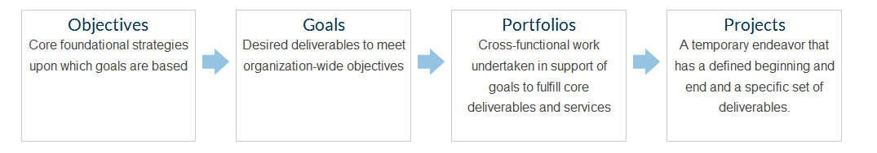

### Definition of terms can be found in the [ICANN online glossary](https://www.icann.org/resources/pages/glossary-2014-02-03-en).

### Key Performance Indicators (KPIs) may vary over time as they are refined. Typically KPIs start with one of the following:

### $ = Value of

### # = Number of

### % = Percentage of

### Portfolios throughout the Five-Year Operating Plan may contain projects that contribute to other Portfolio(s) within the same Goal or another Goals.

### Relative resource prioritization is a key dependency that applies to all goals.

### Goal-level risks are described in the Five-Year [Strategic Plan](https://www.icann.org/resources/pages/strategic-engagement-2013-10-10-en). ICANN staff systematically reviews and manages risks on an ongoing basis.

# Planning – Community Roles and Responsibilities

The planning process is part of the bottom-up multistakeholder process and requires the collaborative effort of the whole ICANN Community. This includes its Supporting Organizations, Advisory Committees, and Nominating Committee as well as its Board and staff.

This calendar depicts the involvement of the ICANN Community and the timeline of the planning process.

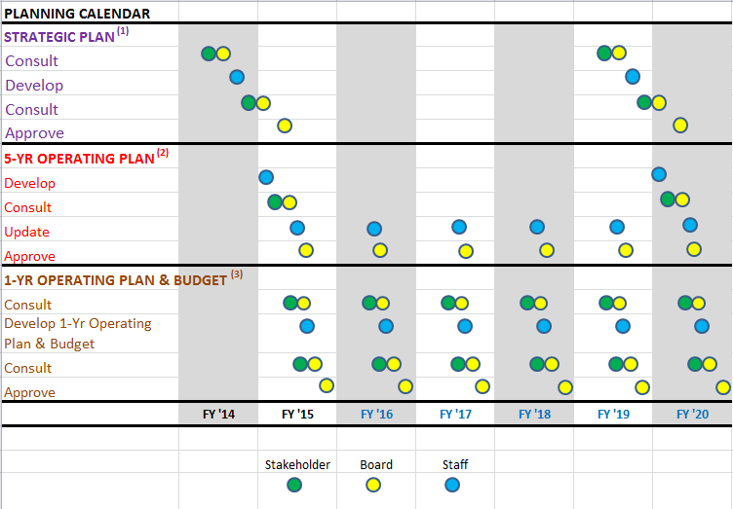

[1] The next Strategic Planning effort for FY21 – FY25 will start in FY19.

[2] The Five-Year Operating Plan is updated each year to reflect actual performance and recent events. Changes are made for the remaining years in the planning cycle. The current Five-Year Operating Plan calendar is available on page 11.

[3] The Five-Year Strategic Plan for FY16–FY20 is linked to the Five-Year Operating Plan, which informs the Fiscal-Year Operating Plan & Budget.

The charts below describe how everyone would (or could) be involved in the planning process and include frequency of activities, supporting elements and roles and responsibilities.

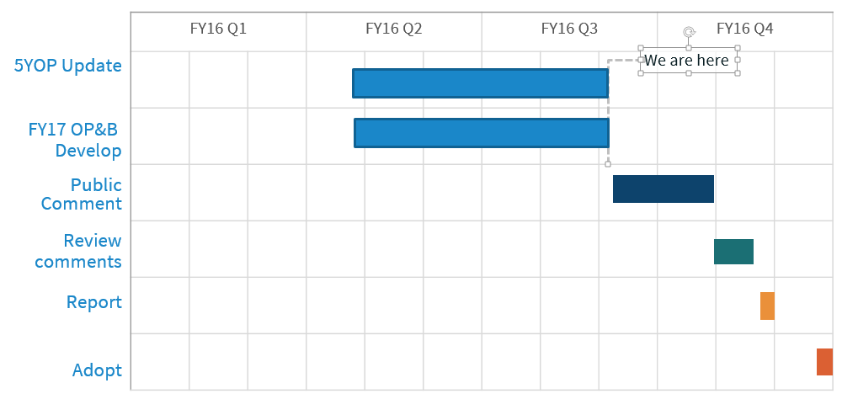

#### Strategic Plan Process

|  |  |  |  |  |  |
| --- | --- | --- | --- | --- | --- |
|  | | | **Community Roles and Responsibilities** | | |
| **Strategic Plan [1]** | **Frequency** | **Supporting Elements [2]** | **Staff** | **Board** | **Stakeholders** |
| 1. Consult | Every 5 years [3] | Strategic Plan Kick-off   * Accomplishments from last planning cycle * Environmental analysis, including SWOT [4] |  | Consult on key challenges and opportunities and areas of strategic importance | Consult on key challenges and opportunities and areas of strategic importance |
| 1. Develop | Every 5 years | Draft Strategic Plan:   * Accomplishments from last planning cycle * Environmental analysis * Vision, Mission * Areas of strategic importance | Develop |  |  |
| 1. Consult | Every 5 years | Public comment and other engagements |  | Consult | Consult |
| 1. Approve | Every 5 years | Final Strategic Plan   * same as above, plus: * Strategic Goals * Key Success Factors * (outcomes) * Strategic Risks | Update based on consultations and long-term planning work | Approve |  |

[1] Five-Year Strategic Plan for FY16–FY20 is linked to the Five-Year Operating Plan, which informs the Fiscal-Year Operating Plan & Budget. The next Strategic Planning effort for FY21 – FY25 will start in FY19.

[2] All documents are posted and publically available.

[3] The next planning cycle will start in FY19 to allow sufficient time for key planning steps.

[4] Environmental analysis is an important aspect of strategic planning. It includes assessment of strengths and weaknesses (internally focused) and opportunities and threats (externally focused).

#### Five-Year Operating Plan Process

|  |  |  |  |  |  |
| --- | --- | --- | --- | --- | --- |
|  | | | **Community Roles and Responsibilities** | | |
| **Five-Year Operating Plan [5]** | **Frequency** | **Supporting Elements [2]** | **Staff** | **Board** | **Stakeholders** |
| 1. Develop | Every 5  years | * Planning Calendar * Five-Year Financial Model * Draft Summary of Five-Year Operating Plan * Strategic goals with corresponding Key Performance Indicators, dependencies, five-year phasing, and list of portfolios | Develop |  |  |
| 2. Consult | Every 5  years | Public comment and other engagements |  | Consult | Consult |
| 1. Update | Each year | Annual Reporting   * Performance as compared to   plan for prior Fiscal Year, starting with FY16   * Explanation of variances * Required changes to Five-Year   Operating Plan[6] if warranted | Update based on consultations |  |  |
| 1. Approve | Each year | Final Summary Five-Year Operating Plan |  | Approve |  |

[5] The Five-Year Strategic Plan for FY16–FY20 is linked to the Five-Year Operating Plan, which informs the Fiscal Year Operating Plan and Budget. The Five-Year Operating Plan is updated each year to reflect actual performance and recent events. Changes are made for the remaining years in the planning cycle.

[6] The Five-Year Operating Plan will be updated, when appropriate, for the rest of the cycle. No changes to the Five-Year Strategic Plan for FY16 – FY20 are anticipated. They would be made if a critically significant event or development is observed.

#### Fiscal-Year Operating Plan & Budget Process

|  |  |  |  |  |  |
| --- | --- | --- | --- | --- | --- |
|  | | | **Community Roles and Responsibilities** | | |
| **Fiscal-Year Operating Plan & Budget [7]** | **Frequency** | **Supporting Elements [2]** | **Staff** | **Board** | **Stakeholders** |
| 1. Consult | Each year | * Draft Revenue Model * Draft list of Initiatives and Engagements |  | Consult | Consult |
| 1. Develop | Each year | * Draft Fiscal-Year Operating Plan * Draft Fiscal-Year Budget | Develop/update based on Five-Year Operating Plan, consultations and recent history of events |  |  |
| 1. Consult | Each year | Public comment and other  engagements |  | Consult | Consult |
| 1. Approve | Each year | Final Fiscal-Year Operating Plan  & Budget | Update based on consultations | Approve |  |

[7] Strategic Plan for FY16–FY20 is linked to the Five-Year Operating Plan, which informs the Fiscal-Year Operating Plan & Budget.

#### ICANN Five-Year Operating Plan Current Calendar

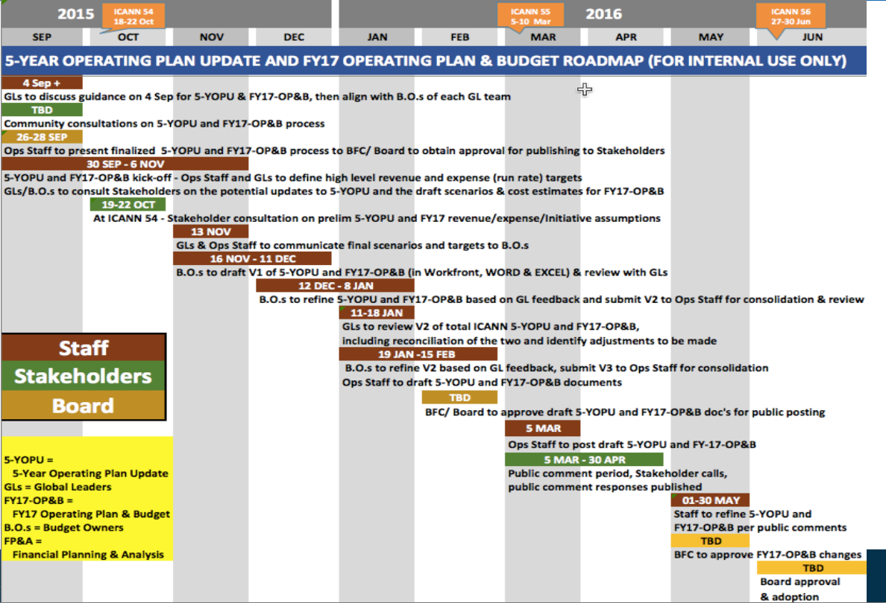

# Operating Plan – Strategic Goal Level

## Summary of Changes

This is the first update to ICANN’s Five-Year Operating Plan & Financial Model. ICANN updates this document each year to take account of what has been achieved and review and refine the planned future work based on what has already been delivered and the changing environment.

The table below provides a high-level overview of changes from the initial Five-Year Operating Plan & Budget. This table describes changes to portfolios, KPIs, dependencies, and year-by-year phasing of work.

In each goal section, a status update box has been added to note the work completed and planned to be accomplished during FY16..

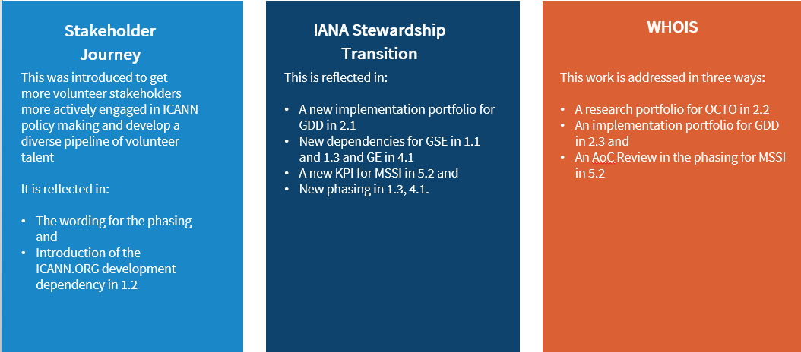

|  |  |  |
| --- | --- | --- |
| **Goal Number** | **Change Type** | **Change Summary** |
| All | Dependency removed - resource prioritization | Moved to Reference & Notes and made implicit for all ICANN work |
| 1.1 | KPI reworded | Based on work to refine and improve the quality of the measurement |
| 1.1 | Dependency updated | IANA Stewardship Transition added as an activity that could change focus |
| 1.2 | KPI reworded | Based on work to refine and improve the quality of the measurement |
| 1.2 | New dependency | ICANN.ORG development added as a dependency |
| 1.2 | Phasing – new phrasing | Introduction of “Stakeholder Journey” in FY17-FY20 activities based on FY16 work with the community |
| 1.3 | Portfolio moved from here | Structural Organizational Reviews portfolio moved to 5.2 as there are strong similarities with the AoC Reviews work |
| 1.3 | New dependency | Impact of the IANA Stewardship Transition on the Multistakeholder Model |
| 1.3 | Phasing – new items | FY17 work now includes work related to the IANA Stewardship Transition and subsequent years include work related to implementing the outcomes of Organizational Reviews |
| 1.3 | Phasing – items deleted | Reviews work removed as it is transferred to 5.2 |
| 1.3 | Phasing – new activity | IANA Stewardship Transition implementation added as an FY17 activity |
| 2.1 | Portfolio closed | Root Zone Update System Enhancement portfolio removed as the work is now complete |
| 2.1 | Portfolio moved from here | Root Server System Evolution & Security, Stability, and Resiliency of Internet Identifiers moved to 2.2 |
| 2.1 | New portfolios | Portfolios for GDD Operations and Product Management moved from 2.3 and new portfolios for Global Customer Support and IANA Functions Stewardship Transition Implementation |
| 2.1 | Phasing - changes | Reports on work originally planned for 4.4 and moved during FY16 |
| 2.1 | Phasing - changes | FY17 work restructured to take account of portfolio changes |
| 2.2 | Portfolios moved to here | Root Server System Evolution & Security, Stability, and Resiliency of Internet Identifiers moved from 2.1 |
| 2.2 | Portfolio removed | Root Server System Evolution portfolio removed from FY17 |
| 2.2 | KPI reworded | KPI text refined to focus on ICANN’s contribution to the health of identifiers |
| 2.2 | Dependency removed | Budget related dependency is now moved to Reference & Notes, bullet #6 |
| 2.2 | Phasing - changes | FY17-20 updated to refer to multiple roadmaps instead of just one |
| 2.3 | Portfolio removed | Public Safety Registrations portfolio removed as the work is now being performed in the community |
| 2.3 | Portfolios moved | Contractual Compliance portfolios moved to 4.4 so there is separation from GDD |
| 2.3 | Portfolio renamed | Registrant Interest Representation portfolio renamed as GDD Registrant Engagement & Support |
| 2.3 | New portfolios | New portfolios for WHOIS Coordination & Implementation, Domain Name Services, Next gTLD Round Planning, Universal Acceptance, Registry Services, and Registrar Services |
| 2.3 | KPIs restructured | Technical Reputation Index renamed Domain Name Marketplace Health Index and Service Level Targets KPI now solely in 2.1 |
| 2.3 | Phasing - changes | FY17-FY20 work restructured to take account of portfolio changes |
| 2.3 | Phasing - changes | FY17 work related to WHOIS and RDAP added |
| 3.1 | Portfolio renamed | Business Excellence and Business Intelligence renamed to Organizational Excellence and Intelligence |
| 3.1 | Dependency removed | Budget related dependency is now moved to Reference & Notes, bullet #6 |
| 3.1 | Phasing | FY17 work updated to include implementation of improvements |
| 3.1 | Phasing | FY19-20 updated to refer to the next strategic planning cycle |
| 3.2 | Portfolios restructured | New Cybersecurity portfolio. Infrastructure and Maintenance portfolios merged. Root Systems Operations portfolio removed. |
| 3.2 | Dependency removed | Budget related dependency is now moved to Reference & Notes, bullet #6 |
| 3.2 | Phasing – changes | IANA functions measurements work updated to reflect anticipated Post-Transition IANA |
| 3.3 | Portfolio removed | Business Excellence portfolio removed as this work is now entirely within 3.1 |
| 3.3 | Dependency removed | Budget related dependency is now moved to Reference & Notes, bullet #6 |
| 3.3 | Phasing - changes | Business Excellence related portfolio removed as it now sits in 3.1 |
| 4.1 | Portfolio removed | Build Stronger Partnerships with Internet Organizations and Initiatives portfolio removed as project work was moved to other portfolios |
| 4.1 | KPI changes | Updated KPI on touch points. KPI on agreements restructured to look at trend data. |
| 4.1 | Dependencies removed | Dependencies related to past events removed |
| 4.1 | Phasing changes | FY17 work descriptions updated to focus on activities rather than measurements |
| 4.2 | Dependencies removed | Dependencies related to past events removed |
| 4.2 | Phasing changes | FY17-FY20 work reworded to refer to “trust agreements” and focus on activities rather than measurements |
| 4.3 | KPI reworded | KPI now refers to participation in the ecosystem |
| 4.3 | Dependencies removed | Dependencies related to past events and agreement language, which has been completed, removed |
| 4.3 | Dependency reworded | Change in the word order for the MoU language dependency |
| 4.3 | Phasing changes | FY17 work restructured, wording changes and FY18 “best practices” work removed |
| 4.4 | Portfolios restructured | Work previously in 2.3 now in 4.4 with portfolios renamed and restructured |
| 4.4 | Dependency reworded | External dependency explicitly acknowledges “ability to reach consensus, changing laws and regulations” |
| 4.4 | Phasing changes | Two FY16 work items were moved to 5.2 mid-year, #2 went to 5.2 and #3 went to 2.1 |
| 4.4 | Phasing changes | FY17 now refers to “accuracy rates” in measurement to quantify trust, benchmarking and reporting work, implicitly absorbing the long range progress work. |
| 5.1 | KPI reworded | Small changes to KPI wording |
| 5.1 | Dependency updated | Small change to wording: “public interest” expanded to “public interest understandings” |
| 5.2 | Portfolios restructured | Organizational Reviews portfolio moved from 1.3 and all AoC Reviews merged to a single portfolio |
| 5.2 | New portfolio | Portfolio for Evolution of Organizational Governance Mechanisms in support of the Multistakeholder Model |
| 5.2 | New KPI | New KPI on fulfilling commitments through Reviews |
| 5.2 | New KPI | New KPI on IANA Stewardship Transition |
| 5.2 | Phasing - changes | Reports on work originally planned for 4.4 and moved mid-year |
| 5.2 | Phasing - changes | FY17-FY20 work restructured to take account of portfolio changes |
| 5.3 | Portfolios restructured | Portfolios restructured based on work areas instead of outcomes |
| 5.3 | KPI reworded | KPI wording improved |
| 5.3 | Dependency removed | Budget related dependency is now moved to Reference & Notes, bullet #6 |
| 5.3 | Phasing changes | Minor changes to wording for FY17 work |

## Strategic Objective 1 – Evolve and further globalize ICANN

### Strategic Goal 1.1 Further Globalize and regionalize ICANN functions

#### Portfolios

1. Raising Stakeholder Awareness of ICANN Worldwide
2. Engagement Planning
3. Language Services

#### Key Performance Indicators (metrics)

* Meeting Services Scorecard, engagement with community in major languages and scripts
* % of ICANN organizational functions globalized and available by region
* Stakeholder Engagement scorecard (previously an index) now belongs in Strategic Goal 1.2 beginning with FY17

#### Dependencies

1. Communications needs may increase or Global Stakeholder Engagement (GSE) focus may shift depending on status of the IANA Stewardship Transition. It also might shift if there is another round of new gTLDs during the Five-Year Operating Plan.

#### Phasing

|  |  |  |
| --- | --- | --- |
| FY16 | **Planned**   1. Integrate global and regional communications strategies. 2. Comprehensive regional engagement plans and strategies covering most ICANN regions. 3. Further distribute ICANN functions at Hub Offices. | **Intended Status at the end of FY16**   1. Regional newsletters streamlined and uniform across regions. We are also capturing foreign language social media statistics across the regions in one place. 2. Communications strategies for the regions now in place 3. Community-driven Engagement Strategies in place for five regions and all regions/functional areas have yearly work plans. We have started tracking with regional scorecards. 4. Several departments have added staff and distributed resources to hub and engagement offices (for example – Global Customer Service Center in Istanbul hub) |
| FY17 | 1. Sustain implementation of communications strategies 2. Wide awareness raising and educational effort if supporting ICANN with another new gTLD round 3. Examine how hubs and engagement offices are supporting ICANN globalization | |
| FY18 | 1. Reevaluate communications strategies and review social media approach and tools 2. Conduct mapping of community to regional engagement; implement recommendations resulting from examination of ICANN Hub Office and engagement site support of ICANN globalization | |
| FY19 | 1. Implement integrated global and regional communications strategies in support of ICANN strategies 2. Implement improvements for GSE based on community mapping in FY18 | |
| FY20 | 1. Conduct holistic evaluation of ongoing integrated global and regional communications strategies 2. Survey community on GSE engagement and support of community engagement at high level 3. Implement improvements on review of GSE web, customer relationship management tools from 2019 | |

## Strategic Objective 1 – Evolve and further globalize ICANN

### Strategic Goal 1.2 Bring ICANN to the world by creating a balanced and proactive approach to regional engagement with stakeholders

#### Portfolios

1. Engage Stakeholders Regionally
2. Broadcast and Engage with Global Stakeholders

#### Key Performance Indicators (metrics)

* Global/regional engagement scorecard (this metric includes the regional Engagement Strategies and Fiscal Year work plans for each of the regions and each regional scorecard is balanced against the ICANN objectives)
* Digital services metrics (to be phased in during FY17)

#### Dependencies

1. Retaining expertise to support ICANN's efforts across the hubs and regions in multiple languages for a diverse range of stakeholders
2. Digital services metrics depend on the ongoing development of ICANN.ORG

#### Phasing

|  |  |  |
| --- | --- | --- |
| FY16 | **Planned**   1. Implement Global Stakeholder Engagement (GSE) web tools for supporting Stakeholder Engagement activities at regional and local level. 2. Examine effectiveness of regional strategies launched in FY13-FY14. | **Intended Status at the end of FY16**   1. Internal collaboration tool adopted and used by all GSE regional/functional teams to support Stakeholder Engagement. 2. Several community-driven regional Engagement Strategies were updated (Africa, LAC and Middle East) |
| FY17 | 1. Examine # of community participants in ICANN programs to enable measurement of the Stakeholder Journey 2. Complete first cycle regional Engagement Strategies and regional plan | |
| FY18 | 1. Conduct mapping of Stakeholder Journey to regional engagement 2. Enhance online ICANN meeting hubs to contribute to and increase engagement during meetings 3. Review effectiveness of ICANN web tools for supporting globalization and regionalization for community | |
| FY19 | 1. Implement improvements for GSE based on Stakeholder Journey mapping in FY18 2. Increase participation of active participants across technical community, civil society, governments and business stakeholders | |
| FY20 | 1. ICANN participants cover all regions 2. Achieve participation from all sectors of community and support improvement of Stakeholder Journey in contributions to ICANN. 3. Survey community on engagement with, and support of, community at high level 4. Implement improvements on review of GSE web, customer relationship management tools from FY19 | |

## Strategic Objective 1 – Evolve and further globalize ICANN

### Strategic Goal 1.3 Evolve policy development and governance processes, structures and meetings to be more accountable, inclusive, efficient, effective and responsive

#### Portfolios

1. Support Policy Development, Policy Related and Advisory Activities
2. Reinforce Stakeholder Effectiveness, Collaboration and Communication Capabilities
3. Evolving Multistakeholder Model

#### Key Performance Indicators (metrics)

* # of participants in the policy development and governance processes by type, status and location
* Quality-of-service index (for example, “active” participants in policy development calls and meetings; # of publication subscribers/readers in "print" and on web; # of public comments submitted in ICANN Public Forums; Twitter Subscribers & Tweets; and so on)

#### Dependencies

1. Making available IT/Online Community Services a part of ensuring that our global stakeholders can access improved tools
2. Dedicated communications strategies and services are required to ensure successful outcomes
3. The legal team may be needed to advise in the policy and decision making process.
4. Final plans to transition stewardship of the IANA functions and the outcomes of work to enhance ICANN’s accountability may impact the Multistakeholder Model

#### Phasing

|  |  |  |
| --- | --- | --- |
| FY16 | **Planned**   1. Complete a comprehensive inventory of all resources and capabilities that ICANN provides to the current stakeholder communities. 2. Complete a comprehensive assessment of delivery of all resources and capabilities that are provided to the stakeholders. 3. Analyze, evaluate and plan for how to balance resource abilities and capabilities among stakeholders. 4. Evolve Generic Names Supporting Organization (GNSO) Secretariat Pilot program into permanent support status. 5. Assess implementation of Accountability and Transparency Review Team 2 (ATRT2) Recommendation 7, in preparation for ATRT3 | **Intended Status at the end of FY16**   1. 2, and 3, In FY16, the staff is updating an initial inventory of resources and capabilities available to the community. This inventory helps both the community and staff to assess the delivery of those capabilities and to analyze and evaluate how those resources are balanced. A Community Engagement and Policy staff team is working to comprehensively align policy development activities of support and engagement matters. 2. The staff continues to collaborate with community leaders in the non-contracted house of the GNSO to offer tailored secretariat support services to those groups. More experience is needed to confirm the value of a permanent resource, but assessments so far confirm the value of this support to community groups. 3. Implementation of the ATRT2 Recommendation 7 started in January 2105. In December 2015, staff published a report assessing the value of the implementation effort. It concluded that the process and operational enhancements to the public comment forum infrastructure provided substantial value and should be continued. The report is on the [Community Wiki](https://community.icann.org/display/atrt/Rec+%237). |
| FY17 | 1. Complete assessment of language services capabilities for proficiency, accuracy consistency and reliability 2. Review ICANN’s Language Services Policy 3. Conduct final Supporting Organization and Advisory Committee special request process 4. Assess effectiveness and value of telecoms vendors 5. Assess implementation of relevant accountability provisions resulting from final plans to transition stewardship of the IANA functions | |
| FY18 | 1. Complete a comprehensive assessment of delivery of all resources and capabilities that are provided to the stakeholders (every two years) 2. Analyze, evaluate and plan for how to balance resource abilities and capabilities among stakeholders (every two years) 3. Assess progress towards five-year goal – toward wide use of improved tools and mechanisms for global participation and representation, including the use of remote participation to engage stakeholders from emerging regions 4. Implement improvements resulting from ICANN Reviews as part of continuous accountability enhancement work | |
| FY19 | 1. Implement improvements resulting from ICANN Reviews as part of continuous accountability enhancement work. | |
| FY20 | 1. Stakeholders and staff use improved tools and mechanisms for global participation and representation to collaborate. This includes the use of remote participation to engage stakeholders from emerging regions 2. Implement improvements resulting from ICANN Reviews as part of continuous accountability enhancement work | |

## Strategic Objective 2 – Support a healthy, stable and resilient unique identifier ecosystem

### Strategic Goal 2.1 Foster and coordinate a healthy, secure, stable, and resilient identifier ecosystem

#### Portfolios

1. IANA Department Operations
2. IANA System Enhancements
3. Advice Registry Management
4. Global Domains Division (GDD) Operations
5. Global Customer Support
6. Product Management
7. Implementation of IANA Functions Stewardship Transition & Enhancing ICANN Accountability

#### Key Performance Indicators (metrics)

* % of Service Level Targets met across multiple departments including but not limited to IANA, GDD Operations, and Global Customer Support departments.

#### Dependencies

1. IT department support

#### Phasing

|  |  |  |
| --- | --- | --- |
| FY16 | **Planned**   1. Develop and achieve community approval of all domain name system (DNS)/Unique identifiers health metrics. 2. Develop and achieve community approval of the stability and resiliency exercises specified. 3. Develop and achieve community approval of the ICANN legitimacy survey designed. 4. Collaborate with community to reduce gap of IPv6 and DNSSEC deployment by 5% year over year (Year over Year). 5. Develop and achieve community approval of the Identifier registration data access/update system requirements specified | **Intended Status at the end of FY16**   1. Adopted Key Performance Indicators for IANA functions (names, numbers, and protocol parameters) after public consultation in 2013 and post [monthly reports on measurements](https://www.iana.org/performance) for each of the KPIs. Development is underway to collect measurements defined by [CWG](https://community.icann.org/display/gnsocwgdtstwrdshp/CWG+to+Develop+an+IANA+Stewardship+Transition+Proposal+on+Naming+Related+Functions) for Service Level Expectations in processing root zone and root zone data changes. 2. Moved to Goal 2.2 3. Moved to Goal 2.3 4. Moved to Goal 2.2 5. Moved to goal 2.2   In FY16, we deployed a Global Customer Support team to provide 24x5 coverage for inquiries from contracted parties, registrants and the community at large. Both the Global Support and GDD Operations teams delivered service according to published service level targets. Service delivery against those targets was published on a monthly basis. |
| FY17 | 1. Deliver services to the ICANN Community according to service level targets 2. Monitor and manage service delivery against targets, identify opportunities for improvement and efficiency 3. Implement process improvements for increased operational efficiency and customer satisfaction 4. Implement system enhancements for increased operational efficiency and effectiveness | |
| FY18 | 1. All DNS/Unique identifiers health metrics v1 results reviewed and improvements to metrics and functions are recommended 2. Stability and resiliency exercises repeated, gap analysis performed, and necessary improvements made 3. ICANN legitimacy survey repeated, gap analysis performed, and necessary improvements made 4. Collaborate with community to reduce gap of IPv6 and DNSSEC deployment by 5% year over year 5. Identifier registration data access/update system requirements revised and approved by the community | |
| FY19 | 1. All DNS/Unique identifiers health metrics v2 implemented and baselines posted 2. Stability and resiliency exercises repeated, gap analysis performed, and necessary improvements made 3. ICANN legitimacy survey repeated, gap analysis performed, and necessary improvements made 4. 4 Collaborate with community to reduce gap of IPv6 and DNSSEC deployment by 5% year over year 5. 5. Revised identifier registration data access/update system implemented and beta tested by the community | |
| FY20 | 1. All DNS/Unique identifiers health functions recommendations implemented and v2 metrics are reviewed for progress 2. Stability and resiliency exercises repeated, gap analysis performed, and necessary improvements made 3. ICANN legitimacy survey repeated, gap analysis performed, and necessary improvements made 4. Collaborate with community to reduce gap of IPv6 and DNSSEC deployment by 5% year over year. 5. Revised identifier registration data access/update system put into production | |

## Strategic Objective 2 – Support a healthy, stable and resilient unique identifier ecosystem

### Strategic Goal 2.2 Proactively plan for changes in the use of unique identifiers, and develop technology roadmaps to help guide ICANN activities

#### Portfolios

1. WHOIS Core Function/Service & Improvements
2. Identifier Evolution
3. Technical Experts Group
4. Security, Stability, and Resiliency of Internet Identifiers

#### Key Performance Indicators (metrics)

* Identifier Technologies Health Index will measure ICANN's contribution to health of identifiers in both the ICANN and broader Internet communities

#### Phasing

|  |  |  |
| --- | --- | --- |
| FY16 | **Planned**   1. Department fully staffed. 2. Draft technology roadmap developed. 3. Relationships with protocol/technology development organizations enhanced. 4. Ratio of registered domain names to active IP addresses base lined. 5. Ratio of registered domain names to Internet users regionally and globally base lined | **Intended Status at the end of FY16**   1. Office of the Chief Technology Officer department researchers and administrative staff hired, although more staff needed. 2. Roadmap for evolution for Root Zone Management System has been drafted based on requirements from the [CWG](https://community.icann.org/display/gnsocwgdtstwrdshp/CWG+to+Develop+an+IANA+Stewardship+Transition+Proposal+on+Naming+Related+Functions). Implementation of the roadmap has begun with milestones set for delivery of [SLE](https://community.icann.org/display/gnsocwgdtstwrdshp/DT-A+Service+Levels+Expectations) measurements and removal of the NTIA authorization module. Project to draft technology roadmap initiated. 3. Relationship with [IETF](https://www.ietf.org/), [DNS-OARC](https://www.dns-oarc.net/), and other technology development organizations enhanced by increased participation. [ISOC](https://www.internetsociety.org/) invited ICANN staff to teach joint sessions on ICANN-related topics to policy attendees (fellows) to IETF. Relationships with [RIRs](https://www.nro.net/about-the-nro/regional-internet-registries) still being developed. 4. Ratios being established. 5. Ratios being established. |
| FY17 | 1. Additional technology roadmaps approved by community 2. At least five identifier technology-related white papers are published 3. Demonstrate growth in ratios in developing regions | |
| FY18 | 1. Implementation of year one of technology roadmaps done 2. At least two more identifier technology-related white papers are published 3. Demonstrate growth in ratios in developing regions | |
| FY19 | 1. Implementation of year two of technology roadmaps done 2. Additional identifier technology-related white papers are published 3. Demonstrate growth in ratios in developing regions | |
| FY20 | 1. Review of technology roadmaps and recommendations received 2. Implementation of year three of technology roadmap done 3. Additional identifier technology-related white papers are published 4. Demonstrate growth in ratios in developing region | |

## Strategic Objective 2 – Support a healthy, stable and resilient unique identifier ecosystem

### Strategic Goal 2.3 Support the evolution of the domain name marketplace to be robust, stable and trusted

#### Portfolios

1. WHOIS Coordination & Implementation
2. GDD Registrant Engagement & Support
3. GDD Technical Services
4. Internationalized Domain Names
5. New gTLD Program
6. Outreach and Relationship Management with Existing and new Registry, Registrar Community
7. Domain Name Services
8. Next gTLD Round Planning
9. Universal Acceptance
10. Registry Services
11. Registrar Services

#### Key Performance Indicators (metrics)

* Domain Name Marketplace Health Index.

#### Dependencies

1. IT resources availability and prioritization

#### Phasing

|  |  |  |
| --- | --- | --- |
| FY16 | **Planned**   1. Multistakeholder satisfaction survey baseline completed. 2. Baseline of Domain Name industry segments defined | **Intended Status at the end of FY16**   1. Development of customer satisfaction on track for completion by end of FY16. Baseline to include results from Global Support and IANA ratings. 2. Development of Domain Name Marketplace Health Index on target. Baseline to be completed by end of FY16 |
| FY17 | In FY17, we will continue to support the development of a robust, stable and trusted domain marketplace by:   1. Ongoing development and monitoring of the Domain Name Marketplace Health Index 2. Improve customer satisfaction by reducing survey gap by at least 10% year over year 3. Show stable healthy year over year growth in the domain name industry 4. Finish the current round of the New gTLD Program and a committed plan toward the start of a subsequent round year over year 5. Conclude policy work on WHOIS improvements and the Next Generation Registry Directory Services 6. Develop implementation plans for new WHOIS policies or Next Generation Registration Directory Services as appropriate | |
| FY18 | 1. Ongoing development and monitoring of the Domain Name Marketplace Health Index 2. Improve customer satisfaction by reducing survey gap by at least 10% year over year 3. Show stable healthy year over year growth in the domain name industry | |
| FY19 | 1. Ongoing development and monitoring of the Domain Name Marketplace Health Index. 2. Improve customer satisfaction by reducing survey gap by at least 10% year over year 3. Show stable healthy year over year growth in the domain name industry | |
| FY20 | 1. Ongoing development and monitoring of the Domain Name Marketplace Health Index 2. Improve customer satisfaction by reducing survey gap by at least 10% year over year 3. Show stable healthy year over year growth in the domain name industry | |

## Strategic Objective 3 – Advance organizational, technological and operational excellence

### Strategic Goal 3.1 Ensure ICANN’s long-term financial accountability, stability and sustainability

#### Portfolios

1. Strategic and Operating Planning
2. Organizational Excellence and Intelligence
3. Finance and Procurement
4. Enterprise Risk Management
5. Support Operations

#### Key Performance Indicators (metrics)

* Financial accountability, stability & sustainability indices (composite index of ratios and metrics) including but not limited to:
  + Actual to budget Reserve Fund balance & utilization, and financial performance metrics
  + Internal control performance indicators
  + % project completion indices (with emphasis on major projects)
  + % comparisons of actual to target succession plan readiness
  + % comparisons of actual to target enterprise risk management roadmap achievements
* On-time delivery index of the ICANN Planning process (includes: ICANN Five-Year Strategic Plan for FY16-FY20, Five-Year Operating Plan, Fiscal-Year Operating Plan & Budget, achievements and progress reporting)

#### Dependencies

1. IT system implementation roadmap enabling efficiency & advancement in analytics, metric tracking/reporting/review, process improvement implementation, and mitigation assessment & implementation
2. Community bandwidth and focus to provide direction and feedback

#### Phasing

|  |  |  |
| --- | --- | --- |
| FY16 | **Planned**   1. Refine the FY15 model – financial framework, roadmap, targets and metrics - with target to achieve within three years the foundation for Key Success Factors (KSFs) (outcome) supported by adequate system advancement in place. 2. Align with budget availability and IT system implementation roadmap. 3. Review and obtain approval by Board, staff and stakeholders | **Intended Status at the end of FY16**   1. Developed roadmap to complete Five-Year Operating Plan update and FY17 Operating Plan & Budget 2. Launched and to complete FY16 total organization continuous improvement internal assessment based on EFQM organization excellence framework, and identify gaps and develop improvement roadmap 3. Launched Dashboard reporting beta , progressed to Version 1 and continue on advancements on metrics, contents and systems 4. Continue to conduct and refine quarterly stakeholders calls increasing accountability and transparency 5. Completed FY15 financial reporting and annual audit with no deficiencies noted 6. Concluded enterprise risk management maturity assessment and working on deriving maturity targets to refine risk management discipline. 7. Selected ERP system and begin to launch implementation |
| FY17 | 1. Achieve financial roadmap targets 2. Review operational processes and implement improvements 3. Modify roadmap as needed | |
| FY18 | 1. Achieve the foundation for Key Success Factors (outcome) supported by adequate system advancement in place 2. Continue to improve and achieve elevated target performance levels as per roadmap 3. Modify roadmap as needed | |
| FY19 | 1. Continue to improve and achieve elevated target performance levels as per roadmap 2. Modify roadmap as needed 3. Initiate strategic planning process | |
| FY20 | 1. Complete roadmap as planned 2. Reassess and plan for future years 3. Conclude strategic planning process and develop Five-Year Operating Plan | |

## Strategic Objective 3 – Advance organizational, technological and operational excellence

### Strategic Goal 3.2 Ensure structured coordination of ICANN’s technical resources

#### Portfolios

1. Cybersecurity Hardening and Control
2. IT Infrastructure and Service Scaling
3. Root Systems Operations

#### Key Performance Indicators (metrics)

* % of global IT infrastructure uptime (scaling from 99.9% in FY 2016 to 99.999 % in 2020 for top tier services)

#### Phasing

|  |  |  |
| --- | --- | --- |
| FY16 | **Planned**   1. Develop and socialize a suite of uptime metrics for IT Services. 2. Define, divide and socialize IT services into a three-tier classification. 3. Define, socialize and adopt a baseline Lean Process Capability metric for IANA functions. 4. Measure and record a baseline for the IANA functions. 5. Define, develop and socialize a metric for on-time, on-budget IT projects delivery. | **Intended Status at the end of FY16**   1. Metrics for all areas of IT have been developed and socialized internally 2. All IT services were classified and this has been socialized 3. The process capabilities were documented and reviewed 4. A baseline for availability was established 5. A project delivery metric has been developed and socialized. This is published monthly internally |
| FY17 | 1. Measure and record a baseline for IT Services uptime by tier 2. Reflective of Post-Transition IANA, measure and record a new baseline of capabilities and costs for IANA functions year over year 3. Report on metric for on-time, on-budget IT projects delivery | |
| FY18 | 1. Drive IT Services uptime for Tier 1 towards 99.99% availability 2. Measure and compare metric for the IANA functions against baseline for year over year improvement 3. Report on metric for on-time, on-budget IT projects delivery, driving to improvement year over year on performance | |
| FY19 | 1. Drive IT Services uptime for Tier 1 to 99.999% availability 2. Drive uptime for Tier 2 towards 99.99% availability 3. Measure and compare metric for the IANA functions against baseline for year over year improvement 4. Report on metric for on-time, on-budget IT projects delivery, driving to improvement year over year on performance | |
| FY20 | 1. Maintain IT Services uptime for Tier 1 to 99.999% availability 2. Maintain uptime for Tier 2 to 99.99% availability or better 3. Drive uptime for Tier 3 towards 99.9% availability or better 4. Measure and compare metric for the IANA functions against baseline for year over year improvement 5. Report on metric for on-time, on-budget IT project delivery, driving to improvement year over year on performance | |

## Strategic Objective 3 – Advance organizational, technological and operational excellence

### Strategic Goal 3.3 Develop a globally diverse culture of knowledge and expertise available to ICANN’s Board, staff and stakeholders

#### Portfolios

1. Talent Management
2. ICANN Technical University

#### Key Performance Indicators (metrics)

* % of achievement in comparison to best practice benchmark metrics of global diverse culture, and knowledge levels of Board, staff and stakeholders
* % of completion - actual to target implementation milestones of global development programs to advance the knowledge and expertise of staff, Board and stakeholders

#### Dependencies

1. IT system implementation roadmap enabling efficiency & advancement in analytics, metric tracking/reporting/review, process improvement implementation, and mitigation assessment & implementation
2. Community bandwidth and focus to provide direction and feedback

#### Phasing

|  |  |  |
| --- | --- | --- |
| FY16 | **Planned**   1. Build on the FY15 achievements related to this goal KSFs (outcome). 2. Complete first internal European Foundation for Quality Management (EFQM) radar evaluation & assessment of key areas of focus, identify gaps and developed mitigation/ improvement roadmap. 3. Identify benchmark organizations and derive key benchmarking metrics | **Intended Status at the end of FY16**   1. Board Operations continues to improve the Board’s training program and is on track with plan and Chairman’s direction 2. On target with staff talent management roadmap implementation. This includes the revamp of the new hire orientation program, continuous improvement of staff communication, elevating quality of management development and training, and the development of succession plan 3. Developed and implementing stakeholder internship program, programs to increase stakeholder participation and collaboration, and educational programs and academic outreach to the community |
| FY17 | 1. Develop and perform regular reporting of performance metrics against key benchmark metrics. 2. Identify gaps and implement mitigation | |
| FY18 | 1. Identify gaps and continue to improve 2. Advance on applying systems to refine measurements 3. Collaborate with stakeholders on progress evaluation and improvements | |
| FY19 | 1. Continue evaluation against best practice and advance | |
| FY20 | 1. Continue evaluation against best practice and advance | |

## Strategic Objective 4 – Promote ICANN’s role and multistakeholder approach

### Strategic Goal 4.1 Encourage engagement with the existing Internet governance ecosystem at national, regional and global levels

#### Portfolios

1. Coordination of ICANN Participation in Internet Governance (IG)

#### Key Performance Indicators (metrics)

* This is a compound index measuring the # of touch points between ICANN and national governments, regional governmental entities, and Intergovernmental organizations, and international organizations.
* Measurement of quarterly engagement comparing to previous fiscal year quarterly engagement to show trend data

#### Dependencies

1. Successful NTIA IANA functions Stewardship Transition
2. Revision of MoUs to more clearly recognize ICANN’s role

#### Phasing

|  |  |  |
| --- | --- | --- |
| FY16 | **Planned**   1. Increase % participation rates from documented baseline established in FY15. 2. Increase # of demonstration projects in the regions reflecting collaboration with organizations active in the IG ecosystem | **Intended Status at the end of FY16**   1. [WSIS](https://www.itu.int/net/wsis/index.html) outcome and participation were successfully concluded which led to continued follow-up in [CSTD](http://unctad.org/en/Pages/CSTD.aspx), [ITU](http://www.itu.int) and other forums 2. Active participation at IGFs at the global regional and national levels 3. Continued support for the multistakeholder model in global IG forums 4. Active engagement to support a positive outcome in the [OECD](https://www.oecd.org/) Ministerial meeting 5. Increased total participation rates for FY16 compared to the baseline established in FY15. In addition participation data was collated to compare FY activity by quarters to show trends 6. Joint projects were added as key regional metrics |
| FY17 | 1. Continuation of FY16 activities to increase % participation rates documented as baseline established in FY16 2. Continuation of FY16 activities to support the development of global acceptance by stakeholders of the IANA Stewardship Transition | |
| FY18 | 1. Third year review of strategy and mapping exercises 2. Evolution of global and regional work plans to reflect outcome of review | |
| FY19 | 1. Increase from baseline participation rates documented as baseline established in FY18 | |
| FY20 | 1. Strong fully structured working relationships with organizations and entities active in the IG following a successful IANA Stewardship Transition | |

## Strategic Objective 4 – Promote ICANN’s role and multistakeholder approach

### Strategic Goal 4.2 Clarify the role of governments in ICANN and work with them to strengthen their commitment to supporting the global Internet ecosystem

#### Portfolios

1. Support GAC Engagement
2. Engagement with Governments and Intergovernmental Organizations

#### Key Performance Indicators (metrics)

* Increase # of GAC members (level of actual active participation and level of representation at ICANN meetings)

#### Phasing

|  |  |  |
| --- | --- | --- |
| FY16 | **Planned**   1. Updated Government Engagement Strategy is reflected in the work plan for each region. 2. Baseline determination completed to map existing entities within the Internet governance (IG) ecosystem and their posture toward ICANN and the multistakeholder model | **Intended Status at the end of FY16**   1. Effective regional webinars were held increasing regional awareness and participation 2. Active engagement to work toward successful ICANN 55 High-Level Government Meeting and African Ministerial meeting 3. Active engagement to work toward GAC support for the IANA Stewardship Transition process 4. Effective participation in GAC and ICANN work |
| FY17 | 1. Increase the # of governmental entities actively participating in ICANN | |
| FY18 | 1. Third year review of strategy 2. Revise global and regional work plans to reflect outcome of strategy review | |
| FY19 | 1. Increase # of governmental entities actively participating in ICANN | |
| FY20 | 1. Enhanced relationships with governments that encourage them to support the adoption of the multistakeholder IG approaches on national, regional and global levels | |

## Strategic Objective 4 – Promote ICANN’s role and multistakeholder approach

### Strategic Goal 4.3 Participate in the evolution of a global, trusted, inclusive multistakeholder Internet governance ecosystem that addresses Internet issues

#### Portfolios

1. Support Internet Governance (IG) Ecosystem Advancement

#### Key Performance Indicators (metrics)

* Quarterly trend data showing cumulative participation in IG Ecosystem Evolution

#### Phasing

|  |  |  |
| --- | --- | --- |
| FY16 | **Planned**   1. Increase in # of cooperation agreements with respective Internet organizations and regional and national multistakeholder IG approaches over baseline established in FY 2015. 2. Increase # national IG multistakeholder approaches over baseline established in 2015 | **Intended Status at the end of FY16**   1. Worked to develop and finalize cooperation agreements with Intergovernmental Organizations/International Organizations (such as [GSMA](http://www.gsma.com/), [CTO](http://www.cto.int/), [OSCE](http://www.osce.org/) and others) 2. Increased participation of governments and IGOs in ICANN work 3. Promoted multistakeholder model for IG at national and regional levels |
| FY17 | 1. Identification of potential best practices among national and regional multistakeholder IG approaches. These are to be highlighted in outreach work for further adoption of multistakeholder model IG governance mechanisms 2. Establish a baseline measurement of projects and work reflecting collaboration with respective Internet organizations | |
| FY18 | 1. Year three review of the goals and delivery strategy for those goals 2. Evolution and improvement of global engagement work plan based on completed review 3. Continuation of FY17 projects and work to reflect collaboration with respective Internet organizations | |
| FY19 | 1. Revise global strategy and goals reflected in regional strategies and work plans 2. Increase in # of projects and work reflecting collaboration with respective Internet organizations over baseline established in FY18 | |
| FY20 | 1. ICANN involvement, consistent with its mission and within its mandate, in a full implementation of a distributed trusted fully inclusive multistakeholder IG ecosystem 2. Perception that technical and non-technical IG issues are successfully addressed using multistakeholder model | |

## Strategic Objective 4 – Promote ICANN’s role and multistakeholder approach

### Strategic Goal 4.4 Promote role clarity and establish mechanisms to increase trust within the ecosystem rooted in the public interest

#### Portfolios

1. Contractual Compliance Functions
2. Contractual Compliance Initiatives and Improvements
3. Contractual Compliance and Safeguards
4. Strategic Initiatives

#### Key Performance Indicators (metrics)

* Develop a framework that generates institutional confidence in ICANN and builds trust over time
  + Assemble and refine Accountability-related KPIs as a means of measuring ICANN's accountability
  + Implement means of measuring long-range progress

#### Dependencies

1. External: ICANN Community, ability to reach consensus, changing laws and regulations
2. Internal: Policy, GSE, Communications and Legal (in the context of the Board)
3. Touch points with Board, staff and stakeholders

#### Phasing

|  |  |  |
| --- | --- | --- |
| FY16 | **Planned**   1. Assess current practices and documentation. 2. Assemble and refine Accountability-related KPIs, in line with Accountability Framework proposed by One World Trust in response to recommendations of Accountability and Transparency Review Teams to implement a means of measuring ICANN's accountability. 3. Identify and propose best practices. 4. Propose measurements and benchmarks | **Intended Status at the end of FY16**  FY16 is on target –   1. On-going effort for continuous improvement 2. This work moved to 5.2 mid-year and is reported there 3. This work moved to 2.1 mid-year and is reported there 4. Measurement metrics for contractual compliance service level targets are included in the [ICANN Beta KPI Dashboard](https://www.icann.org/progress) |
| FY17 | 1. Implement agreed-upon plan and practices 2. Implement ongoing measurement, benchmarking and reporting of accuracy rates | |
| FY18 | 1. Implement agreed-upon plan and practices. 2. Implement ongoing measurement, benchmarking and reporting | |
| FY19 | 1. Implement agreed-upon plan and practices. 2. Implement ongoing measurement, benchmarking and reporting | |
| FY20 | 1. Assess and adjust plan and practices as needed | |

## Strategic Objective 5 – Develop and implement a global public interest framework bounded by ICANN’s mission

### Strategic Goal 5.1 Act as a steward of the public interest

#### Portfolios

1. Legal Advisory Function
2. Public Interest Decision Making
3. Legal Internal Support
4. Support ICANN Board

#### Key Performance Indicators (metrics)

* # of ICANN decisions and advice (Board, staff and stakeholders) that are rationalized based on common consensus-based definition(s) and understandings of public interest within ICANN's remit

#### Dependencies

1. Community, Board and staff involvement in the dialogue regarding the public interest understandings, definitions and framework to hold as an ICANN standard

#### Phasing

|  |  |  |
| --- | --- | --- |
| FY16 | **Planned**   1. Create Framework for ICANN Supporting Organizations and Advisory Committee to assist them in assessing how their actions are aligned to the public interest | **Intended Status at the end of FY16**   1. A High Interest Session on this topic was held at ICANN55 where discussions took place on next steps and planning. Detailed progress on this collaborative dialogue- along with details on developments to date are on the [Community Wiki](https://community.icann.org/x/epRYAw) |
| FY17 | 1. Measure and baseline the % of actions by ICANN in decision making and how rationales are including the public interest assessments as part of decision making | |
| FY18 | 1. Increase from the baseline the % actions by ICANN in decision making and how rationales are including the public interest assessments as part of decision making | |
| FY19 | 1. Continue to increase on the % actions by ICANN in decision making and how rationales are including the public interest assessments as part of decision making | |
| FY20 | 1. Reach goal of all material actions including a consideration of decision making and how rationales are including the public interest assessments as part of decision making | |

## Strategic Objective 5 – Develop and implement a global public interest framework bounded by ICANN’s mission

### Strategic Goal 5.2 Promote ethics, transparency and accountability across the ICANN community

#### Portfolios

1. Affirmation of Commitments (AoC) Reviews
2. Organizational Reviews
3. Conflicts of Interest and Organizational Ethics
4. IANA Functions Stewardship Transition & Enhancing ICANN Accountability
5. Accountability and Transparency Mechanisms

#### Key Performance Indicators (metrics)

* Public interest framework index (for example, ICANN’s Documentary Information Disclosure Policy and correspondence posted on time, compliance with the conflict of interest policy and compliance with the Board Code of Conduct)
* Develop a framework for increasing trust in ICANN’s fulfilment of its commitments through efficient and effective Reviews:
  + Broad and diverse participation in ICANN Reviews
  + Community engagement in using ICANN Reviews to drive continuous improvement in accountability, transparency and organizational effectiveness (such as community participation in public comments pertaining to Reviews and other forms of engagement)
* Transmission of all Board approved proposals from the ICG and CCWG-Accountability to NTIA
* Completion of all community proposals that meet NTIA criteria for the IANA transfer for Chartering Organization approval

#### Dependencies

1. Stakeholder Community, Board and staff agreement on a clear, actionable Accountability and Ethical Framework
2. Final plans to transition stewardship of the IANA functions and the outcomes of work to enhance ICANN’s accountability
3. Community participation in conducting Reviews

#### Phasing

|  |  |  |
| --- | --- | --- |
| FY16 | **Planned**   1. Create and publish revised Accountability and Ethical Framework and develop baseline metrics to measure to demonstrate impact on organization | **Intended Status at the end of FY16**   1. Work supporting the IANA Stewardship Transition continued with the [IANA Stewardship Transition Coordination Group](https://www.ianacg.org/) finalizing its proposal on schedule and the [CCWG-Accountability](https://community.icann.org/display/acctcrosscomm/CCWG+on+Enhancing+ICANN+Accountability) sought consensus from its six Chartering Organizations with delivery of final proposal in February 2016 2. [ATRT2 implementation](https://community.icann.org/display/atrt/ATRT2+Implementation+Program) is proceeding on-schedule with quarterly updates published 3. The [Competition, Consumer Trust and Consumer Choice Review](https://newgtlds.icann.org/en/reviews/cct) started on schedule. 4. Community feedback has been respected and the Second Security, Stability and Resiliency of the DNS Review and the Second WHOIS Policy Review have been delayed 5. The independent examiner report on the review of the Generic Names Supporting Organization [was published](https://www.icann.org/news/announcement-2-2015-09-15-en) and the review of the At-Large Organization is scheduled 6. The reviews process has been enhanced based on best practices and [improved reviews web pages](https://www.icann.org/resources/reviews) have been published |
| FY17 | 1. Measure against the baseline metrics developed in FY16 and show increase in acceptance and impact of Accountability and Ethical Framework 2. Continue to review for improvements and enhancements. Measure and baseline the % of actions by ICANN in decision making and how rationales are including the public interest assessments as part of decision making 3. Complete the first AoC Review on Competition, Consumer Choice and Trust in new gTLDs 4. Launch and conduct the second AoC Review on Security, Stability and Resiliency 5. Launch and conduct the second AoC Review on WHOIS 6. Preparation for and launch the third AoC Review on Accountability and Transparency | |
| FY18 | 1. Meet increased metrics developed in FY16-FY17 and show increase in acceptance and impact of Accountability and Ethical Framework 2. Continue to review for improvements and enhancements 3. Implementation of the recommendations from the first AoC Review on Competition, Consumer Choice and Trust in new gTLDs 4. Conclude the second AoC Review on Security, Stability and Resiliency and plan implementation 5. Conclude the second AoC Review on WHOIS and plan implementation 6. Conduct the third AoC Review on Accountability and Transparency | |
| FY19 | 1. Meet increased metrics developed in FY16-FY18 and show increase in acceptance and impact of Accountability and Ethical Framework 2. Continue to review for improvements and enhancements 3. Implement recommendations from the second AoC Review on Security, Stability and Resiliency in New gTLDs 4. Implement recommendations from the second AoC Review on WHOIS 5. Plan implementation of the recommendations from the third AoC Review on Accountability and Transparency | |
| FY20 | 1. Reach five-year goals in acceptance and impact on organization set out in the Accountability and Ethical Framework. 2. Continue to review for improvements and enhancements. 3. Continue to review for improvements and enhancements. 4. Plan for second AoC Review on Competition, Consumer Choice and Trust in New gTLDs 5. Complete implementation of the recommendations from the second AoC Review on Security, Stability and Resiliency and plan for third Review 6. Complete implementation of the recommendations from the second AoC Review on WHOIS and plan for third Review 7. Implement the recommendations from the third AoC Review on Accountability and Transparency | |

## Strategic Objective 5 – Develop and implement a global public interest framework bounded by ICANN’s mission

### Strategic Goal 5.3 Empower current and new stakeholders to fully participate in ICANN activities

#### Portfolios

1. Development and Public Responsibility Tools
2. Development and Public Responsibility Programs
3. Development and Public Responsibility Collaborations
4. Development and Public Responsibility New Program Development

#### Key Performance Indicators (metrics)

* Level of stakeholder participation for development and public responsibility programs, tools, and collaborations

#### Dependencies

1. Clear understanding of the definition in relation to ICANN's mandate and mission
2. Engagement and support both with and for other ICANN internal departments
3. SO/AC buy-in and support for approach
4. Working relationships with Governments in developing and underdeveloped regions as key points of access.

#### Phasing

|  |  |  |
| --- | --- | --- |
| FY16 | **Planned**   1. Establish engagement baseline for under-represented countries and communities and other underrepresented groups and address critical engagement gaps | **Intended Status at the end of FY16**   1. Development and Public Responsibility Department efforts to address current critical multistakeholder gaps can be tracked through the [ICANN Beta Dashboard](https://www.icann.org/progress). Additional work is underway to increase understanding of current gaps and underrepresented groups, along with potential remedies in the form of programs, tools, or collaborative efforts in the greater ecosystem. |
| FY17 | 1. Increase access, knowledge, and capability of priority groups through a fully operational Development and Public Responsibility Department | |
| FY18 | 1. Continue improvement of increased access, knowledge, and capability of target audiences and consolidation of regional strategies | |
| FY19 | 1. Continue improvement of increased access, knowledge, and capability of target audiences | |
| FY20 | 1. Assess efforts and impact on target audiences and plan for evolution of operations to continue to address evolving community needs | |

# Five-Year Financial Model

### Introduction

The financial model provides a long-term perspective on ICANN’s high-level revenue and expenses trends. It is a forward looking perspective based on assumptions.

The benefit of building such a model is to raise strategic questions, suggest possible trends, and to provide a tool for management to plan organizational activities. As events and activities unfold, adjustments may become necessary and will naturally impact the five-year financial model.

The financial model is not:

* the result of a detailed budget-like exercise
* a public position statement
* fixed for a long time

### 1. Approach to Five-Year Financial Model



### 2. Principles

The five-year financial model should:

1. Reflect a conservative approach.
2. Assume that incoming funds should equal or exceed outgoing funds.
3. Assume that the level of outgoing funds reflects the costs of the resources required to achieve the Strategic and Operating Plans.
4. Include an assumption on maintaining the appropriate level of cash reserve.
5. Be developed and communicated with clear assumptions.
6. Provide the sensitivity of fluctuations (for example, scenarios).
7. Define aggregates (envelopes), not itemized components.

### 3. Assumptions

a. Revenue Assumptions:

* Market and historical trends impacting the evolution of registration volumes, separately for historical top-level domains.
* (previous to the current round) and for new TLDs.
* For new TLDs, registration volumes exceeding the billing threshold for the registry transaction-based fees.
* Number of active TLDs (delegated in the root), including resulting from a subsequent generic TLD (gTLD) application round.
* Fee per unit.
* Contributions received from country code TLD (ccTLD) operators and Regional Internet Registries.
* Sponsorship contribution received.
* Revenues for the New gTLD Program: driven by the duration, the annual amount of application expenses, and the level of application refunds.

b. Expenses Assumptions:

* Year-on-year variation of operating and capital expenses.
* Non-cash expenses (for example, depreciation of fixed assets).
* Special/large, multi-year projects and related expenses (for example, USG IANA Stewardship Transition, infrastructure expansion/improvements).
* Expenses for the New gTLD Program divided between evaluation costs, historical development costs repayment, and hard-to-predict costs (including risks). Evaluation costs to be split into direct costs by phase (initial evaluation, extended evaluation, other phases), and overhead (new gTLD team costs, administration costs, and costs allocation).

### 4. Contents of the financial model

The contents of the financial model is under development at the time of this update and will shared later.

a. Financial statements

* Statement of Operations (“P&L”)
* Statement of Cash flows

b. Assumptions, including scenarios

c. Risks and Opportunities

One World, One Internet

**ICANN.ORG**

**ICANN.ORG**