gTLD Registry Data Escrow Agent Application Instructions

Instructions on how to apply to become an ICANN-approved gTLD registry data escrow agent.

02 March 2023

TABLE OF CONTENTS

Overview 3
Application to Become an ICANN-Approved gTLD Registry Data Escrow Agent 4
A. General Information 4
B. Required Appendices 7
C. Applicant Capabilities 8
D. Applicant Operations 9
E. Additional Information 9
F. Attestation of Complete and Truthful Disclosure 9

Overview
For your application to be considered, you must send the following items to ICANN:
- A completed application. A completed application consists of your responses to the questions set forth in this document, typed then signed.
- All supporting documents as indicated further in this application. These will generally include an insurance certificate and an independently verified financial statement, along with any other supporting documents needed to provide complete answers to the questions below.
- The Application Fee. USD $7,100 (non-refundable), exclusive of any banking fees. ICANN will provide payment instructions to you following receipt of your completed application.

Completed applications should be submitted to globalsupport@icann.org.

There is no deadline to complete the application.

Please provide answers to each request and include a reference to the question number. If there is no answer available for a particular question, please indicate that next to the number corresponding to the question. Please give the most complete answer possible, explaining all capabilities in detail, and attaching, labeling, and referencing all necessary supporting documents to the application.

Note: For any legal name, street, electronic or mailing address that is not in Latin characters, please specify and also provide a transliteration in Latin characters.

Please direct any questions regarding this application to the Global Support Center at globalsupport@icann.org.

By submitting my personal data, I agree that my personal data will be processed in accordance with the ICANN Privacy Policy, and agree to abide by the electronic Terms of Service.

Application to Become an ICANN-Approved gTLD Registry Data Escrow Agent
Answer each of the following requests in line below, as completely and thoroughly as possible.

A. General Information

- Full legal name of the new gTLD Escrow Agent Applicant (the
“Applicant”).

- Legal form of the Applicant (e.g., LLC, Corporation, Government Body, IO).

- The jurisdiction in which the Applicant’s business is registered for legal and financial purposes.

- The Applicant’s business registration number and the name of the authority that has issued this number.

- Every business name and/or trade name used by the Applicant or that the Applicant intends to use at the time of approval.

- Attach documentation demonstrating that the Applicant entity is legally established and in good standing. These documents include both: Articles of Incorporation (or equivalent document); AND Certificate of Good Standing (or equivalent document) that is no more than six (6) months old. Note: If the Applicant is a government body or organization, provide a certified copy of the relevant statute or governmental decision under which the government body or organization has been established. Where no such certificates or documents are available in the Applicant's jurisdiction, an affidavit drafted and signed by the Applicant and either a notary public or a legal practitioner duly qualified in the courts of the Applicant's jurisdiction, declaring that the organization is established and in good standing, must be submitted.

- Correspondence address for the Applicant. This address will be used for contractual purposes, and the Applicant must be able to accept notices and service of legal process at this address. No Post Office boxes are allowed.

- Primary Phone number where the Applicant can be reached.

- Primary Fax number where the Applicant can be reached.

- Primary Email address where the Applicant can be reached.

- If the location or address of Applicant’s principal place of business is different from the address provided in Question #7 please provide details including address, phone number, fax number, and email address.

- List all of the locations that will oversee or be involved in the delivery of services contemplated under this program. If different from either its principal business or correspondence address provided above. (Please explain.)

- Identify the gTLD registry operator(s) sponsoring this application (i.e., the gTLD registry operator(s) that intend(s) to utilize the data escrow services of the Applicant)

- Public contact (this contact will be listed publicly for the Applicant, should this application be approved).
· Name
· Title
· Address
· Phone number
· Fax number
· Email address

- Application contact (if different) (this person will be ICANN’s main point of contact for all matters concerning this application).
· Name
· Title
· Address
· Phone number
· Fax number
· Email address

- Provide the full names, dates of birth, city and country of residences, contact information, and positions of all owners and the ownership percentage each owner maintains.

- Provide the full names, dates of birth, city and country of residences, contact information, and positions of all directors of the Applicant.

- Provide the full names, dates of birth, city and country of residences, contact information, and positions of all officers of the Applicant.

- Provide the full names, dates of birth, city and country of residences, contact information, and positions of all relevant managers of the Applicant.

- For every person or entity mentioned in the answers to questions 16 to 19, indicate if that person or entity:

a) within the past ten years, has been convicted of a misdemeanor related to financial activities or of any felony, or has been judged by a court to have committed fraud or breach of fiduciary duty, or has been the subject of a judicial determination that is similar or related to any of these;

b) within the past ten years, has been disciplined by any government or industry regulatory body for conduct involving dishonesty or misuse of funds of others;

c) is currently involved in any judicial or regulatory proceeding that could result in a conviction, judgment, determination, or discipline of the type specified in questions #20(a) or 20(b); or

d) had an application declined by ICANN for a registrar accreditation or registry or registrar data escrow services.

If any of the above events in (a)-(d) have occurred, please provide details here:

- Does the Applicant or any of the people or entities mentioned in this application have and/or previously had control/common controlling interest in/by one or more existing or former ICANN accredited registrars, providers of registrar data escrow services, gTLD registry operators or new gTLD registry applicants, back-end registry operators, or resellers? If yes, please list the concerned entities or persons and describe the connections between them, including the relevant time periods.

- Has the Applicant and/or any of the persons or entities mentioned in the answers to questions 16 to 19 submitted to ICANN within the past year an application for approval as Registry or Registrar Data Escrow Agent or material accompanying such an application that ICANN has found to contain a material misrepresentation, material inaccuracy, or materially misleading statement? If yes, then please explain the circumstances.

- Please list all URL(s) and/or domain name(s) the Applicant uses or intends to use for conducting its services at the time of approval.

B. Required Appendices

Attach printed copies of the following documentation to your completed application as appendices:

Appendix A - Evidence of Adequate Insurance
Provide evidence of the Applicant's current public and/or professional liability insurance policies.

Appendix B - Evidence of Sufficient Capital
Provide recent audited financial statements, including at least a balance sheet and statement of cash flows for the most recently completed fiscal year.

Appendix C - Letter of Intent from new gTLD registry operator
Provide a signed letter from the new gTLD registry operator identified in number 13 above, stating intent to engage the Applicant as its registry data escrow agent.

Appendix D - Copy of the ISO 27001 certification.

Appendix E - Copy of the TIER III certification or evidence that facilities are TIER III equivalent. In case of using colocation space evidence that the Applicant's operations comply with TIER III (e.g. double power circuits are used).

Appendix F - Escrow agreement template of new gTLD data escrow services.

Appendix G: Conflict of Interest Form
The conflict of interest form should be signed by the most senior person in your organization that is in charge of data escrow services.

Appendix H: Trade Regulations Form
To be completed by whoever in your organization has the authority to sign documents, such as a director or officer.

C. Applicant Capabilities

- Provide an overview of your relevant business operations (including specific number of years of experience in areas such as data backup; data, source code, or technology escrow; traditional escrow; and off-site storage).

- How many gTLD registry operators does the Applicant anticipate enrolling in its registry data escrow service? Please specify the time frame considered. Separately, please specify any capacity limitations.

- What other areas of business is the Applicant involved in?

- Approximately how many employees does the Applicant have?

- How many employees or contractors will be involved in the operation (i.e., not sales) of the registry data escrow services?

- Describe any registry data escrow service-related work that will not be performed directly by the Applicant and identify the vendor(s) or other entities or individuals that will be providing such services.

- Describe in detail the hardware that will be used for registry data escrow services.

- Describe in detail the software that will be used for registry data escrow services.

- Describe in detail the Internet connectivity available for your registry data escrow services, including providers and bandwidth.

- Describe in detail your disaster and business continuity planning and contingency preparedness efforts applicable to registry data escrow service.

- Describe in detail if you will provide the registry data escrow services over IPv6. If IPv6 is not available for the registry data escrow services, please provide a plan to offer the registry data escrow services over IPv6 in less than 12 months.

D. Applicant Operations

- Describe in detail the procedures and processes that will be implemented to accept registry data escrow deposits:

- Describe in detail the processes and methods by which deposited registry data escrow service data will be stored.

- Describe in detail the Applicant's procedures, including relevant timeframes, for responding to and complying with a request by ICANN for release of deposited data. Include a description of all available methods of transmission of released data.

E. Additional Information

- Provide any additional information and/or evidence showing the Applicant complies with the criteria to provide registry data escrow services.

F. Attestation of Complete and Truthful Disclosure
(Please initial each paragraph and sign in full at the end.)

________Initial | By signing this application, the undersigned Applicant attests that the information contained in this application and all supporting documents included with this application, including documents and correspondence provided in support of this application at any time, are true, accurate, and complete, to the best of the Applicant's knowledge.
________Initial | By signing this application, the undersigned Applicant gives ICANN org permission to contact third parties, investigate, request, and obtain additional information and documentation, and otherwise verify the information contained in this application. Applicant waives liability on the part of ICANN org for its actions in verifying the information provided in this application. Applicant further waives liability on the part of any third parties who provide truthful, material, relevant information about Applicant as requested in this application. Applicant further waives liability on the part of any third parties who perform pre-delegation testing on Applicant’s services.
________Initial | Applicant understands that failure to provide truthful, accurate, and complete information in this application will result in the non-approval of the application by ICANN or withdrawal of approval if approval was already granted.
________Initial | Applicant understands that ICANN org may approve or not approve this application in ICANN org’s sole discretion and that ICANN org is not obligated to approve this application.
________Initial | If this application is approved, Applicant will implement (or use the official ICANN open source developed data escrow deposit testing suite) the extended verification procedure of the data escrow deposit files in less than 30 days after publication by ICANN.
________Initial | If this application is approved, Applicant will provide ICANN with the extended reports of the contents of the data escrow deposit files in less than 30 days after publication by ICANN.
________Initial | The applicant acknowledges an Interim Registration Data Policy became effective 20 May 2019 which requires gTLD registry operators and ICANN-accredited registrars to continue to implement measures that are consistent with the Temporary Specification for gTLD Registration Data (which includes Supplemental Data Escrow Requirements) on an interim basis.
________Initial | Applicant understands and agrees to incorporate into its agreement with gTLD registry operators any additional data protection requirements, if (i) ICANN reasonably determines that applicable data protection laws require the additional data protection requirements, or (ii) an authority issues guidance or an order that additional data protection requirements are required. Failure to incorporate such requirements into Applicant’s agreement with gTLD registry operators within 90 days of notice of either occurrence may result in non-approval of the application by ICANN or withdrawal of approval if approval was already granted.

________________________________ ____________________
Signature Date

________________________________
Name of Signor (please print)

________________________________
Title

________________________________
Name of Applicant Entity

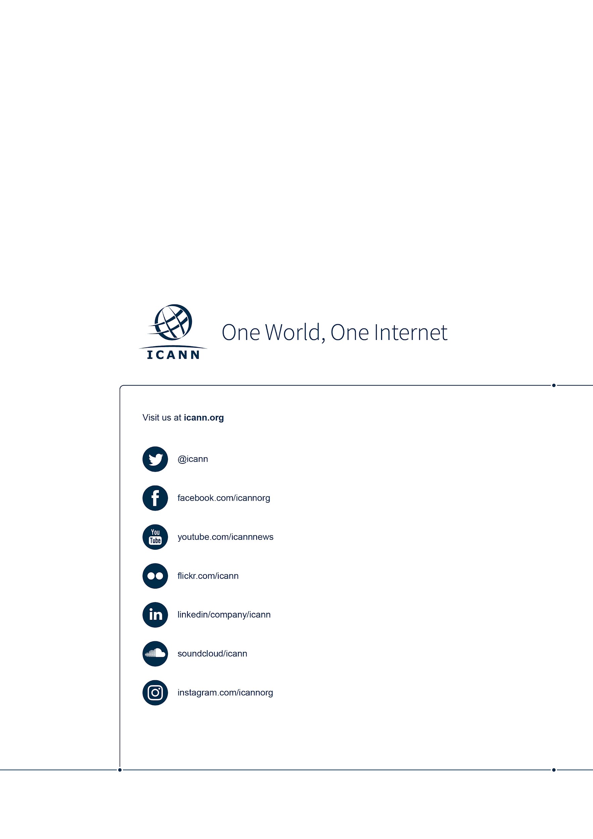

*ICANN reserves the right to change the application fee in case of a change in the costs involved in the review process.

